ASE ASSIGNMENT 5

CONTRIBUTORS:

NIKHITHA KOLLURI – 12

PEDDAKAM DILEEP REDDY – 20

Introduction

Objectives:

1. Create your own firebase account enable authentication using email and password
2. Plugin : Use at least one Cordova plugin.
3. Save the results obtained from the step -2 into any of the cloud services like firebase Real Time Database/storage to the user’s respective account such that when he login again it should display the previously stored data.
4. Deploy the application to Web/Android/Ionic.

Features:

1. User can create an account with this system. If he doesn’t have an account.
2. After creating the account he can login to the system with his credentials.
3. After logging in, if he is an old user he can see his past locations his device is in. If he is a new user, he can get his device geolocation. He can click on the geolocation button as many times as he needs, he would get all the geolocations every second. All of them would be displayed on the screen.

Design:

1. Technologies or languages used in this assignment are

* Webstorm IDE
* Npm
* Angular CLI
* TypeScript
* Bootstrap
* Geolocation plugin
* Cordova
* Firebase

1. Created few pages such as Login, Home, Geolocation

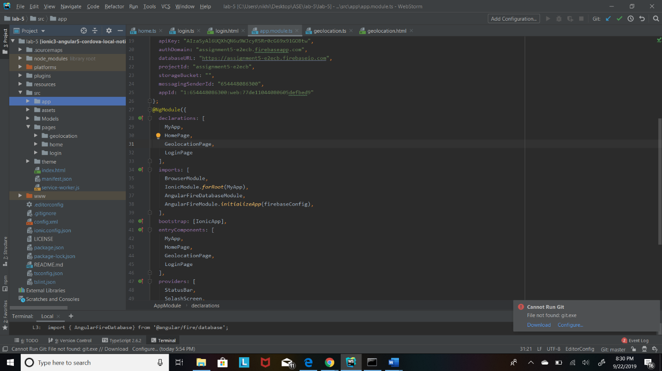

1. Implemented Firebase to store the details and have used the geolocation plugin.

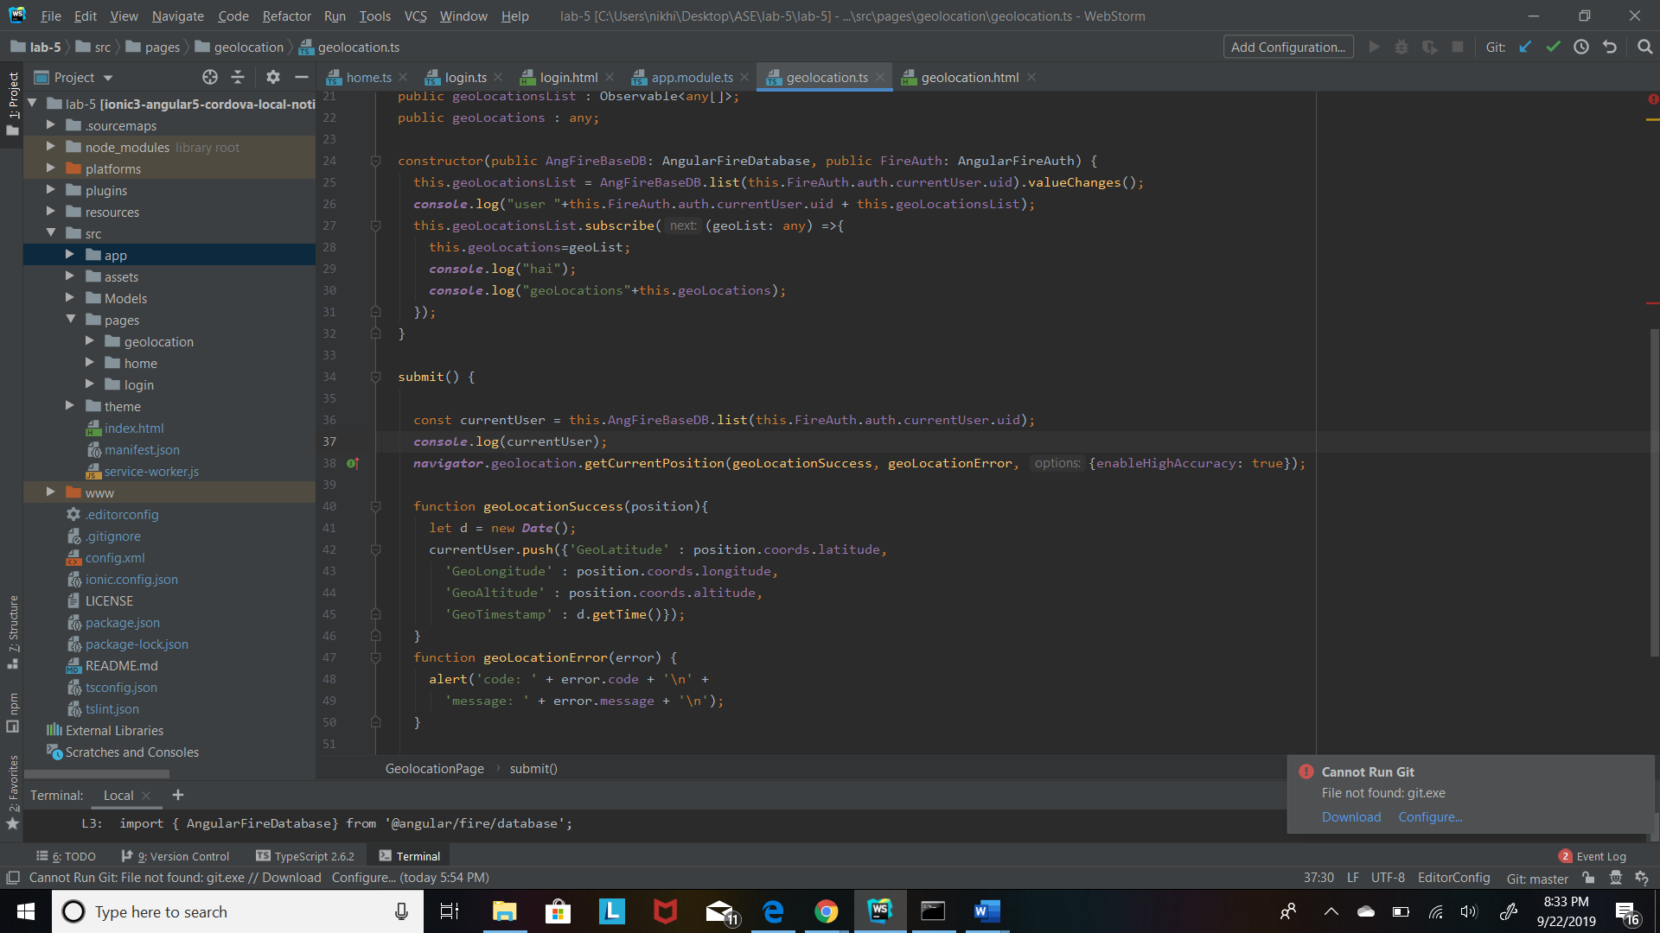

1. Login page of this site.

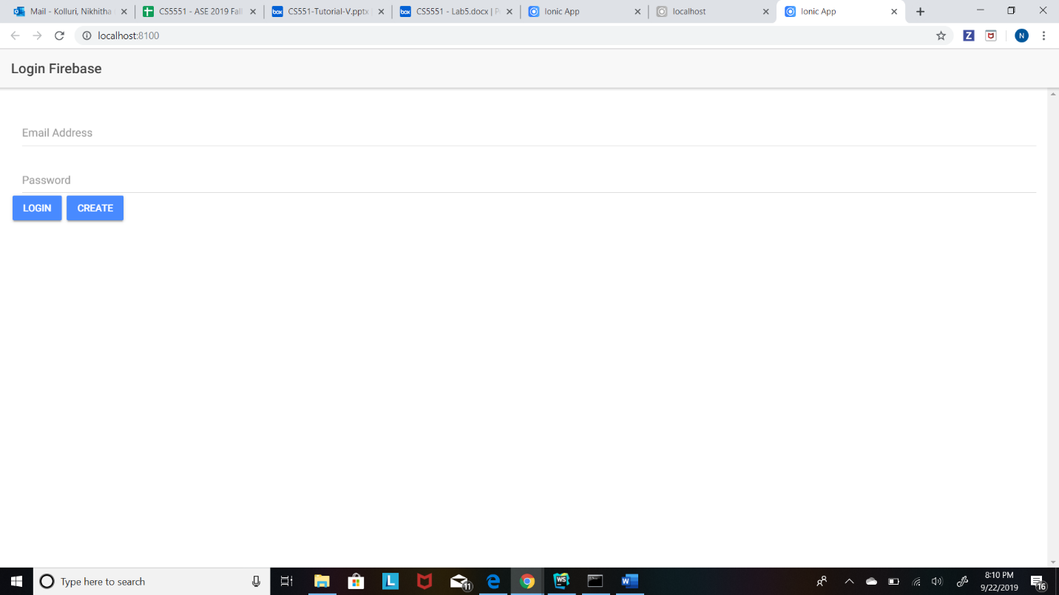

1. If user don’t have an account, he can create an account. After creating, he gets a success alert window.

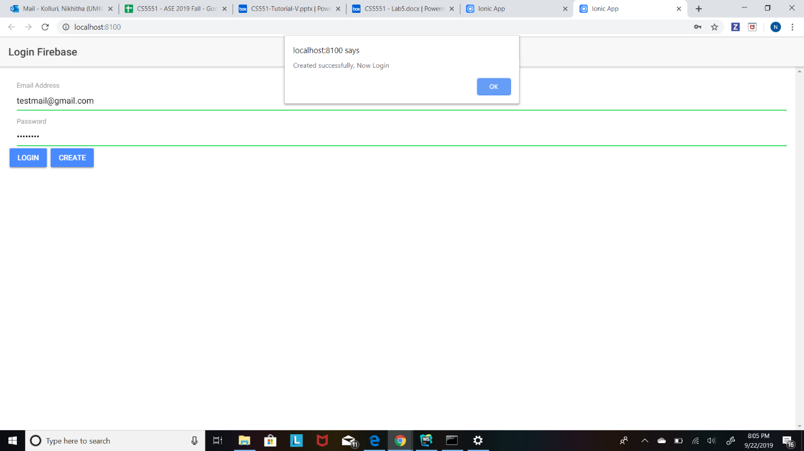

1. After clicking on ok. The user can login using his newly created credentials.

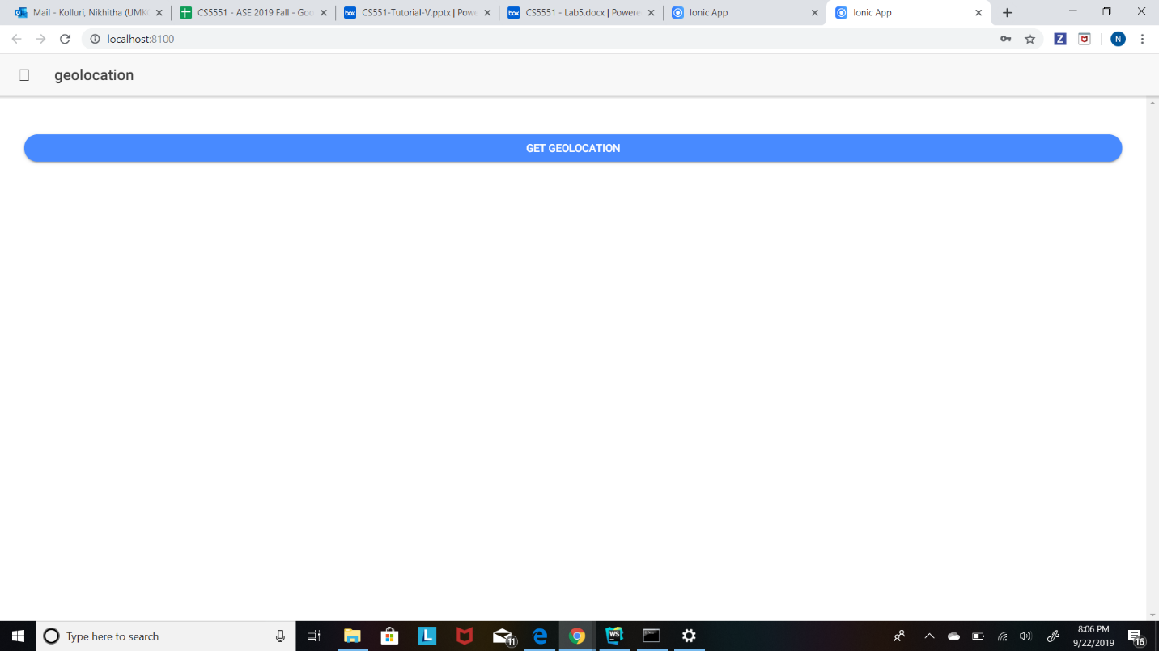

1. After logging in, a get geolocation button will be displayed. If we click on that, user will be able to get his device latitude, longitude and timestamp.

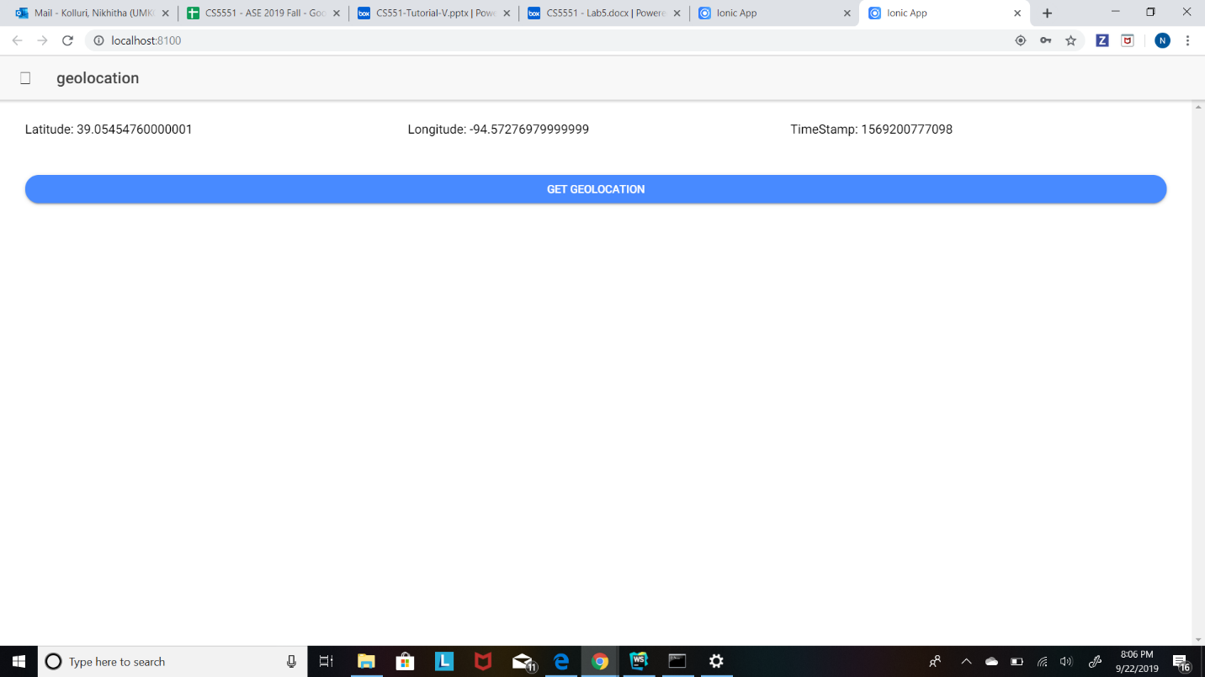

1. The user can click the button many times, it displays all the results including the past results.

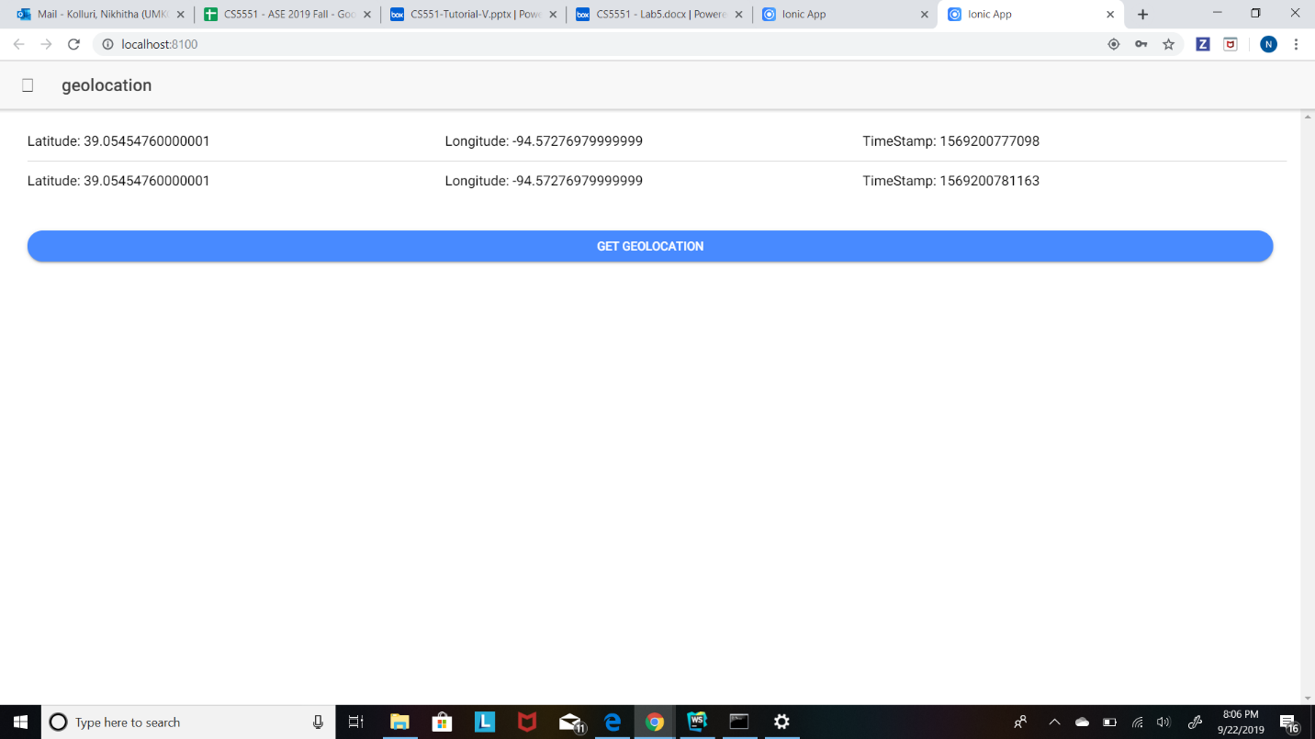

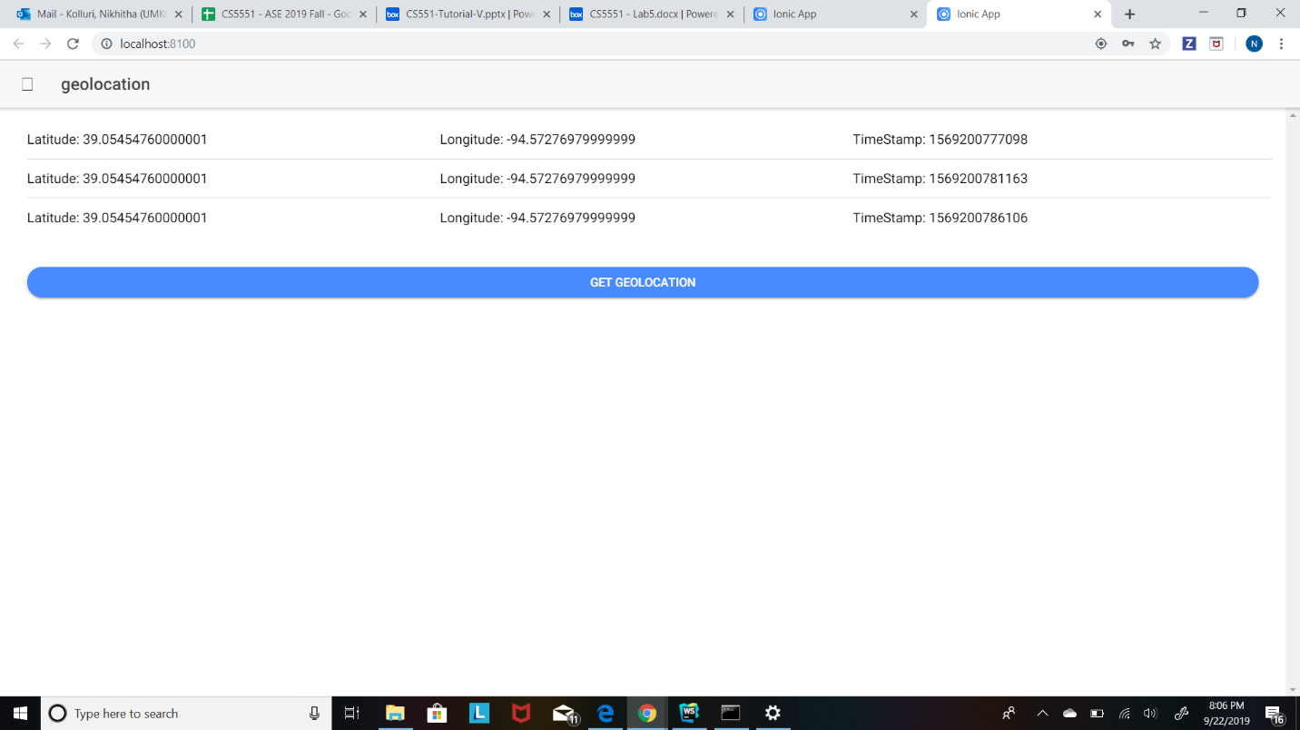

1. We can see all the user details in the firebase database.

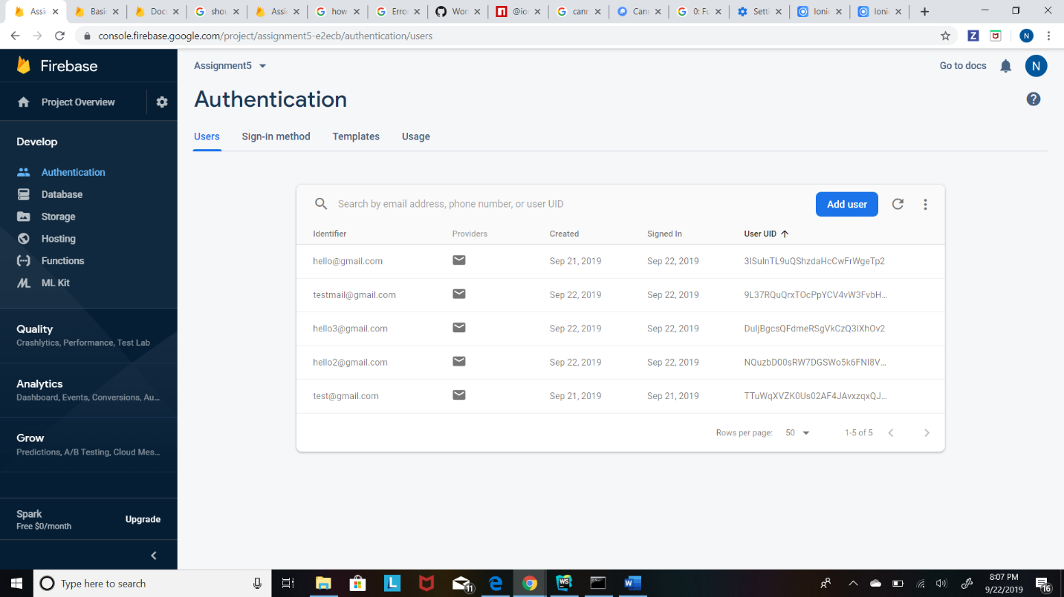

1. If we open FireBase we can view all the geolocations of the device of all the logged in users.

