The Aplication is using the Stanford CoreNLP to extract all nouns or all verbs from a sentence.

The query can be accomplished by Postman, as there are 3 options:

* Extracting all nouns from a sentence:

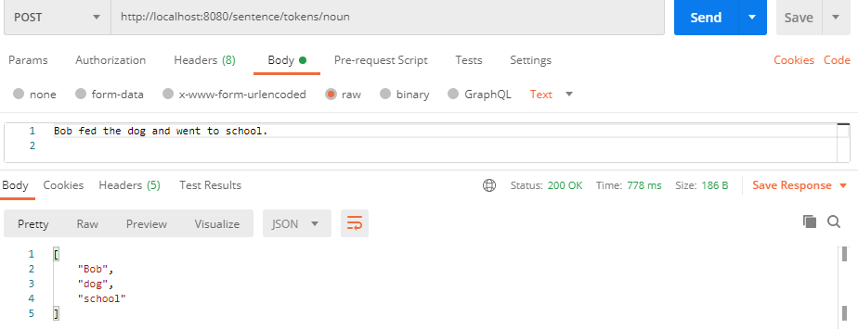

* Extracting all verbs from a sentence:

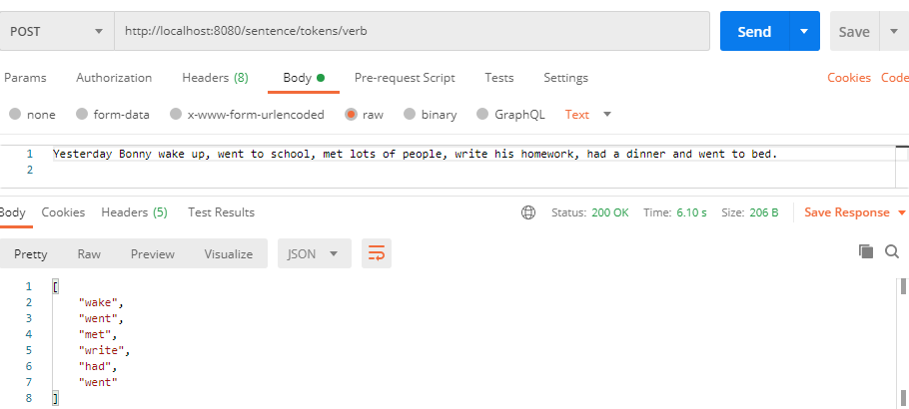

* 404 is thrown, when you don’t give a part of the speech:

