Harmonic Coupling Analysis in Passive Microwave Filters with Nonlinear Dielectric Posts

Names
Department of Electronics and Telecommunications,
University of Florence,
Via di Santa Marta 3, I-50139,
Florence, Italy

Abstract—The nonlinear intermodulation coupling problem of a waveguide filter with dielectric posts is solved by means of the harmonic balance finite element technique. Materials nonlinear behavior generates higher order harmonics when a single tone analysis is performed, and intermodulation products appear for multi-tone analysis. A method to compute two-tone intermodulation products in dielectric posts filter with Kerr-type nonlinear behavior is presented.
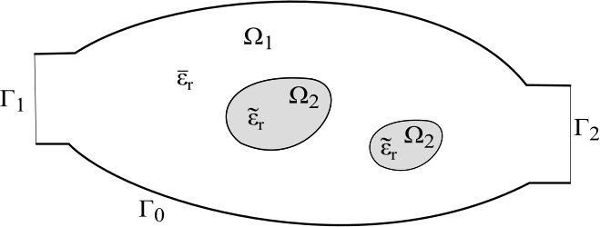
Figure 1. Generic H-plane filter with nonlinear dielectric posts

Keywords-component; Filter devices, Kerr-like permittivity, intermodulation, nonlinear interaction, finite elements, harmonic analysis

Introduction
Waveguide filters are widely used in high power applications because of their low-loss performance. Under high-power excitations, waveguide filters designed with dielectric posts can no longer be described by a linear set of equations. Considering higher-order (cubic) terms of the permittivity, echo signals in the time domain and intermodulation coupling in the frequency domain must be included in a nonlinear theory.
Third-order nonlinearity in materials generate intermodulation noise in the signal bandwidth, and its effect become important in telecommunications systems. It can desensitize a receiver that is tuned to any of the intermodulation products [1].
A frequency domain analysis by using conventional (single-harmonic) finite elements, does not allow for the computation of signal coupling between an in-band signal and a strong out-of-band interferer. Including multiple harmonics in the analysis and performing the necessary computations to derive coupling coefficients results to be an attractive alternative to time domain analysis.
The theory of harmonic balance finite element (HBFE) method, also known as multiharmonic finite element, is presented for the analysis of a generic H-plane microwave device comprehending Kerr-like dielectric materials. This technique has been successfully employed in magnetostatics problems [2], [3]. The final goal is to show whether a waveguide device affected by nonlinear behavior presents a reduced performance, especially for sensible applications. Simulation results for a two-posts H-plane filter with Kerr-like nonlinearity are discussed in section III.

FORMULATION
Consider a generic two port device H-plane cross section as depicted in Error: Reference source not found. Due to H-plane symmetry of the original 3D waveguide device [4], the associated 2D boundary value problem requires the solution of the scalar Helmholtz equation of the out-of-plane electric field component E_{z}

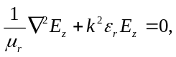

within the domain Ω, comprising linear media in Ω₁ and nonlinear media in Ω₂, with port boundary conditions on Γ₁ and Γ₂ and perfect electric conductor boundary conditions on Γ₀. k is the free space wavenumber.
The scalar relative permittivity in Ω can be expressed as

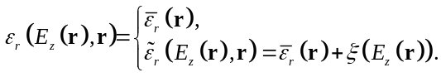

where E_{z}(r) is the electric field in the generic point r and ξ denotes a generic scalar operator describing the nonlinear behavior. The scalar relative permeability µ_{r} is unitary all over Ω.
Using a conventional FE Galerkin framework, the domain is discretized into a set of non overlapping finite elements and the electric field is approximated as a linear combination of scalar basis functions φ_{n}

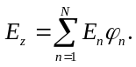

Then by testing Helmholtz equation with weighting functions φ_{m}, chosen equal to the basis, the following weak form is obtained:

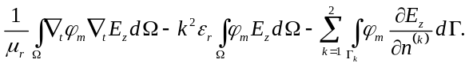

Considering the two-tones problem at hand, the multi-harmonic behavior is introduced by approximating the electric field as

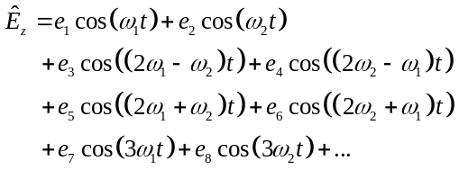

where ω₁ is the in-band signal angular frequency and ω₂ is the angular frequency of the edge-band interferer.
The complex harmonic amplitudes constitute the unknowns of a conventional finite element system, with k in computed with the corresponding harmonic frequency

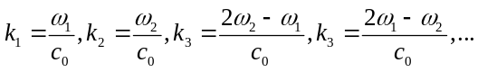

being c₀ the speed of light in free space.
The harmonics retained in are selected due to the particular nonlinear permittivity operator ξ which will be used in the simulations performed in Section III, which indeed is quadratic (Kerr-like permittivity).
In general, operators of even power orders generate third order intermodulation products, especially those that contribute to increase the noise floor within the signal bandwidth (2ω₁- ω₂ and 2ω₂- ω₁). From now on in this paper, eight harmonic amplitudes in will be considered.
The nonlinear behavior of the relative permittivity engenders coupling between the previous harmonic signals at the frequencies that expand the electric field. Being dependent on the electric field, the permittivity in Ω₂ can be expressed as

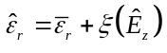

which constitutes, for the nonlinear characteristic of the function ξ, a wider sum of harmonics than that of the field.
For the numerical analysis performed in section III, the Kerr-like permittivity () leads to the following expression

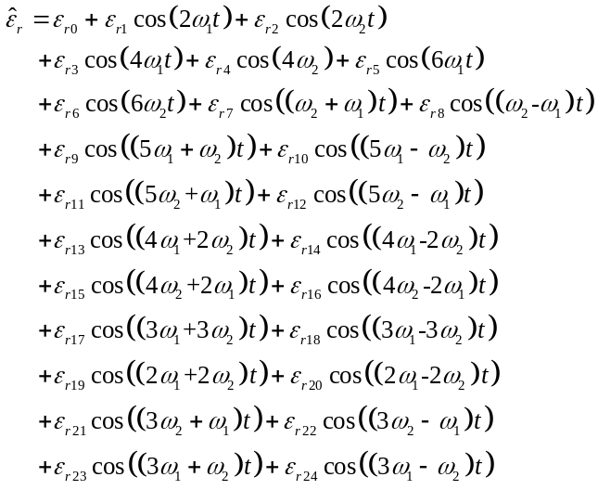

The harmonic amplitude ε_{r} of the permittivity is computed by testing its time evolving value at the sought frequency

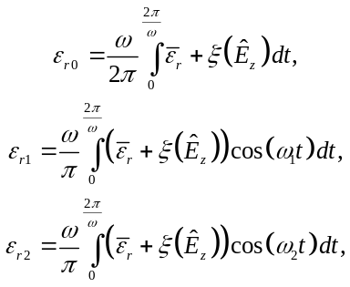

and so on, where ω is the greatest common multiple (GCM) frequency of the integrand frequencies.
Further harmonic testing is performed in , leading to a large scale linear HBFE system which has formally the same structure as a conventional FE system

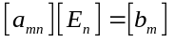

but in which each entry 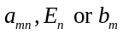is itself a matrix or a vector:

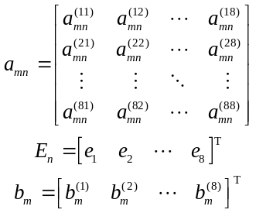

The harmonic testing can be computed analytically when the signal and interferent frequencies are fixed. However, in order to evaluate the coupling over a wide frequency bandwidth of the signal, the FFT algorithm can be used to retrieve the harmonic amplitudes by setting the time sampling to be a period of the GCM frequency.
The nonlinearity is finally handled via a Picard iteration [5]. As a starting point a null electric field 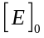is assumed, computing the pertinent system matrix 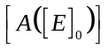and known term 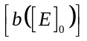and solving the system

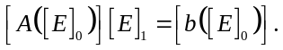

The newly computed field 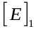 can now be used to update system matrix and known term and perform the following Picard iteration

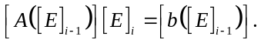

The process is repeated until the relative error between the updated solution and the previous one, in the sense of the Euclidean norm, is less than a prescribed value τ (10⁻⁶ in Section III). The order of the resulting HBFE system is 8N, N being the number of degrees of freedom.
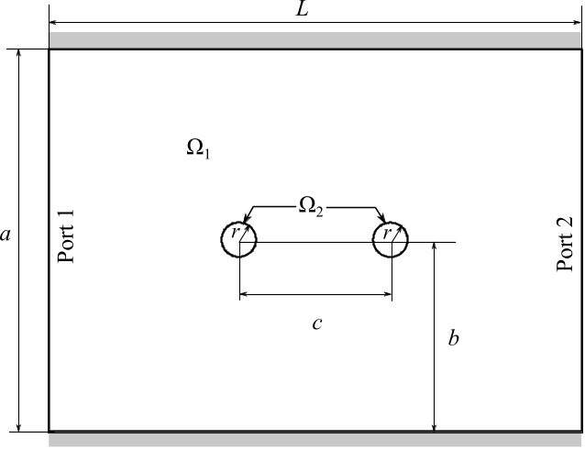
Figure 2. Sketch of the X-band two nonlinear dielectric posts waveguide filter analyzed (H-plane cross section). a = 19.05 mm, b = a/2, r = 0.05a, c = 0.4a and L=1.4a.

NUMERICAL RESULTS
An X-band two-posts waveguide filter (Error: Reference source not found) is here analyzed Error: Reference source not found. The purpose of this section is to illustrate the potentiality of the HBFE formulation in the computation of third order intermodulation products. The filter consists in a WR75 (0.750”x0.375”) waveguide of perfect electric conductor walls comprising two dielectric posts of radius 0.9525 mm as depicted in Error: Reference source not found. The scalar linear permittivity term ε̅_{r} of the posts equals 112.5. Linear analysis of the device is first performed to assess the filter bandwidth.
The FE discretization of Ω leads to 2010 triangular elements with 1042 nodes. Linear nodal basis functions are employed to approximate the out-of-plane electric field. The filter response (ω₁) is depicted in Error: Reference source not found, assuming an impinging TE₁₀ mode at Port 1.
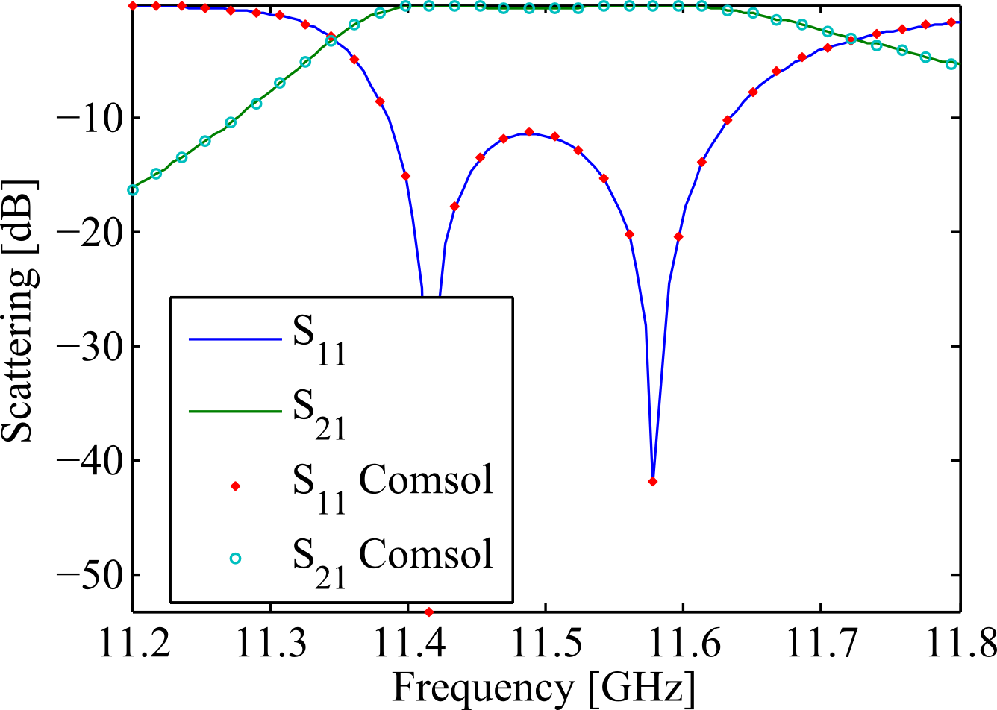
Figure 3. Filter response computed assuming linear permittivity of the posts (εr=112.5). The computed scattering agrees with a simulation performed with Comsol Multiphysics RF module [8] using the same mesh.

The multiharmonic simulation is performed assuming an impinging TE₁₀ mode of 1 W within the filter bandwidth (11.2-11.8 GHz) and a TE₁₀ mode of interferer at 12 GHz of 1, 10 and 100 W. At 12 GHz, the linear filter presents an insertion loss of 9 dB. The Kerr permittivity of the posts is set as [7]
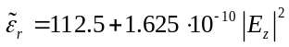

The nonlinear filter response (ω₁) is shown in Figure 5. As the power of the interferer increases, power coupling leads to spectral modification of the filter response.
The computed third order intermodulation products and their scattering levels are shown in Figure 6 and Figure 4, the first related to angular frequencies 2ω₁-ω₂ and the latter at 2ω₂-ω₁. The first is of relevant interest as the intermodulation product covers the signal bandwidth. An increase of the power levels is noticeable as the difference between the signal frequency and the interferer frequency lowers. This behavior is in good agreement with [9]. As the power of the interferer increases, the power delivered to the mixing products grows of a proportional amount.

The noise floor level reaches -45 dB when the power of the power of the interferer is 20 dB (100 W interferer over 1 W signal) higher than the signal.

CONCLUSION
The harmonic balance finite element method have been presented and applied to the computation of third order intermodulation products in waveguide filters with dielectric posts presenting Kerr-like permittivity.
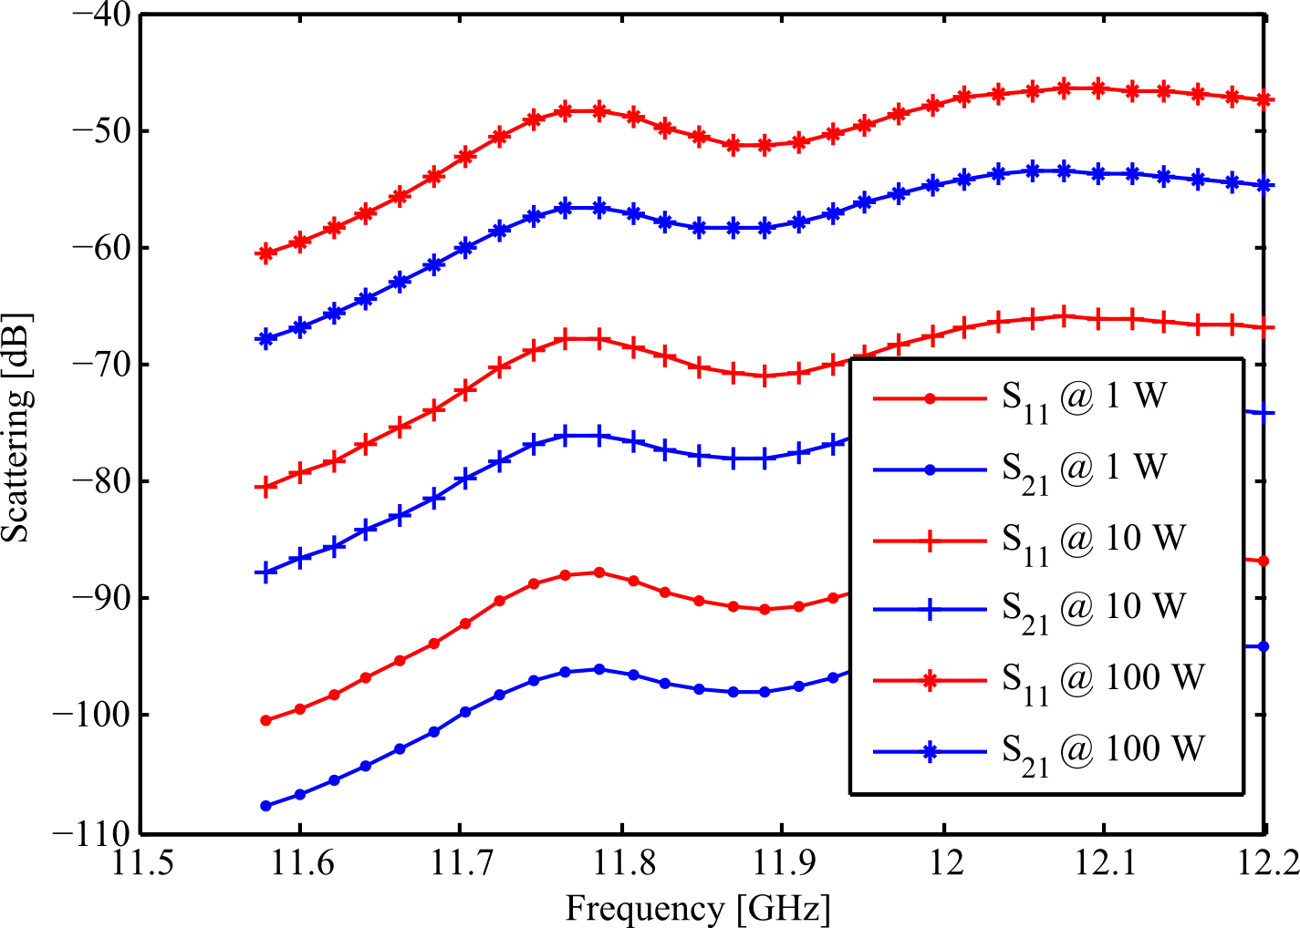
Figure 4. Scattering parameters of the third intermodulation products computed at 2ω₂-ω₁.

Further studies are conducted to compute the effective nonlinear intermodulation products within the more critical ferrite junction devices [9].

References
- B. Razavi, RF Microelectronics, Upper Saddle River NJ: Prentice Hall, 1998, ch. 2, pp.14–25.
- H. De Gersem, H. Vande Sande, and K. Hameyer, “Strong coupled multi-harmonic finite element simulation package,” COMPEL, vol. 20, no. 2, pp. 535–546, 2001.
- S. Yamada, K. Bessho, and J. Lu, “Harmonic balance finite element method applied to nonlinear AC magnetic analysis,” IEEE Trans. Magn.,vol. 25, no. 4, pp. 2971–2973, Jul. 1989.
- G. Pelosi, R. Coccioli, and S. Selleri, Quick Finite-Element for Electromagnetic Waves, 2nd ed. Nordwood, MA: Artech House, 2009, ch. 4, pp. 83–104.
- P. Silvester and R. Ferrari, Finite Element for Electrical Engineering. New York, NY: Cambridge University Press, 1997, ch. 5, pp. 187–190
- P. Arcioni, V. Boria, M. Bozzi, G. Conciauro, and B. Gimeno, “Analysis of H-Plane Waveguide Components with Dielectric Obstacles by the BI-RME Method,” 32nd European Microwave Conference 2002, Milan, Italy, Sept. 24-26, 2002
- G. Guarnieri, G. Pelosi, L. Rossi, and S. Selleri, “A domain decomposition technique for efficient iterative solution of nonlinear electromagnetic problems,” IEEE Trans. Antennas Propag., vol. 58, no. 12, pp. 4090– 4095, Dec. 2010.
- www.comsol.com
- H. How, C. Vittoria, R.Schmidt, “Nonlinear intermodulation coupling in ferrite circulator junctions ,” IEEE Trans. Microwave Theory Tech., vol.45, no.2, pp.245-252, Feb 1997

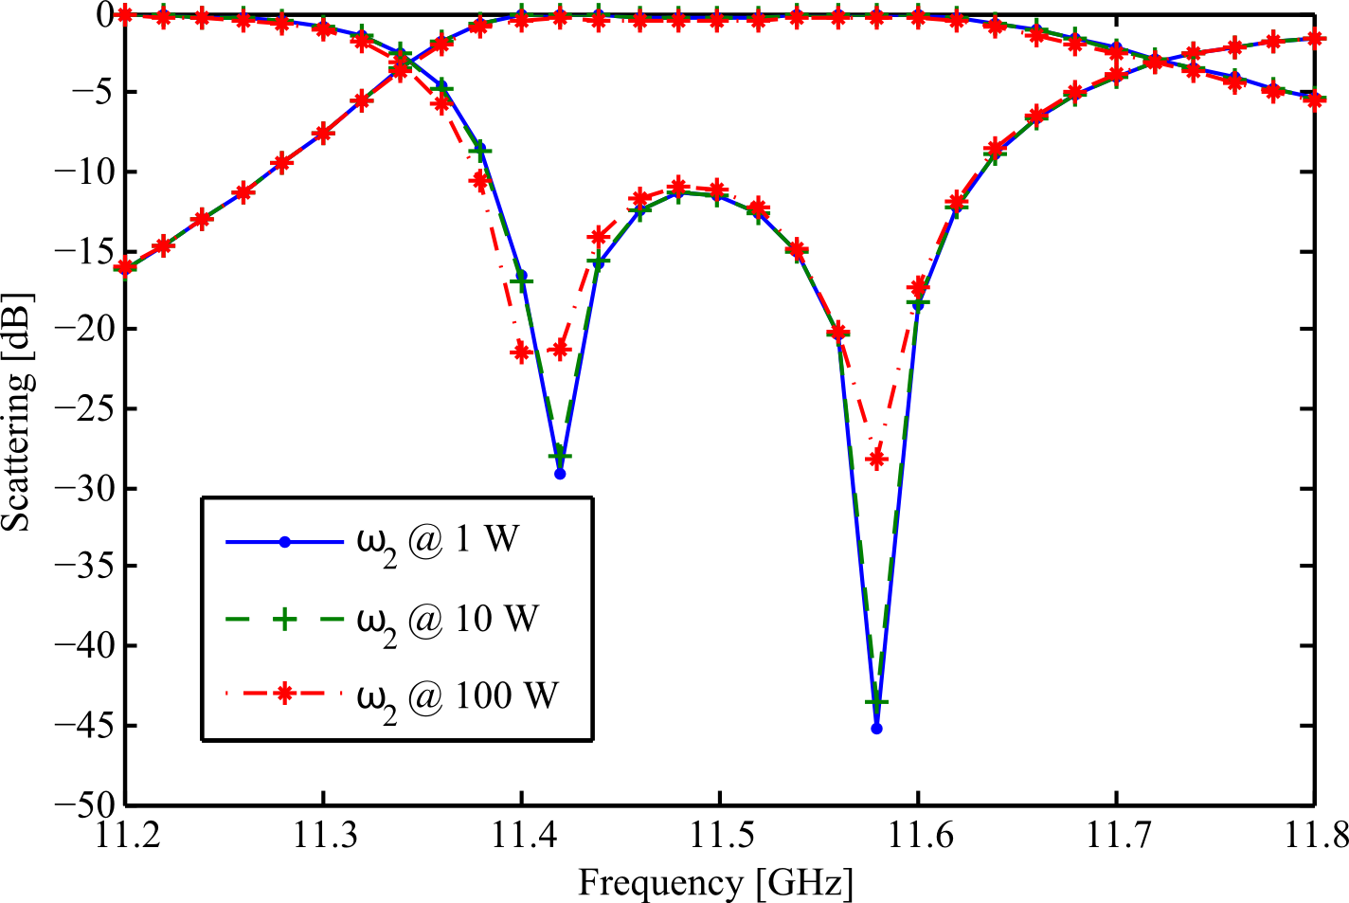
Figure 5. Filter response at ω₁ in presence of an edge-band interferer of increasing power.

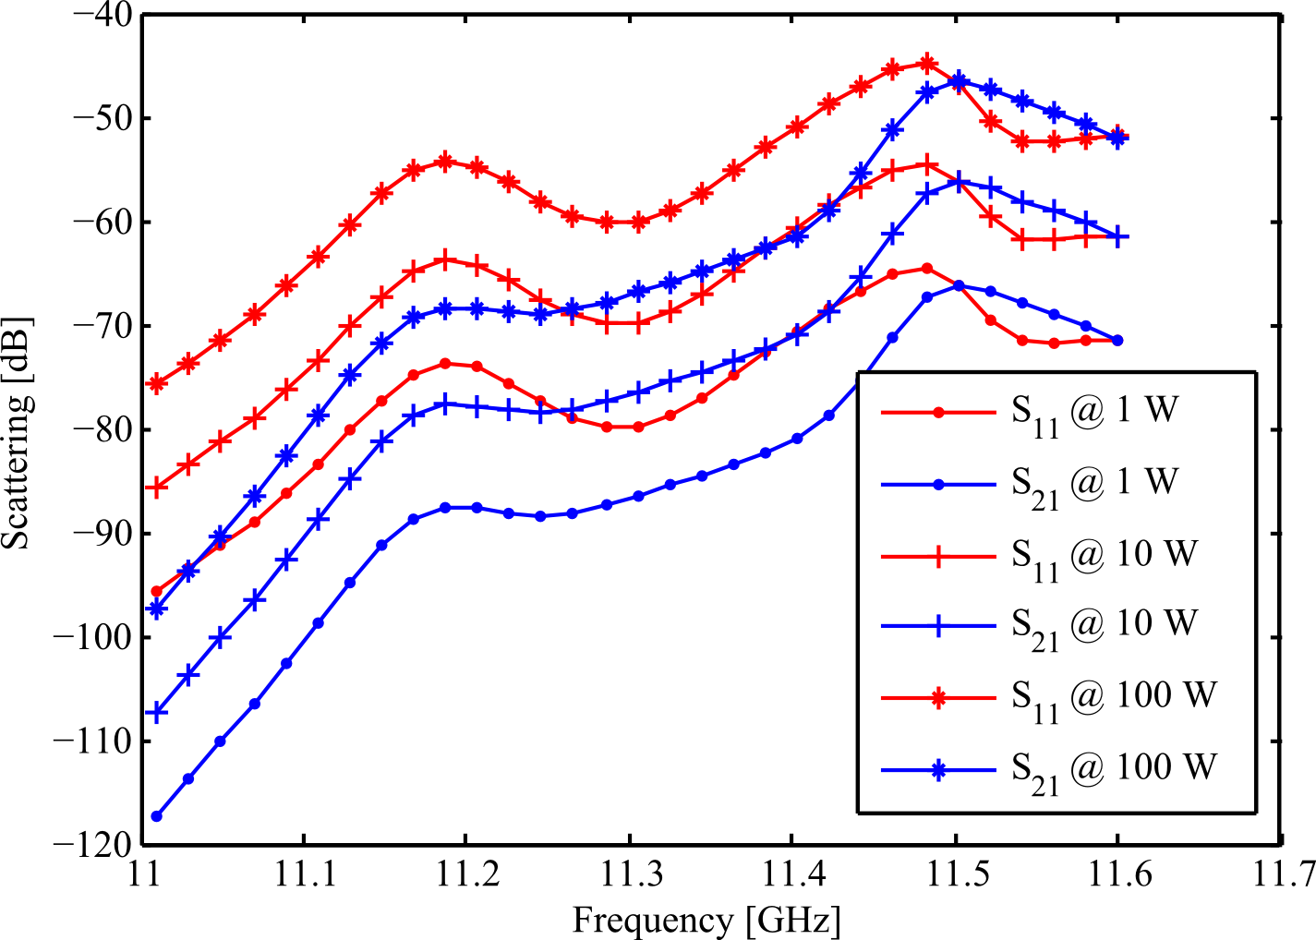
Figure 6. Scattering parameters of the third intermodulation products computed at 2ω₁-ω_{2.}

