Harmonic Balance Finite Element Analysis of Third Order
Intermodulation Products in Ferrite Devices

L. Ntibarikure⁽¹⁾, G. Pelosi⁽¹⁾, S. Selleri⁽¹⁾

- Department of Electronics and Telecommunications,
University of Florence,
Via di Santa Marta 3, 50139, Florence, Italy
stefano.selleri@unifi.it

Abstract
Results of a study of nonlinearities and intermodulation products of 3-port H-plane waveguide circulators are presented. Based on a harmonic balance finite element analysis of the third-order nonlinearity in ferrites, computational results are derived for the field strength and the power level of the intermodulation signal.
Index Terms − Finite elements, harmonic analysis, ferrite device, gyromagnetic property, intermodulation, junction circulator, nonlinear interaction.

- Introduction

Waveguide devices are widely used in high-power applications because of their low-loss performance. Under high-power excitations, the motion of the magnetization vector can no longer be described by a linear set of equations. Considering higher-order terms of the permeability, echo signals in the time domain and intermodulation coupling in the frequency domain must be included in the nonlinear theory. Third-order nonlinearity in ferrites generate intermodulation noise in the signal bandwidth.
A frequency domain analysis, by using conventional (single-harmonic) finite elements, does not allow for the computation of signal coupling between an in-band signal and a strong out-of-band interferer. Including multiple harmonics in the analysis and performing the necessary computations to derive coupling coefficients results to be an attractive alternative to time domain analysis.
The theory of harmonic balance finite element (HBFE) method, also known as multiharmonic finite element, is presented for the analysis of a generic H-plane microwave ferrite device. This technique has been successfully employed in magnetostatics problems [2]-[3]. The final goal is to show whether a ferrite device affected by nonlinear behavior presents a reduced performance, especially for sensible applications. The HBFE theory is reported in Section II, while simulation results for a 3-port H-plane ferrite circulator are discussed in section III. Section VI draws some conclusions.

- Formulation

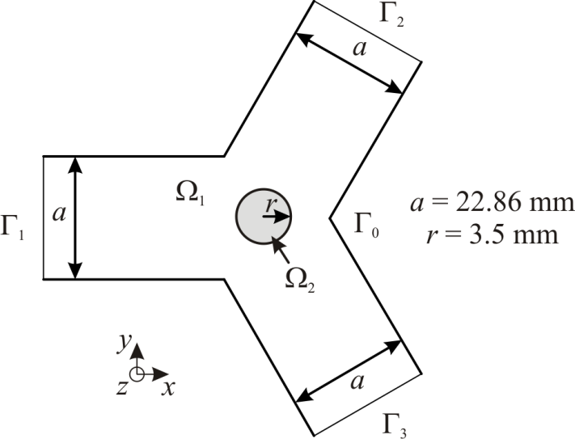
Fig. 1 − Sketch of the analyzed circulator with a cylindrical ferrite post.

Consider the waveguide circulator whose cross-section is depicted in Fig. 1. Due to H-plane symmetry of the actual 3D device, the associated 2D boundary value problem requires the solution of the vector Helmholtz equation for the electric field, with only the out-of-plane component E_{z} being non null
within the domain Ω, comprising linear media in Ω₁ and nonlinear media in Ω₂, with port boundary conditions on Γ_{i} , i=1…3, and perfect electric conductor boundary conditions on Γ₀. k is the free space wavenumber. The gyrotropic relative permeability tensor μ_{r} has the form
where ω is the angular frequency, γ the gyromagnetic ratio, H₀ the internal DC magnetic field and M_{s} the saturation magnetization. Values employed in Section III are given in [4].
The conventional finite element formulation for anisotropic media can be retrieved in [5].
The diagonal permeability tensor coefficients can be expressed as
where E_{z}(r) is the electric field in the generic point r and ξ denotes a generic scalar operator describing the nonlinear behavior. Analogously for k_{r}.
Considering the two-tones problem at hand, the multi-harmonic behavior is introduced by approximating the electric field as
where ω₁ is the in-band signal angular frequency and ω₂ is the angular frequency of the edge-band interferer.
The complex harmonic amplitudes constitute the unknowns of a conventional finite element system, with k in (1) computed with the corresponding harmonic frequency
being c₀ the speed of light in free space.
The harmonics retained in (4) are selected due to the particular nonlinear permittivity operator ξ which will be used in the simulations performed in Section III, which indeed is quadratic. In general, operators of even power orders generate third order intermodulation products, especially those that contribute to increase the noise floor within the signal bandwidth (2ω₁ - ω₂ and 2ω₂ - ω₁). From now on in this paper, eight harmonic amplitudes in (4) will be considered.
The nonlinear behavior of the relative permeability tensor coefficients generates coupling between the previous harmonic signals at the frequencies that expand the electric field. In section III, a quadratic dependence on the magnetic field in Ω₂, deducible from the electric field with Faraday’s law, is assumed as sufficient to generate third order intermodulation products, can be expressed as
which constitutes a wider sum of harmonics than that of the field. Quadratic permeability tensor coefficients leads to the following expression

The harmonic amplitude μ_{r} of the permittivity is computed by testing its time evolving value (7) at the sought frequency
and so on, where ω is the greatest common multiple (GCM) frequency of the integrand frequencies.
Further harmonic testing is performed, leading to a large scale linear HBFE system which has formally the same structure as a conventional FE system
but in which each entry is itself a matrix or a vector:

The harmonic testing can be computed analytically when the signal and interferent frequencies are fixed. However, in order to evaluate the coupling over a wide frequency bandwidth of the signal, the FFT algorithm can be used to retrieve the harmonic amplitudes by setting the time sampling to be a period of the GCM frequency.
The nonlinearity is finally handled via a Picard iteration. As a starting point a null electric field is assumed, computing the pertinent system matrix and known term and solving the system

The newly computed field can now be used to update system matrix and known term and perform the following Picard iteration

The process is repeated until the relative error between the updated solution and the previous one, in the sense of the Euclidean norm, is less than a prescribed value τ (10⁻⁶ in Section [1]). The order of the resulting HBFE system is 8N, N being the number of degrees of freedom.
- Numerical results

- Conclusion

In Table I you can see a table. Tables are numbered with Roman numerals. Note that no vertical lines are present in a table.
Use the word “Table” (without abbreviation) inside a sentence to mention a table. Please verify that the figures you mention in the text actually exist.

References

[1] B. Razavi, RF Microelectronics, Upper Saddle River NJ: Prentice Hall, 1998, ch. 2, pp.14–25.
[2] H. De Gersem, H. Vande Sande, and K. Hameyer, “Strong coupled multi-harmonic finite element simulation package,” COMPEL, vol. 20, no. 2, pp. 535–546, 2001.
[3] S. Yamada, K. Bessho, and J. Lu, “Harmonic balance finite element method applied to nonlinear AC magnetic analysis,” IEEE Trans. Magn.,vol. 25, no. 4, pp. 2971–2973, Jul. 1989.
[4] N. Okamoto, “Computer-Aided Design of H-plane Waveguide Junctions with Full-Height Ferrites of Arbitrary Shape,”
[5] M. Koshiba, and M. Suzuki, “Finite-Element Analysis of H-plane Waveguide Junction with Arbitrarily Shaped Ferrite Post,” IEEE Trans. Microw. Theory Tech., vol.34, no. 1, Jan. 1986.

