Model Order Reduction in Finite Element Analysis of
Phased Array Antennas

Laurent Ntibarikure

Department of Electronics and Telecommunications,
University of Florence,
Via di Santa Marta 3, 50139, Florence, Italy
laurent.ntibarikure@unifi.it

Abstract
The model order reduction technique is applied to finite element analysis of phased array antennas, allowing for fast and accurate computation of the radiation pattern in front of a beam steering process. Computational timings and approximation error of the reduced model are shown for a patch antennas array, proving the noticeable advantages of the approach.
Index Terms − finite elements, phased array antennas, model order reduction, beam steering.

- Introduction

In modern communication systems and many other applications such as radar utilization, large arrays of antennas are employed to form an electronically steerable antenna beam while completely avoiding mechanically moving parts. In order to adjust such a beam to the given dynamically changing needs, a large amount of consecutive fully three dimensional field analysis runs would be necessary for the processing of each and every emerging parameter set.
Due to the enormous computational effort that would have to be employed for such an analysis, it is highly desirable to extract a subset of information from those fully three dimensional results which enables the fast tuning on a somewhat reduced accuracy level. In mathematical terms, the challenge is to reduce a very large linear system of equations with typically millions of unknowns to a comparatively small one with only thousands of unknowns while keeping the relevant information in the system. This kind of approach belongs to the group of model order reduction algorithms which are nowadays employed in many areas, in particular in electronic design processes [1].
The formulation employed for near-field computation, near-field to far-field transformation and the model reduction approach are presented in Section II. Section III shows results obtained for the analysis of a 3-by-5 patch antennas array. Section IV draws some conclusions.

- Formulation

The boundary value problem (Fig. 1) consists of solving the vector Helmholtz equation
with perfect electric boundaries conditions on Γ_{E}, absorbing boundary conditions on Γ_{R} and wave ports conditions on , p=1…P. For the sake of simplicity, all metallic parts are assumed to be perfect electric.
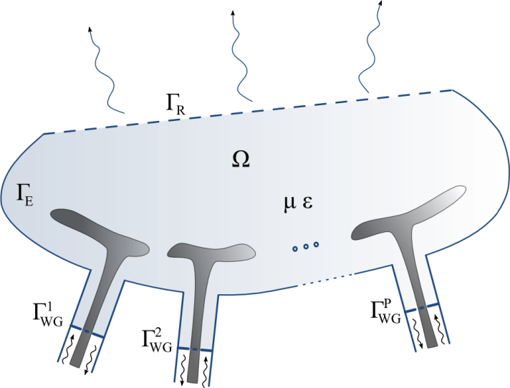
Fig. 1 − Phased array antennas near-field domain Ω
analyzed with finite elements.

Upon applying the conventional Galerkin finite element (FE) method with edge basis functions [2], a linear system of the form [A]x=b is obtained, where [A] is a sparse matrix due to local character of basis functions. For the superposition principle, b can be decomposed in a sum of vectors b_{p} as much as the number of ports, in order to extrapolate from the system the complex excitations enforced at each port, the actual inputs of the system.
As the radiation pattern is sought for, Stratton-Chu formulas [3] are used to compute the far-field from the FE solution on Γ_{R}, then, with the knowledge of the accepted power at antennas ports, antenna gain, output of the system, can be retrieved all over the observation directions. This near-field to far-field transformation can be viewed as the application of an operator c^{H} on the FE solution such that g=c^{H}x, with g the gain value in the selected observation direction and [·]^{H} is the hermitian transpose operator. For further reduction of the model, c have been approximated in terms of truncated Fourier series on the θ-angle, leading to less operations to compute the pattern. c is thus written in terms of vectors c_{q} associated to a given harmonic function.
A projection-based model order reduction technique is finally performed by properly choosing independent FE solutions computed for different port excitations, that is for different scan angles. Those solutions, which constitute global basis functions for the reduced system, are collected in a matrix V that is used to project the full input (steering excitations)-output (gain) system in the following manner

leading to the reduced system

where i_{p} are the complex excitations for each antenna element and o_{q} are the harmonic functions that expand the near-field to far-field transformation operator.

- Results

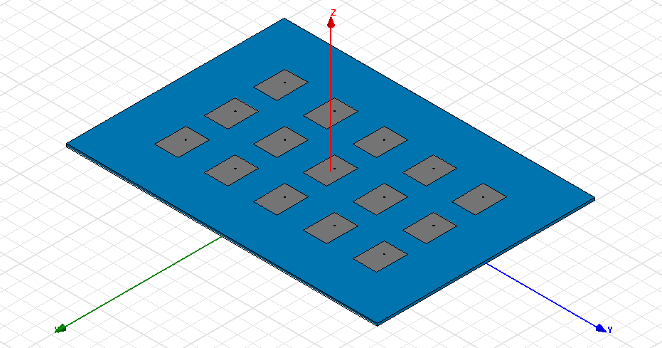

Fig. 2 − Array of 3 by 5 coaxial-fed rectangular patch antennas analyzed for fast beam steering computations.

The array of 3 by 5 patch antennas shown in Fig. 2 have been analyzed with the proposed technique. The spacing between the antennas is of λ₀/2, λ₀ being the free space wavelength. First order basis functions have been chosen, requiring for sufficient accuracy a mesh density of λ₀/10, leading to about 3.6x10⁵ unknowns. 21 Fourier coefficients have been retained to approximate c. To reduce the model, 15 FE solutions have been required allowing for an relative error as low as 10⁻¹¹. To validate the FE code, the simulation have been run with the commercial package HFSS. Results, shown in Fig. 3, validate the present formulation.
To emphasize the advantages of the model order reduction, timings in the pattern computations have been compared. HFSS requires about 35 s to compute the patterns of Fig. 3 while the present code requires only 150 ms.

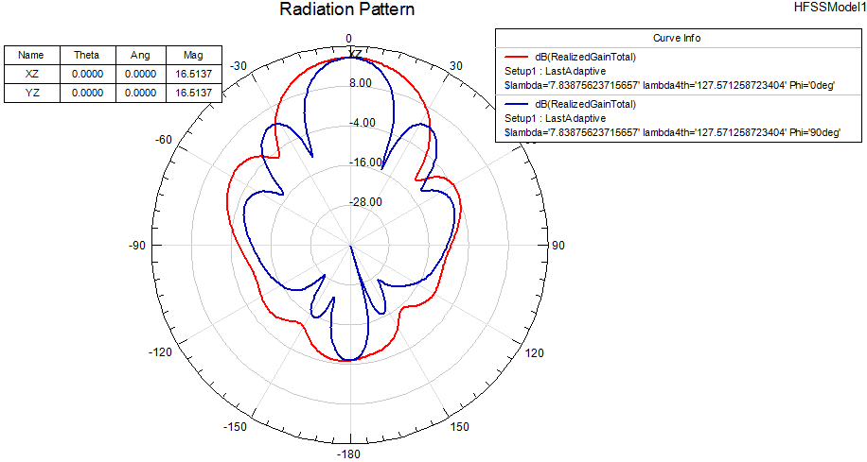
Fig. 3− Patterns computed on the XZ and YZ planes with (left) HFSS and (right) present FE code.

- Conclusion

Model order reduction have been successfully employed to speed-up the computation of the radiation pattern from finite elements simulations of phased array antennas. Noticeable acceleration have been obtained with very good accuracy.

References

[1] A. C. Antoulas, Approximation of Large-Scale Dynamical Systems, SIAM, Advances in Design and Control, 2005.

[2] G. Pelosi, R. Coccioli, and S. Selleri, Quick Finite-Element for Electromagnetic Waves, 2nd ed. Nordwood, MA: Artech House, 2009.

[3] J. A. Stratton, Electromagnetic Theory, NY: McGraw-Hill, 1941.

