Model Order Reduction in Finite Elements Analysis of
Phased Array Antennas

Laurent Ntibarikure

Department of Electronics and Telecommunications,
University of Florence,
Via di Santa Marta 3, 50139, Florence, Italy
laurent.ntibarikure@unifi.it

Abstract
The model order reduction technique is applied to the finite elements analysis of phased array antennas, leading to fast and accurate computation of the radiation pattern in front of a beam steering process. Computational timings and approximation error of the reduced order model are shown for a patch antennas array, proving the noticeable advantages of the presented approach.
Index Terms − Finite elements, phased array antennas, model order reduction, beam steering.

- Introduction

In modern communication systems and many other applications such as radar utilization, large arrays of antennas are employed to form an electronically steerable antenna beam while avoiding completely mechanically moving parts. In order to adjust such a beam to the given dynamically changing needs, a large amount of consecutive full-wave field analysis runs would be necessary to process every emerging parameter set.
Due to the enormous computational effort that would have to be needed for such analysis, it is highly desirable to extract, in an off-line stage, a subset of information from those numerically accurate fully three dimensional results, enabling, in an on-line stage, fast tuning of parameters at a lower accuracy level. In mathematical terms, the challenge is to reduce a very large linear system of equations, with typically millions of unknowns, to a comparatively small one with only thousands of unknowns, while necessarily keeping the relevant information. This kind of approach belongs to the group of model order reduction algorithms which are nowadays employed in many areas, in particular in electronic design processes [1].
Due its capability to handle materials inhomogeneity and geometrical complexity of modern antennas, to its formulation which allows for antennas coupling analysis, the finite elements method results to be a suitable analysis tool for phased array antennas. Being usually truncated by means of absorbing boundary conditions, the domain of analysis is restricted to the near fields. Radiation patterns must hence be computed in a post-processing step from the knowledge of the tangential near fields on the enclosing surface boundaries.
The finite elements formulation employed for the near-field computation, the near-field to far-field transformation method and the employed model order reduction technique are presented in Section II. Section III shows results obtained from the analysis of a 3-by-5 patch antennas array. Section IV draws some conclusions.

- Formulation

The analyzed boundary value problem (Fig. 1) consists of solving the vector Helmholtz equation
with perfect electric boundaries conditions on Γ_{E}, absorbing boundary conditions on Γ_{R} and wave ports conditions (keeping only fundamental mode) on , p=1…P. For the sake of simplicity, all metallic parts that compose the antennas array are assumed to be perfect electric.
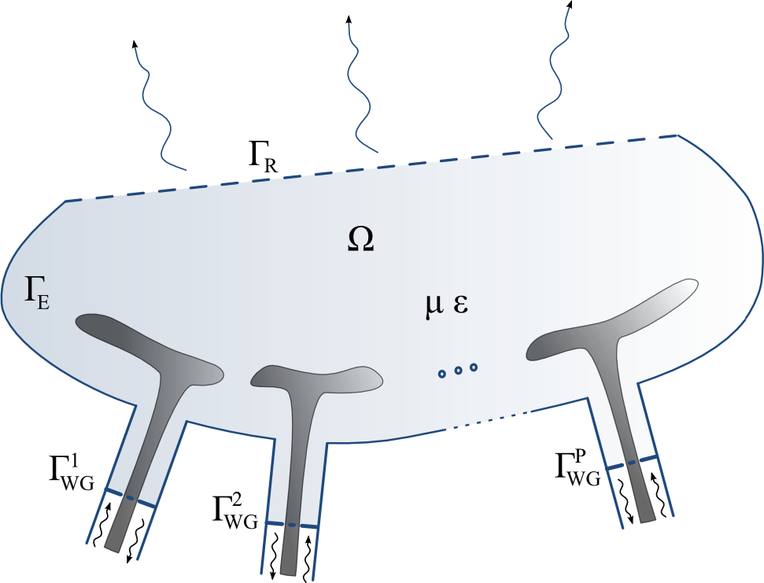
Fig. 1 − Sketch of the phased array antennas
finite element analysis domain Ω.

Upon applying the conventional Galerkin finite elements (FE) method with edge basis functions [2], a linear system of the form [A]x=b is obtained, where [A] is a sparse matrix, due to local character of the chosen basis functions. For the superposition principle, the right hand side b can be expanded into a sum of vectors b_{p} as much as the number of ports, in order to extrapolate from the system the complex excitations enforced at each port, allowing to set the excitation of each port for beam steering operation.
As the radiation pattern is sought for, Stratton-Chu formulas in Kottler’s form [3] are used to compute the far-field from the FE solution on Γ_{R}, then, with the knowledge of the accepted power at antennas ports, the antenna gain can be retrieved all over the observation directions. This near-field to far-field transformation can be viewed as the application of an operator c^{H} on the FE solution such that g=c^{H}x, with g the gain value in the selected observation direction and [·]^{H} is the hermitian transpose operator. For further reduction of the model, c have been approximated in terms of truncated Fourier series, lowering the number of floating point operations to compute the pattern. c is thus written in terms of vectors c_{q} associated to a given harmonic function.
A projection-based model order reduction technique is finally performed by properly choosing independent FE solutions computed for different scan angle excitation. Those solutions, which constitute global basis functions for the reduced system, are collected in a matrix V that is used to project the full input (steering excitations)-output (gain) system in the following manner

leading to the reduced order system of full matrices of the form

where i_{p} are the complex excitations for each antenna element and o_{q} are the harmonic functions that expand the near-field to far-field transformation operator.

- Results

The array of 3 by 5 patch antennas shown in Fig. 2 have been analyzed with the proposed technique. The spacing between the antennas is of λ₀/2, with λ₀ the free space wavelength. First order basis functions have been chosen, requiring, for a sufficient near-field accuracy, a mesh density of λ₀/10, leading to about 3.6x10⁵ unknowns. 26 Fourier coefficients have been retained to approximate c, being enough for an approximation error of the gain of 10⁻⁸, relatively to the full operator pattern results. The error introduced at this level is only attributable to the finite element approximation and the numerical integration technique employed for the implementation of Stratton-Chu formulas.
To reduce the model, 15 FE independent solutions where needed, that is for 15 different scan angles, leading to a relative error of the gain as low as 10⁻¹¹, while 14 solutions would have introduced a non-neglectable error (0.3). To validate the FE code, the simulation has been run with the commercial package HFSS. Results, shown in Fig. 3, validate the present formulation.

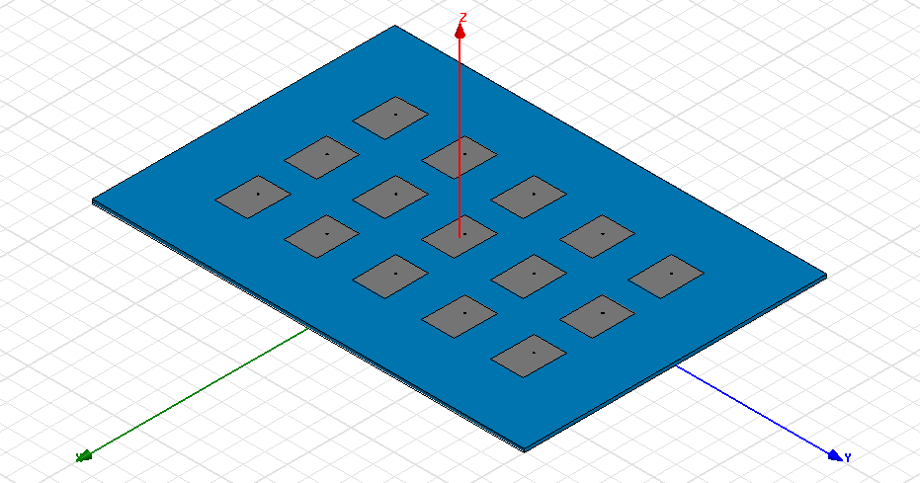
Fig. 2 − Array of 3 by 5 coaxial-fed rectangular patch antennas analyzed for fast beam steering computations.

To emphasize the advantages of the model order reduction, timings in the pattern computations have been compared (Table I). HFSS requires about 35 s to compute the patterns of Fig. 3 while the present code requires only 150 ms, 233 times lower than HFSS times.

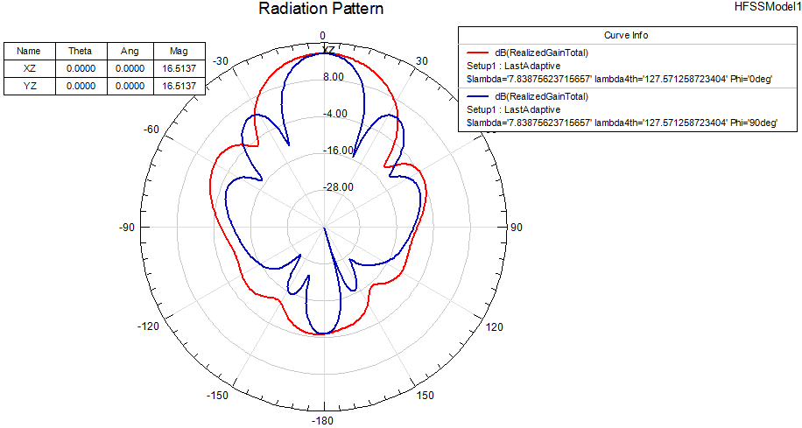
Fig. 3− Patterns computed on the XZ and YZ planes with (left) HFSS and (right) present FE code.

Table I – Computational requirements

 | HFSS | Present code
Full system assembly and solution timings (off-line) | 38 min | 45 min
Total memory requirements for full system (off-line) | 1.5 GB | 625 MB
Memory requirements for reduced system (on-line) | - | 1.5 MB
Radiation pattern computation timings (on-line) | 35 s | 150 ms

- Conclusion

The model order reduction technique have been employed to speed-up the computation of the radiation patterns from finite elements analysis of phased array antennas. Furthermore, as the finite elements system has been parameterized in terms of port excitations, the patterns can be quickly computed in front of a beam steering operation.
It is shown that reduced input systems of dimensions as large as the number of array antennas contain all the necessary information to retrieve the patterns with an error as low as numerical one. Fourier expansion of the near-field to far-field transformation operator reduces computational effort while keeping reasonable accuracy for pattern evaluation.
The presented technique renders practical pattern shaping optimization algorithms applied to full-wave simulations.

Acknowledgement

The author acknowledges the contribution and guidance of Professors Giuseppe Pelosi and Romanus Dyczij-Edlinger, and the insight provided by discussions with Dr. Ing Stefano Selleri and Dr. Ing Ortwin Farle during his Master studentship.

References

[1] A. C. Antoulas, Approximation of Large-Scale Dynamical Systems, SIAM, Advances in Design and Control, 2005.

[2] G. Pelosi, R. Coccioli, and S. Selleri, Quick Finite-Element for Electromagnetic Waves, 2nd ed. Nordwood, MA: Artech House, 2009.

[3] E. J. Rothwell, M. J. Cloud, Electromagnetics, CRC Press LLC, 2001.

