Model Order Reduction in Finite Elements Analysis of
Phased Array Antennas

Laurent Ntibarikure

Department of Electronics and Telecommunications
University of Florence
Via di Santa Marta 3, I-50139 Florence, Italy
laurent.ntibarikure@unifi.it

Abstract
The model order reduction technique is applied to the finite elements analysis of phased array antennas, leading to fast and accurate computation of the radiation pattern in front of a beam steering process. Computational timings and approximation error of the reduced order model are shown for a patch antennas array, proving the noticeable advantages of the presented approach.
Index Terms − Finite elements, phased array antennas, model order reduction, beam steering.

- Introduction

In modern communication systems and many other applications such as radar utilization, large arrays of antennas are employed to form an electronically steerable antenna beam while completely avoiding mechanically moving parts. In order to adjust such a beam to the given dynamically changing needs, a large amount of consecutive full-wave field analysis runs would be necessary to process every emerging parameter set.
Due to the enormous computational effort that would be needed for such analysis, it is highly desirable to extract, in an off-line stage, a subset of information from those numerically accurate fully three dimensional results, enabling in an on-line stage, fast tuning of parameters at a lower accuracy level. In mathematical terms, the challenge is to reduce a very large linear system of equations, with typically millions of unknowns, to a comparatively small one with only thousands of unknowns, while necessarily keeping the relevant information. This kind of approach belongs to the group of model order reduction algorithms which are nowadays employed in many areas, in particular in electronic design processes [1].
Due its capability to handle materials inhomogeneity and geometrical complexity of modern antennas, to its formulation that allows antennas coupling analysis, the finite elements method results to be a suitable analysis tool for phased array antennas. Being usually truncated by means of absorbing boundary conditions, the domain of analysis is restricted to the near fields. Radiation patterns must hence be computed in a post-processing step from the knowledge of the tangential near fields on the enclosing surface boundaries.
The finite elements formulation for the near-field computation, the near-field to far-field transformation method and the model order reduction technique employed are presented in Section II. Section III shows results obtained from the analysis of a 3-by-5 patch antennas array. Section IV draws some conclusions.

- Formulation

The analyzed boundary value problem (Fig. 1) consists of solving the vector Helmholtz equation for the electric field:

with perfect electric boundaries conditions on Γ_{E}, absorbing boundary conditions on Γ_{R} and wave ports conditions (keeping only fundamental mode) on , p=1…P. k₀ is the free-space wavenumber, μ_{r} and ε_{r} are, respectively, the relative permeability and permittivity of the utilized materials. For the sake of simplicity, all metallic parts that compose the antennas array are assumed to be perfect electric.

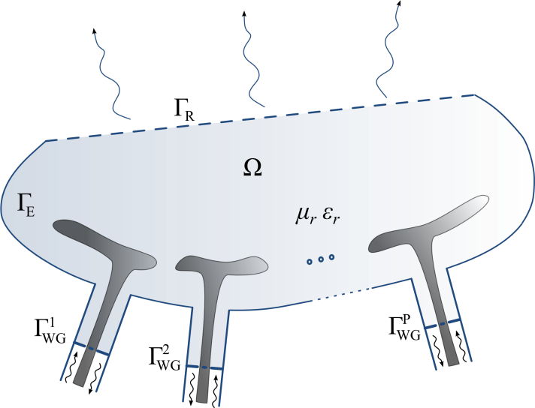
Fig. 1 − Sketch of the phased array antennas
finite element analysis domain Ω.

Upon applying the conventional Galerkin finite elements (FE) method with edge basis functions [2], a linear system of the form [A]x=b is obtained, where [A] is a sparse matrix, due to local character of the chosen basis functions. For the superposition principle, the right hand side b can be expanded into a sum of vectors b_{p} as much as the number of ports, in order to extrapolate from the system the complex excitations enforced at each port, allowing to set the excitations of the ports for a beam steering operation.
As the radiation pattern is sought for, Stratton-Chu formulas in Kottler’s form [3]-[4] are used to compute the far-field from the FE solution on Γ_{R}, then, with the knowledge of the accepted power at antennas ports, the antenna gain can be retrieved all over the observation directions. This near-field to far-field transformation can be viewed as the application of an operator c^{H} on the FE solution such that g=c^{H}x, with g the gain value in the selected observation direction and [·]^{H} is the hermitian transpose operator. For further reduction of the model [5], c have been approximated in terms of truncated Fourier series, reducing the number of operations to compute the pattern. c is thus written in terms of vectors c_{q} associated to a given harmonic function.
A projection-based model order reduction technique [1], [5]-[7] is finally performed by properly choosing independent FE solutions computed for different scan angle excitation. Those solutions, which constitute global basis functions for the reduced system, are collected in a matrix V that is used to project the full input (steering excitations)-output (gain) system matrices in the following manner:

leading to the reduced order system of full matrices of the form:

where i_{p} are the complex excitations for each antenna element and o_{q} are the harmonic functions that expand the near-field to far-field transformation operator. The system matrices of Eq. (3) are now full matrices with an order as low as the dimension of the space spanned by V. The reduced system solution vector is related to the full system solution vector by = [V]^{H} x.

- Results

The array of 3 by 5 patch antennas shown in Fig. 2 have been analyzed with the proposed technique. The spacing between the antennas is of λ₀/2, λ₀ being the free space wavelength. First order basis functions have been chosen requiring, for a sufficient near-field accuracy, a mesh density of λ₀/10, leading to about 3.6x10⁵ unknowns. 26 Fourier coefficients have been retained to approximate c, being enough for an approximation error in the gain of 10⁻⁸, relatively to the full operator pattern results. The main error introduced at this point is only attributable to the finite elements approximation and the numerical integration technique employed for the implementation of Stratton-Chu formulas.
To reduce the model by Eq. (2), 15 FE independent solutions where needed, that is for 15 different scan angles, leading to a relative error of the gain as low as 10⁻¹¹, while 14 and less solutions would have introduced a non-neglectable error (~10⁻¹). To validate the FE code, the simulation has been run with the commercial package Ansys HFSS. Results, shown in Fig. 3, validate the present formulation.

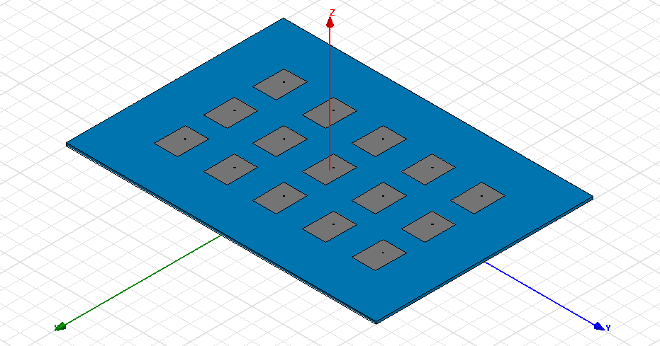
Fig. 2 − Array of 3 by 5 coaxial-fed rectangular patch antennas analyzed for fast beam steering computations.

To emphasize the advantages of the model order reduction, timings in the pattern computations have been compared (Table I). Ansys HFSS requires about 35 s to compute the patterns of Fig. 3 while the present code requires only 150 ms, 233 times lower than Ansys HFSS times.
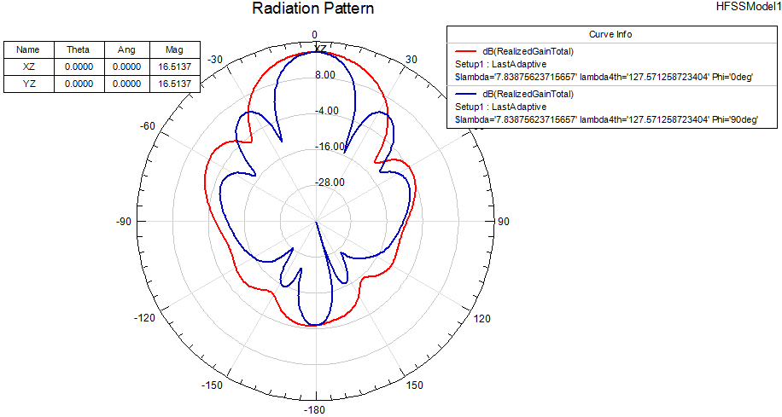
Fig. 3− Patterns computed on the XZ and YZ planes with (left) HFSS and (right) present FE code.

Table I – Computational requirements

 | Ansys HFSS | Present code
Full system assembly and solution timings (off-line) | 38 min | 45 min
Total memory requirements for full system (off-line) | 1.5 GB | 625 MB
Memory requirements for reduced system (on-line) | - | 1.5 MB
Radiation pattern computation timings (on-line) | 35 s | 150 ms

- Conclusion

The model order reduction technique have been employed to speed-up the computation of the radiation patterns from finite elements analysis of phased array antennas. As the finite elements system has been parameterized in terms of port excitations, very fast computation of radiation patterns in front of a beam steering operation can be achieved.
It has been shown that the reduced order systems of dimensions as large as the number of array antennas contain all the necessary information to retrieve the patterns with an error as low as numerical one. Fourier expansion of the near-field to far-field transformation operator reduces computational effort while keeping reasonable accuracy for pattern evaluation.
It is worth noticing that the presented technique might render practical pattern shaping optimization algorithms applied to full-wave simulations.

Acknowledgement

The author acknowledges the contribution, guidance and the insight provided by discussions with Professor Romanus Dyczij-Edlinger and Dr. Ortwin Farle (Lehrstuhl für Theoretische Elektrotechnik, Saarland University, Saarbrücken, Germany) during his Master’s thesis internship.

References

[1] A. C. Antoulas, Approximation of Large-Scale Dynamical Systems, Philadelphia, PA: SIAM, 2005, ch. 7, pp. 207-246.

[2] G. Pelosi, R. Coccioli, and S. Selleri, Quick Finite-Element for Electromagnetic Waves, 2nd ed. Nordwood, MA: Artech House, 2009, ch. 7, pp. 172-188.

[3] E. J. Rothwell, M. J. Cloud, Electromagnetics, New York, NY: CRC Press, 2001, ch. 6, pp 407-428.

[4] P. Monk, “The near field to far field transformation”, COMPEL, vol. 14, n. 1, pp. 41-56, 1995.

[5] P. D. Ledger, J. Peraire, K. Morgan, O. Hassan, N. P. Weatherill, “Parameterised electromagnetic scattering solutions for a range of incident wave angles,” Comput. Meth. Appl. Mech. Eng., vol. 193, n. 33-35, pp. 3587-3605, 2004.

[6] D. B. P. Huynh, A. T. Patera, “Reduced basis approximation and a posteriori error estimates for stress intensity factors,” Int. J. Numer. Meth. Eng., vol. 72, pp. 1219-1259, 2007.

[7] G. Rozza, D. B. P. Huynh, A. T. Patera, “Reduced basis approximation and a posteriori error estimation for affinely parametrized elliptic coercive partial differential equations,” Arch. Comput. Meth. Eng., vol. 15, n. 3, pp. 229-275, 2008.

