Description of the .m2d – file format:

A file begins always with a ‘{‘ and ends with a ‘}’. After the opening statement, the keyword ‘FILE’ followed by the filename must exist.

{ FILE d1
…
}

A ‘.m2d’ –file contains blocks.
A block begins always with the opening statement ‘{ ‘ followed by the blocktype, the blockname and the number N of entries. Then, there are N datablocks and in the end, the closing statement.

{ BLOCKTYPE blockname
3
data
data
data
}

In a .m2d file actually 7 different block types exist:
- ‘POSITIONS‘ contains all cartesian positions,
- ‘NODES‘ contains all nodes,
- ‘EDGES‘ contains all edges,
- ‘FACES‘ contains all faces,
- ‘POLY_EDGES‘ contains collections of edges, on which boundary conditions can be imposed,
- ‘POLY_FACES‘ contains collections of faces, to which different materials can be assigned,
- ‘MESH‘ contains the names of positions, nodes, edges, faces, PolyEdges, PolyFaces that constitute the mesh.

The blocks contain elements that point to other elements. The related blocks are stored in the ‘MESH’ – block.

Arrays
Data in such a block can be arrays. An array looks like this:
Opening statement ‘{‘,
Array type:
- AI for integers,
- AR for doubles,
- AC for complex.
Size
Elements
Closing statement ‘}’.

{ AI 3 0 1 2 }
{ AR 3 0.1 1.1 2e-2 }
{ AC 1 (0,1) }

Block description

Positions
Data-type in a ‘POSITION’ – block :

0 K2 4.9999999999999899e-002 8.5000000000000006e-002

- ‘0’ unique integer ID of a position. These ID’s don’t need to be in order or even positive,
- ‘K2’ position type, (x,y) coordinates,
- ‘4.9999999999999899e-002 8.5000000000000006e-00’ data of the position type. Two values for ‘K2’: x-coordinate and y-coordinate.

{ POSITION SINGLE_MESH
111
0 K2 4.9999999999999899e-002 8.5000000000000006e-002
…
110 K2 2.0000000000000001e-001 -1.0000000000000001e-001
}

Nodes
Data-type in a ‘NODE ‘– block :
0 S 0
- ‘0’ unique integer ID of a node,
- ‘S’ nodetype, is always set to ‘S’ for standard,
- ‘0’ ID of the associated position.

{ NODE SINGLE_MESH
111
0 S 0
…
110 S 110
}

Edges
Data-type in a ‘EDGE ‘– block :
0 S 0 1
- ‘0’ unique integer ID of a edge,
- ‘S’ edge type, is always set to ‘S’ for standard,
- ‘0 1’ ID’s of 2 associated nodes, here: edge points from node 0 to node 1.

{ EDGE SINGLE_MESH
636
0 S 0 1
…
635 S 107 110
}

Faces
Data-type in a ‘FACE ‘– block :
0 T 1 0 11
- ‘0’ unique integer ID of a face,
- ‘T’ face type, is always set to ‘T’ for triangle,
- ‘1 0 11’ ID’s of 3 associated edges.

{ FACE SINGLE_MESH
1018
0 T 1 0 11
…
1017 T 635 632 633
}

Poly-Edges
Data-type in a ‘POLY_EDGES’ – block :
0 S PerfE1 { AI 60 790 …}
- ‘0’ unique integer ID of a polyedge,
- ‘S’ for standard edge,
- ‘PerfE1‘ name of the polyedge,
- ‘{ AI 60 790 …}’ array of integers with edge ID’s.

{ POLY_EDGES SINGLE_MESH
2
0 S PerfE1 { AI 60 790 793 626 629 1719 1725 1419 1425
1921 1925 2212 2214 1856 1860 2139 2142
2175 2179 2568 2572 2324 2330 2357 2360
2593 2595 2613 2616 2425 2428 2433 2437
3363 3366 3560 3563 3727 3729 3977 3981
4342 4346 4251 4255 3941 3944 3965 3968
3893 3897 4049 4052 4017 4021 4446 4449
4328 4331 4290 4296 }
1 S PerfE2 { AI 200 863 865 25 28 53 56 129 131
170 172 577 579 723 725 428 430
…
}

Poly-Faces
Data-type in a POLY_FACES – block :
0 S Box1 { AI 616 … }
- ‘0’ unique integer ID of the polyface,
- ‘S’ for standard face,
- ‘Box1’ name of the polyface,
- ‘{ AI 616 … }’ array of integers with face ID’s.

{ POLY_FACES SINGLE_MESH
5
0 S Box1 { AI 616 2392 2393 2394 2395 2396 2397 2398 2399
2400 2401 2402 2403 2404 2405 2406 2407
2408 2409 2410 2411 2412 2413 2414 2415
2416 2417 2418 2419 2420 2421 2422 2423
2424 2425 2426 2427 2428 2429 2430 2431 …}
1 S Box2{ AI 536 1856 1857 1858 1859 1860 1861 1862 1863
1864 1865 1866 1867 1868 1869 1870 …}
…
}

Mesh
Mesh contains the names of the blocks that form the mesh.

{ MESH SINGLE_MESH
6
Positions SINGLE_MESH
Nodes SINGLE_MESH
Edges SINGLE_MESH
Faces SINGLE_MESH
PolyEdges SINGLE_MESH
PolyFaces SINGLE_MESH
}
- ‘Positions SINGLE_MESH ‘ name of the positions-block,
- ‘ Nodes SINGLE_MESH ‘ name of the node-block,
- ‘Edges SINGLE_MESH ‘ name of the edge-block,
- ‘Faces SINGLE_MESH ‘ name of the face-block,
- ‘PolyEdges SINGLE_MESH ‘ name of the polyedge-block,
- ‘PolyFaces SINGLE_MESH‘ name of the polyface-block.

Topology description
The local topology of a triangle is depicted in Fig. 1. 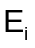 denotes the local edge , 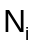 denotes the local node opposite to edge and arrows stand for the local edge directions. In the .mesh2d-file, all triangles must be stored such that the local and the global edge directions are the same.

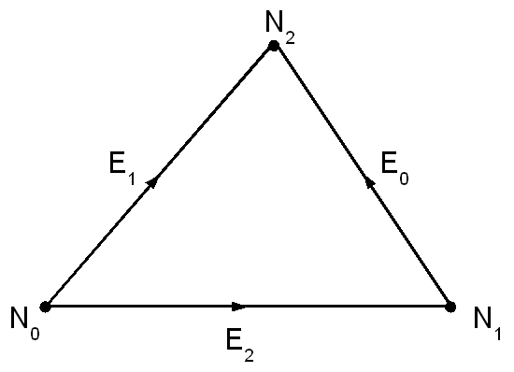

Fig. 1. Topology of a triangle.

