Near fields to far fields transformation from HFSS extracted fields

- Create a *.pts file with the sampling points coordinates on a bounding surface (especially the radiation boundary one)
e.g. the first 7 sampling points on a box
-0.0089483333333333342 -0.0089672727272727265 0.08691299999999999
-0.0089483333333333342 -0.0069239610389610386 0.08691299999999999
-0.0089483333333333342 -0.0048806493506493498 0.08691299999999999
-0.0089483333333333342 -0.002837337662337661 0.08691299999999999
-0.0089483333333333342 -0.00079402597402597301 0.08691299999999999
-0.0089483333333333342 0.0012492857142857149 0.08691299999999999
-0.0089483333333333342 0.0032925974025974046 0.08691299999999999

- Extract the fields from the HFFS solutions with the “fields calculator”
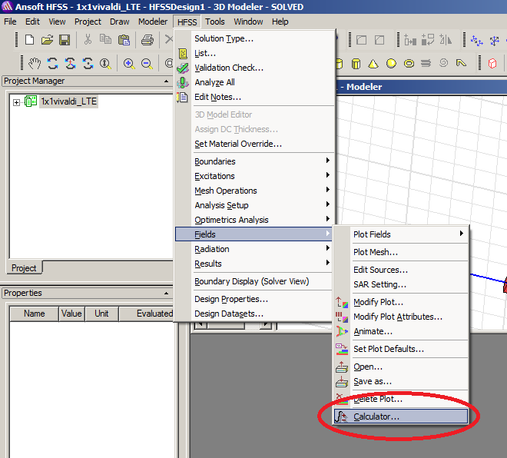

- Then select either the electric field E or the magnetic field H as quantities to export
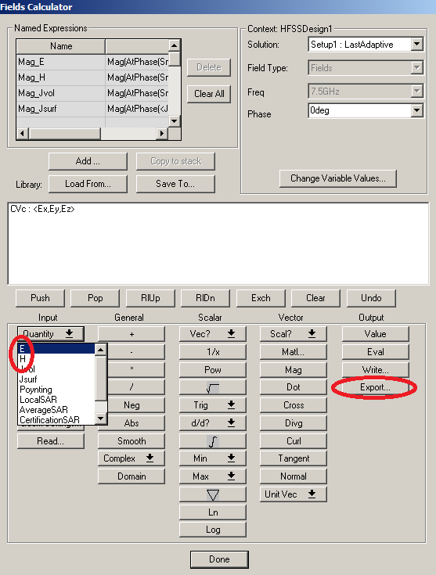

- Once selected the quantity to export, press the button export: a window will appear and we will need to specify the sampling points coordinates file (*.pts) and the output file of the fields to dump (*.reg)
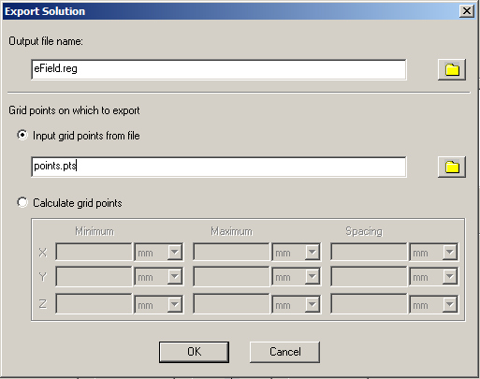
- Now we can apply the near to far transformations from the so-sampled fields on the surface.

Near fields to far fields transformation from LTE solutions and solutions-to- near- fields operator

_callSolvers.bat : batch file that calls the necessary processes for radiation model system matrices. The execution of this code must (should) be combined with a matlab one that calls the ParDiSo (MEX compiled PARallel Direct SOlver)
@echo off
REM Frequency of analysis
set freq=7.5e9
REM Searches automatically the *.hfss file (must be unique!!!) in the directory to obtain the name
REM of the project
for /F "tokens=*" %%* in ('dir /b *.hfss') do call :Sub %%~n*
goto :eof

:Sub
echo Name of Project : %*.hfss
echo Chosen Frequency : %freq% Hz
echo.

REM Copies the HFSS model files (mesh, materials, boundary conditions) into the current directory
cd %*.hfssresults
cd *.results
cd *.cmesh
copy current.* ..\..\..\*
cd ..\..\..\
echo.
echo.

echo Please check if model files have been copied then
echo press a button to call the Mesh Reader ...
echo
pause
echo.

REM calling the MeshReader to create the LTE model from the HFSS model files
call ..\_femSolvers\ANST_MeshReader.exe %*
echo.
echo.
echo Press a button to call the Wave Solver ...
echo
pause
echo.

set path=%path%;..\..\_femSolvers\

cd lte_fileset
REM Modify the *.mpara file to set the polynomials order (the last number in the SOLID definition)
REM remember that HFSS polynomial order begins with 0 while LTE's one with 1 (3D tent basis)
call notepad %*.mpara
REM Modify the *.seinfo file to obtain infos on the phases of excitation of the ports - these
REM informations are dump only if the EM_WaveSolver is called with the +singleEnded option
call notepad %*.seinfo

REM Calls the EM_WaveSolver in order to build the FEM matrix A and the right-hand sides b related to
REM the feeding ports - the solutions-to-fields operator will be dumped using the options
REM +fieldValues +fieldFunctional - the +directMatlab option relies on the mex compiled ParDiSo
call EM_WaveSolver.exe %* %freq% +directMatlab +fieldValues +fieldFunctional
REM call EM_WaveSolver.exe %* %freq% +singleEnded +directMatlab +fieldValues +fieldFunctional
echo
echo.
Pause

The EM_WaveSolver will stop at a certain level in order to compute the solutions x(i) = A\b(i) with the ParDiSo and a FieldEvaluationPoints.fmat file of the near fields sampling points coordinates must be provided, properly formatted with the matlab function writeMatFull(mP, 'lte_fileset\FieldEvaluationPoints.fmat') in order to proceed with the construction of the solutions-to-near-fields operator.
Note: Once the solutions files and the FieldEvaluationPoints.fmat are dumped, an arbitrary character has to be inserted after the command line Press button if solutions are computed: then, pressing enter, the process will proceed.

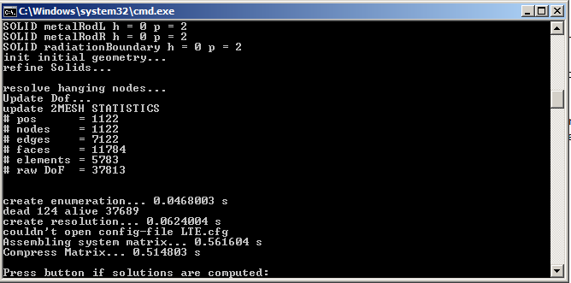

The solutions-to-fields operator is made of 3 parts: fieldFunctional*num2UnNum*comp2Ext where fieldFunctional is the vertical concatenation of mFH (functional that provides the magnetic field on the sampling points ([Hx(1); Hy(1); Hz(1); Hx(2); … ; Hz(N)] for N sampling points) and mFE (idem but for Ex, Ey and Ez).
We only need to supply the N2F operator expanded in a truncated Fourier series to obtain the full radiation model.

