JRG-77 Rev 1

The Linear FMCW Spectrum

– Theory and Analysis

prepared by Mike Turley of DSTO

for discussion at the Fifth JRG 1A/1C/8B Meeting, London

April 2007

Table of Contents
1. Introduction 3
2. LFMCW Theory 3
2.1. Single Chirp 3
2.2. Multiple Chirps 5
3. Spectral Analysis 7
3.1. Fourier transform of a truncated repetitive signal 7
3.2. DFT Analysis 8
DFT of a single chirp 8
DFT of finite sequence of chirps 9
DFT of infinite sequence of chirps 10
3.3. Spectrum Analyser 11
4. Conclusions 12

Table of Figures:
Figure 1 Example theoretical spectrum of a single chirp 4
Figure 2 Example theoretical half spectrum of a single chirp 5
Figure 3 Example frequency segment of multiple chirp modulation for T = 1/250 sec and N=16. 5
Figure 4 Multiple chirp spectrum (N=8) 6
Figure 5 Multiple chirp spectrum (N=128) 6
Figure 6 Theoretical spectra for a single chirp and an infinite sequence of chirps 7
Figure 7 The Fourier transform of a truncated repetitive signal 8
Figure 8 Example simulation of a single chirp. 9
Figure 9 Conventional tapered DFT of finite sequence (8.4 chirps) 10
Figure 10 DFT of single chirp as simulation of theoretical infinite sequence 11
Figure 11 Spectrum Analyser simulation using the STFT 12
Figure 12 Spectrum Analyser Simulation 12

Introduction

During the ITU-R Joint Rapporteurs Group JRG 1A-1C-8B fourth meeting at Mainz, Germany, discussion took place on the spectrum of the Linear FMCW waveform. In particular the following issues arose:

- should out-of-band emission formula be developed for a single chirp, multiple chirps or a continuum, and
- which case does the spectrum of a spectral analyser correspond to.

This paper provides a description of the LFMCW waveform and spectral analysis methods.

LFMCW Theory

The theoretical spectrum of the LFMCW waveform is discussed in a number of JRG documents including JRG-70 and JRG-73. JRG-70 extends the analysis to include flyback waveforms and ‘non-continuous phase’ waveforms. Here we consider only the cases of a single chirp and that of multiple chirps.

Single Chirp

Following JRG-73 the instantaneous frequency of a LFMCW waveform with bandwidth B and chirp duration T is:

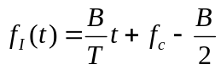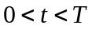 | (1)

where t is time and 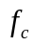 is the carrier frequency. The signal phase can be calculated as:

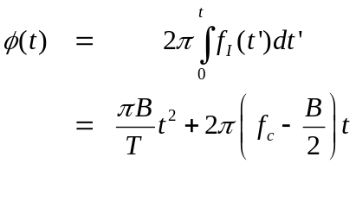 | (2)

with the signal representation:

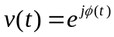 | (3)

The spectrum of this signal can be obtained from its continuous Fourier transform:

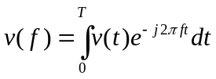 | (4)

letting 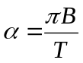and 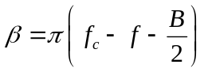

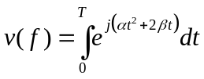 | (5)

which can be solved in terms of Fresnel integrals C(x) and S(x):

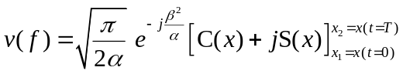 | (6)

where 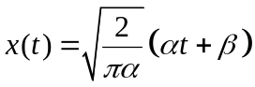 and hence the power spectral density becomes:

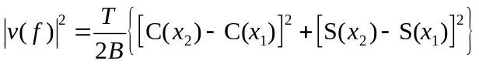 | (7)

For example Figure 1 shows the spectrum calculated for B=10000 Hz and T=1/250 sec. The positive half spectrum is re-plotted with log frequency scale in Figure 2 together with overlaid 20 and 40 dB/decade roll-off curves. We note that the envelope spectrum of a single chirp has a 20 dB/decade sidelobe roll-off, and that for interest, its lower spectral envelope has a 40 db/decade roll-off.

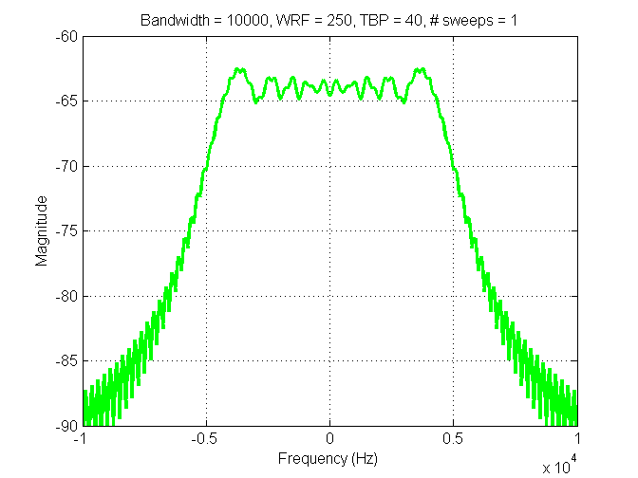
Figure 1 Example theoretical spectrum of a single chirp

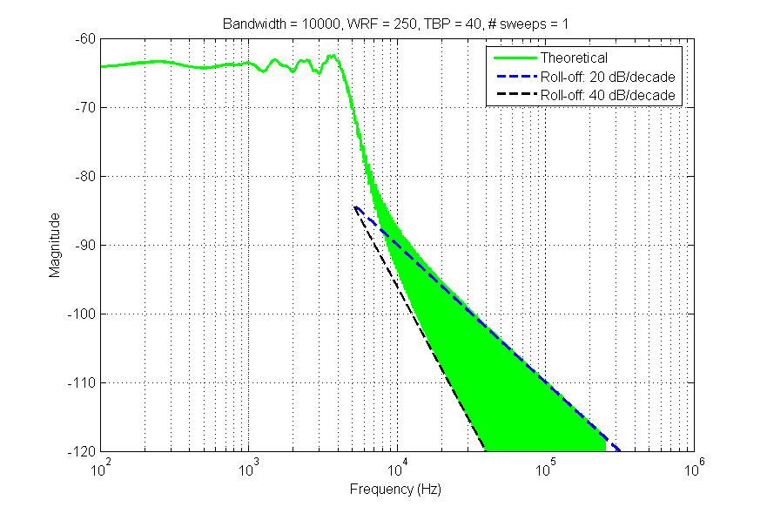
Figure 2 Example theoretical half spectrum of a single chirp

Multiple Chirps

The spectrum of the repetitive form of the single chirp waveform may be derived from the sum of the spectra of time displaced single chirp waveforms. That is:

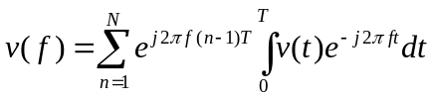 | (8)

where n denotes sweep index and N is the number of chirps, and the Fourier transform time-shift property has been used. The summation term of Equation 8 is shown in Figure 3 for the example of 16 chirps. The repetitive nature of the waveform is responsible for producing line spectra at intervals of 1/T Hz. These line spectra are of sinc form with width 1/NT Hz. As the number of chirps approaches the spectra becomes a set of delta functions with zero amplitude between the lines.
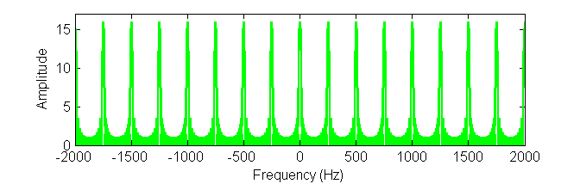
Figure 3 Example frequency segment of multiple chirp modulation for T = 1/250 sec and N=16.

Multiplying this modulation by the single chirp spectrum (Figure 1) provides the multiple chirp spectrum as shown in Figure 4 & Figure 5. As the number of chirps increases the spectrum becomes discrete and the sidelobe roll-off asymptotes to 40 dB/decade. This is demonstrated in Figure 6 where the continuous spectrum from a single chirp is overlaid by the discrete spectrum of the infinite sequence. The infinite discrete spectrum can be obtained by sampling the single chirp spectrum at multiples of the chirp repetition frequency 1/T Hz. It may also be noted that the infinite chirp spectrum matches the lower envelope of the single chirp in the sidelobe zone.

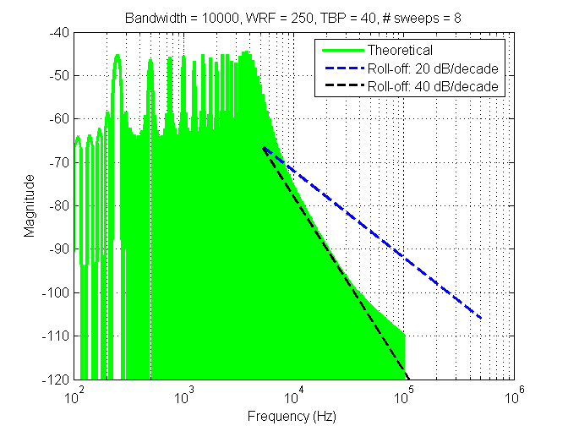
Figure 4 Multiple chirp spectrum (N=8)

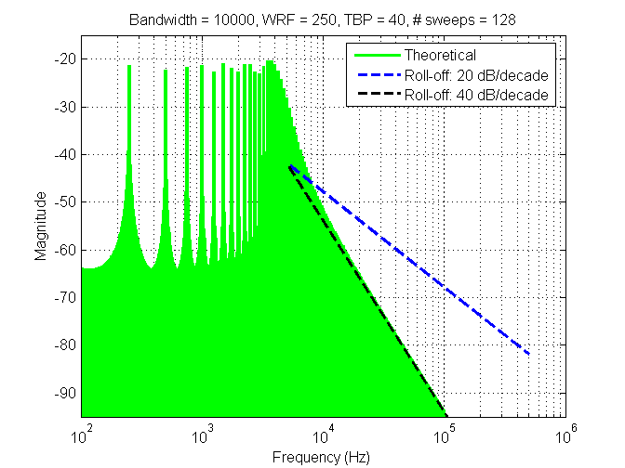
Figure 5 Multiple chirp spectrum (N=128)

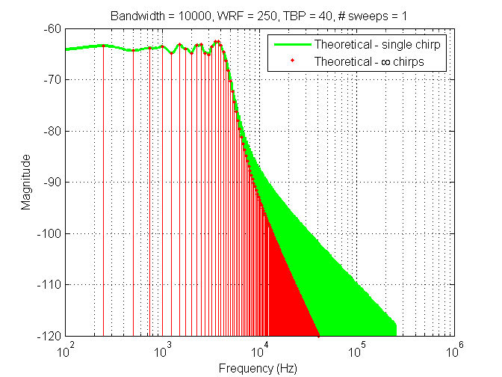
Figure 6 Theoretical spectra for a single chirp and an infinite sequence of chirps

Spectral Analysis

We are also interested in the spectral analysis of numerically simulated data or measurement data. Both simulation and measurement provide avenues to analyse the spectra of a wider variety of waveforms.

Fourier transform of a truncated repetitive signal

To establish the Fourier transform of a finite repetitive sequence let us consider an infinite sequence of chirps, which has the corresponding discrete line spectra shown in Figure 7 (a & b). The temporal and spectral representations are known as a Fourier transform pair. Truncation of the sequence, Figure 7(c) equates to a convolution in the spectral domain between the discrete spectrum and the truncation function’s point spread function. Figure 7(c & d) show the transform pair for a Hann window. The resulting truncated time sequence, Figure 7(e), has a continuous spectrum as in Figure 7(f), where for convenience the discrete spectrum is overlaid.

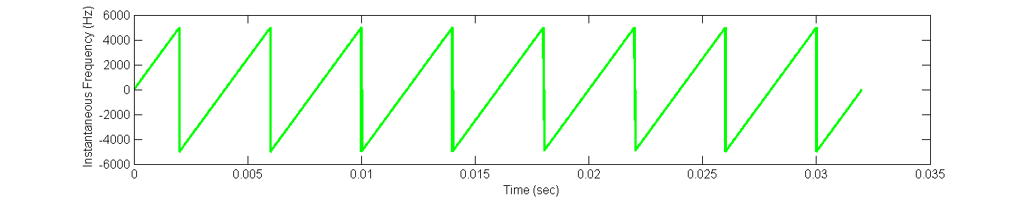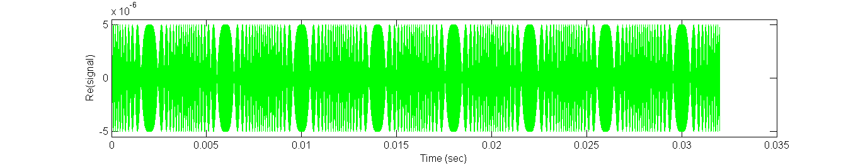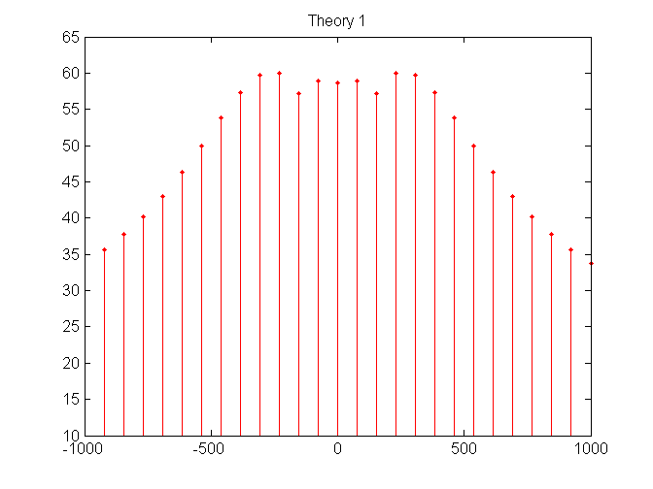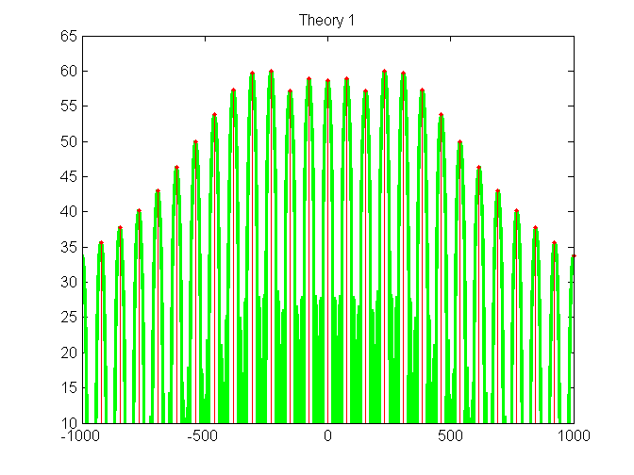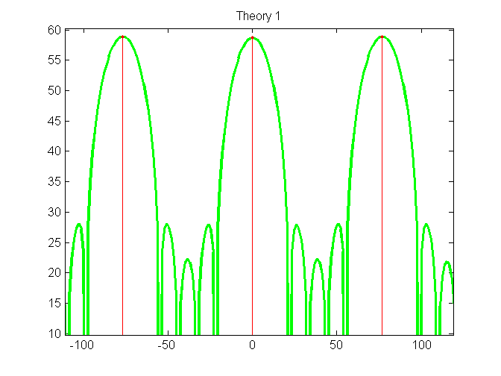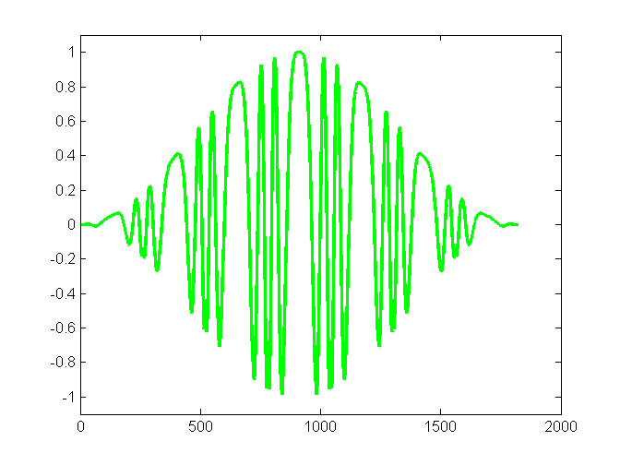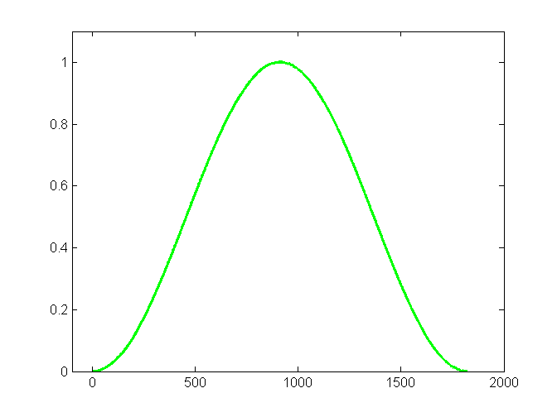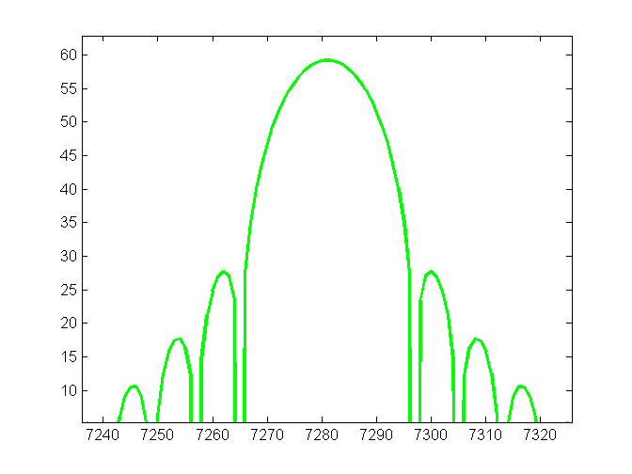
×
*
zoom
(a) Infinite repetitive signal
(c) Truncation
(b) Discrete spectrum
(d) Point Spread function
(e) Truncated time sequence
(f) Convolved Continuous spectrum
Chirp instantaneous frequency
FT pair
Figure 7 The Fourier transform of a truncated repetitive signal

DFT Analysis

DFT of a single chirp

The M-point discrete Fourier transform of the M point sequence x(m) is defined as:

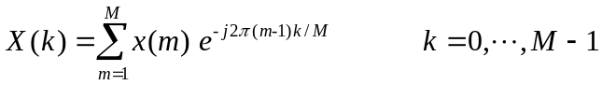 | (9)

where the sample times are 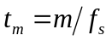, the sampling frequency is 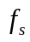, and the spectrum is calculated at the discrete frequencies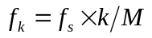. The DFT is typically calculated using a fast Fourier transform algorithm, where a convenient means to calculate intermediate frequency estimates is to append zero valued samples to sequence x. This increases the number of spectral indices M and is known as zero padding.

An example single LFMCW chirp was numerically simulated and its spectrum calculated using an eight times zero padded DFT. The spectrum is shown in Figure 8 together with the envelopes of both the theoretical single and infinite chirp spectra overlaid. The simulation closely matches the theory apart from a deviation at low amplitude (see at high frequency), which is due to Nyquist aliasing. If required this may be reduced by sampling at a higher rate.

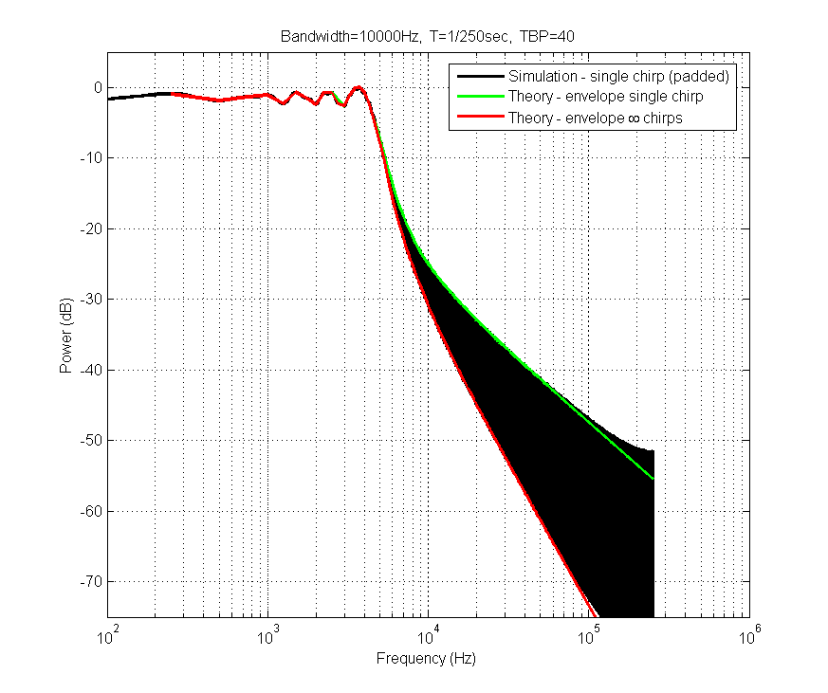
Figure 8 Example simulation of a single chirp.

DFT of finite sequence of chirps

Conventional DFT spectral analysis of a sequence, x, usually employs both the use of a taper function, w, to control sidelobe leakage and zero padding to interpolate spectral values:

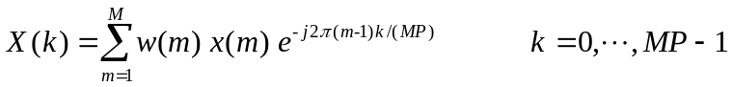 | (10)

where P is the padding factor and MP is the number spectral points. This is demonstrated in Figure 9 for a chirp sequence of 8.4 repetitions using P=4 and a Blackman-Harris 92dB taper function. The spectral envelope approximates that of the theoretical infinite chirp sequence, but does suffer from the Nyquist aliasing problem in this simulation. Under laid in green is the theoretical spectrum for the 8.4 chirp sequence assuming a uniform truncation function. This spectrum displays the poorer sidelobe roll-off rate at low levels, as discussed in Section 2.2 (see also Figure 4).

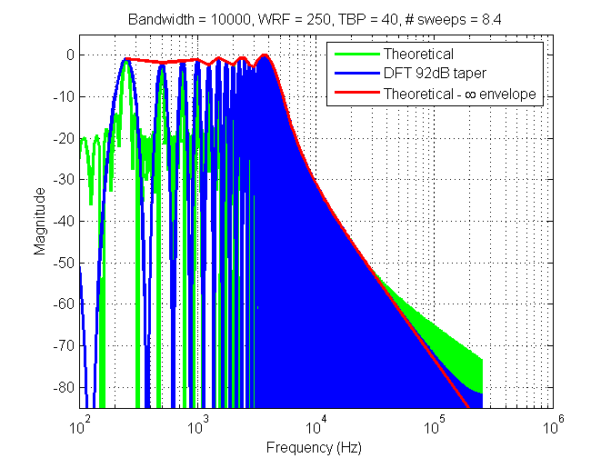
Figure 9 Conventional tapered DFT of finite sequence (8.4 chirps)

We note that conventional DFT spectral analysis cannot be applied to the case of the LFMCW single chirp sequence as the taper modifies the waveform and the spectrum takes the form of an amplitude modulated LFMCW waveform.

DFT of infinite sequence of chirps

The spectrum of an infinite repetitive sequence is a discrete spectrum with lines at multiples of the repetition frequency (1/T Hz). The discrete frequencies in the DFT equation (Equation 9) are calculated at:

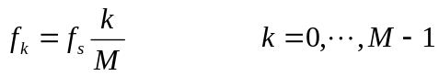 | (11)

For the case where the signal chirp period is exactly a multiple of the sampling period 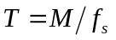, we obtain:

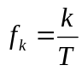 | (12)

which produces frequency estimates at multiples of the repetition frequency. Hence the M point DFT of an M point single chirp sequence produces an estimate of an infinite chirp sequence. An example is shown in Figure 10 where the numerical simulation closely matches the theoretical curve for an infinite sequence, apart from the Nyquist aliasing.

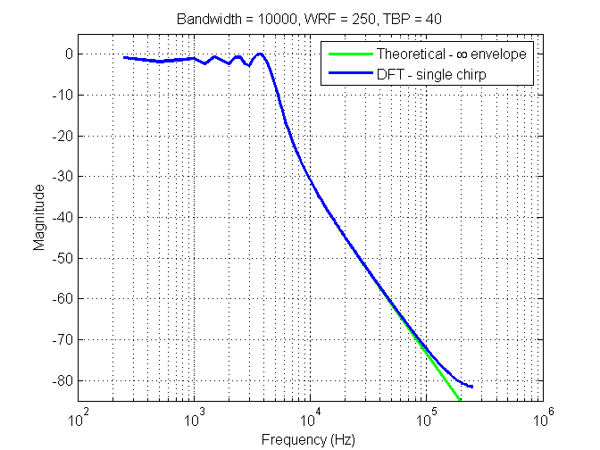
Figure 10 DFT of single chirp as simulation of theoretical infinite sequence

Spectrum Analyser

The spectrum analyser is an instrument that scans a portion of the spectrum. At each scanned frequency the signal is passed through an IF stage which has a defined filter bandwidth known as the resolution bandwidth (RBW). When scanning an FM signal the filter response at any particular frequency becomes a function of time. Using the peak-hold function of the analyser will provide the spectral envelope of the signal.

The process of the spectrum analyser may be considered by examination of the process in Figure 7, where the RBW filter response is equivalent to that of the point spread function. For example let us analyse an LFMCW signal with bandwidth 10000Hz and repetition frequency 50Hz. As a simple IF filter design consider a temporal domain Blackman-Harris taper truncation function (92dB sidelobes). For our purposes we require at least 60dB sidelobe filter response. For a RBW = 300Hz the taper truncation time is 1.90/300 =6.3ms (the 1.9 value refers to the 3dB width for this taper [Harris in Proc. IEEE V66 N1 1978]). This example was simulated by the short time Fourier transform (STFT) analysis shown in Figure 11. The STFT has the advantage of estimating the spectrum at all frequencies for each time instant, unlike a true spectrum analyser instrument that is required to scan the frequencies over time.

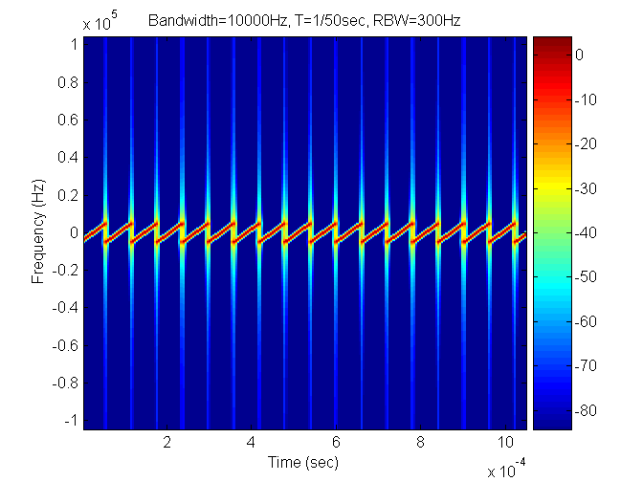
Figure 11 Spectrum Analyser simulation using the STFT

Note the out-of-band emissions are mainly caused at the chirp interfaces. The resulting spectrum analyser spectrum can thus be obtained by applying a peak-hold function and is shown in Figure 12 for various RBWs. The spectra are normalized to their maximum value, and are found to approximate the theoretical spectrum. A true spectrum analyser would not be subject to the Nyquist aliasing affects of this simulation, provided an anti-aliasing filter was applied. We observe that the in-band response is better for the lowest RBW, and that the recommended 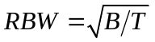= 707Hz causes widening of the 40 dB bandwidth.

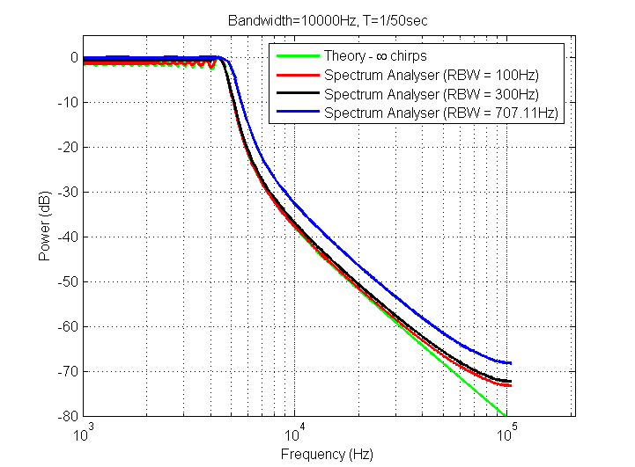
Figure 12 Spectrum Analyser Simulation

Conclusions

In this report we have investigated the spectrum of the LFMCW waveform. Theoretical derivations were used to calculate the true spectrum for single, multiple and infinite chirp sequences. Then spectral analysis using DFT based techniques and a simulated spectrum analyser were conducted.

The theoretical spectrum of a single LFMCW chirp may be calculated using Fresnel Integrals. The spectrum is continuous and has a sidelobe roll-off rate of 20 dB/decade. The spectrum of an infinite chirp sequence is a discrete modulation of the single chirp spectrum. The discrete lines are separated by the waveform repetition frequency (1/T Hz), and the out-of-band roll-off rate is 40 dB/decade. Note that between the lines the spectrum exists (continuous) but has zero valued amplitude.

DFT spectral analysis of a single chirp also produces the 20 dB/decade roll-off provided the spectrum is also calculated at non-integer multiples of the repetition frequency. The DFT can also be used to calculate the spectrum of a finite chirp sequence. In this case if conventional DFT techniques of tapering and zero-padding are employed then the resulting spectral envelope matches that of the theoretical infinite spectrum. It is recommended that about eight or more chirps periods are sampled, and that a taper with at least 60 dB sidelobes is employed. As a special case, if the waveform repetition period is a multiple of the sampling period, then the DFT of a single chirp can be used to estimate the spectrum of the infinite sequence.

An analysis and simulation of a spectrum analyser shows that the analyser provides an estimate of the infinite spectrum. However the scan rate and period, the choice of the IF filter bandwidth, and the filter sidelobe level are all significant.

