NTIMANE NHLELEKO

DATA AGENT
24 MAY 2026

Data Validation Analyst
I am validating the accuracy and reliability of an AI-powered SQL data agent built on a retail sales dataset of 5,000 transactions across 21 stores in Africa, North America, and Europe.
My role is to independently write and run SQL queries against the raw dataset and compare my results to the agent's outputs identifying where it answered correctly, where it made errors, and where it failed to fully utilize the available data.
This project tests both your SQL skills and my ability to critically evaluate AI-generated analysis, which is a key skill in real-world data analytics where AI tools assist but still require human oversight to catch mistakes, misinterpretations, and gaps in reasoning.

Dataset description
Customer Analysis
-CustomerID : Uniquely identifies customer
- Customer Segment :demographic group (Family, Business, Student, Budget, Enterprise)
-Loyalty Tier: Ranks customers loyalty
Sales Analysis
PriorityOrder: priority level (High, Normal, Low)
Payment Method: How the customer paid (Card, EFT, Cash, Wallet, Finance)
Promotion ID: ID of any promotion applied
-Promotion Name: Name/description of the promotion

Store Analysis
-Continent: Continent the store is on (Africa, Europe, North America)
Country: Country the store is in
City: City the store is in
Store ID: Unique store identifier
Store Name: Name of the store
Store Type: Physical format (Mall, Warehouse, etc.)
Channel: How the sale was made (Online, In-Store)

Employee Analysis
Salesperson ID: Unique salesperson identifier
Salesperson Department: Department the salesperson belongs to

Financial Analysis
-Unit Cost: What it costs the business per unit
-Unit Price: What the customer pays per unit
-Discount Amount: Discount applied to the order
-Tax Amount: Tax charged on the order
-Shipping Cost: Cost to ship the order
-Gross Sales: Total revenue before discounts (Unit Price × Quantity)
-Net Sales: Revenue after discounts and adjustments
-COGS: Cost of Goods
-Gross Profit: Net Sales

SCREENSHOTS
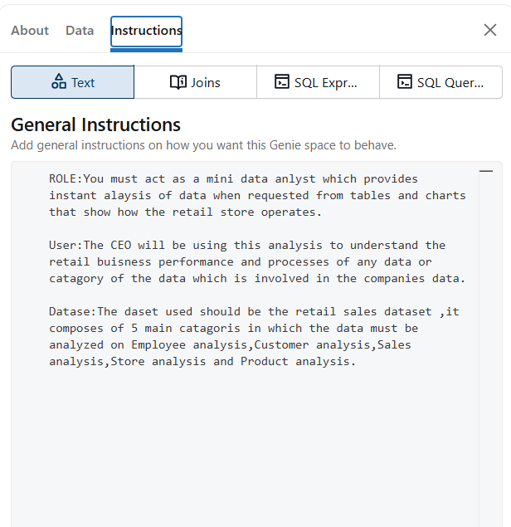
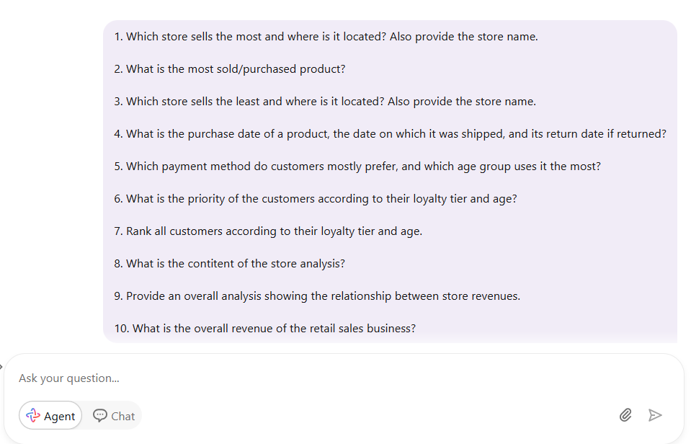
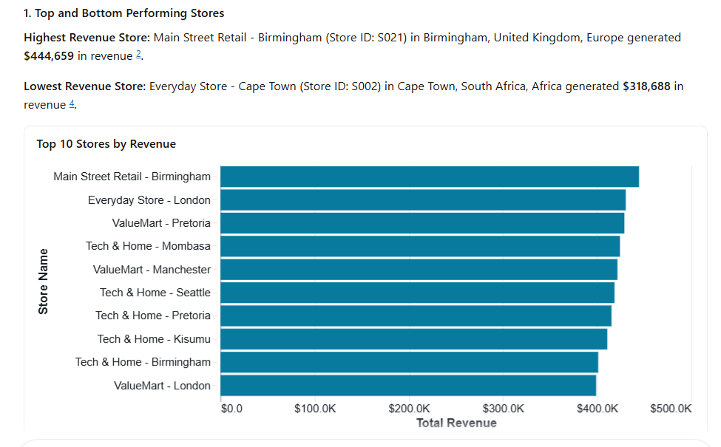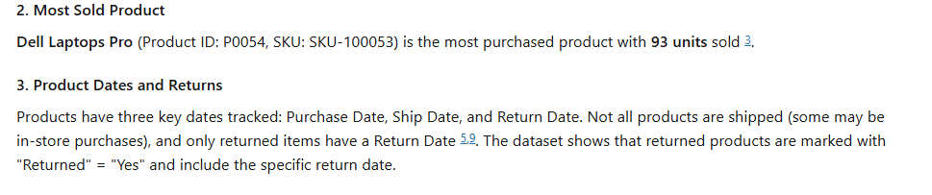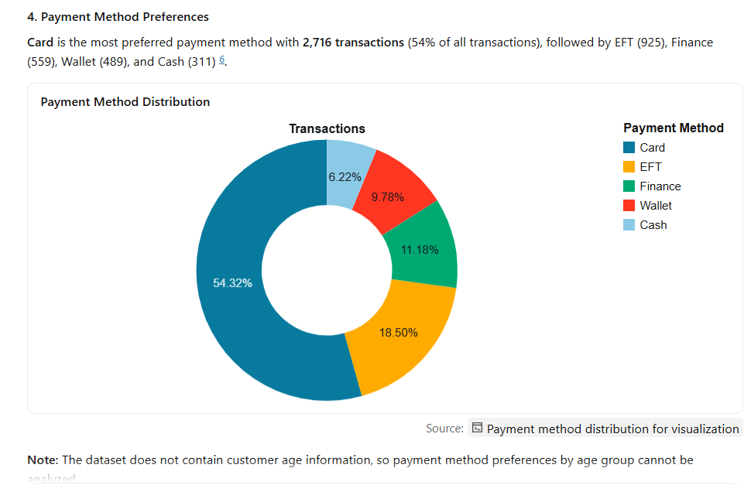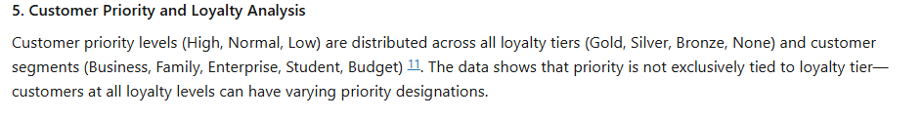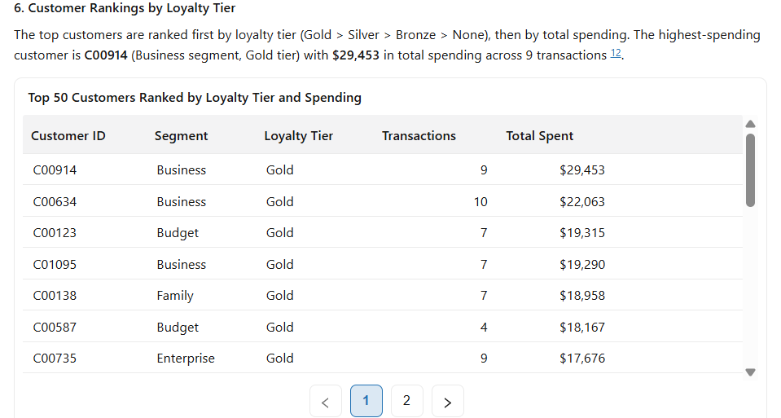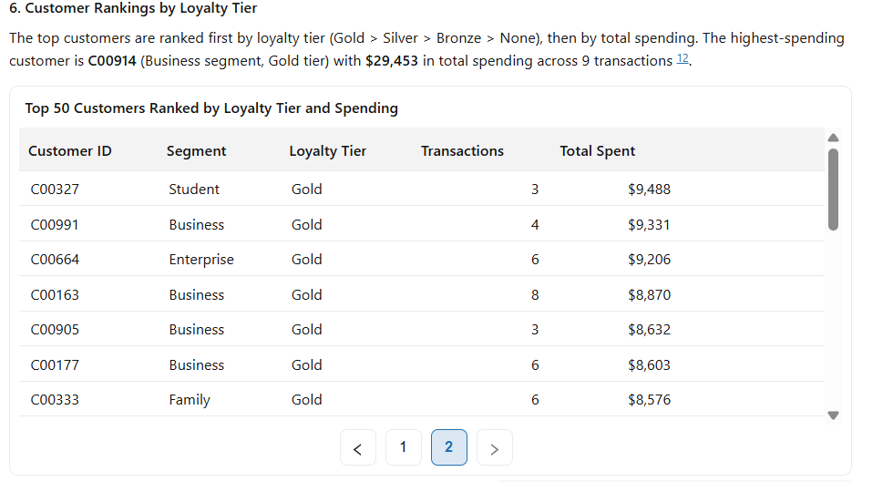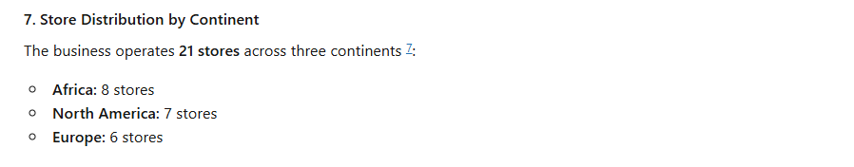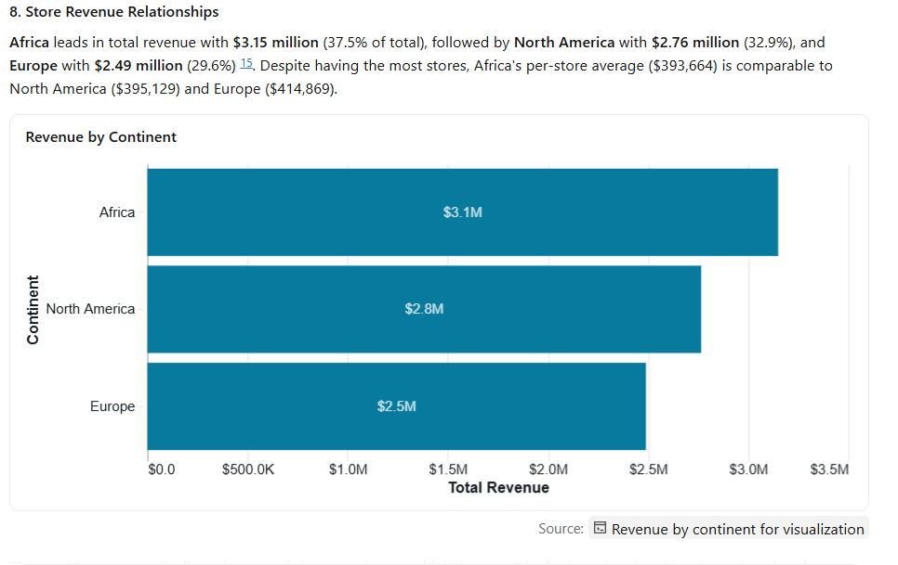
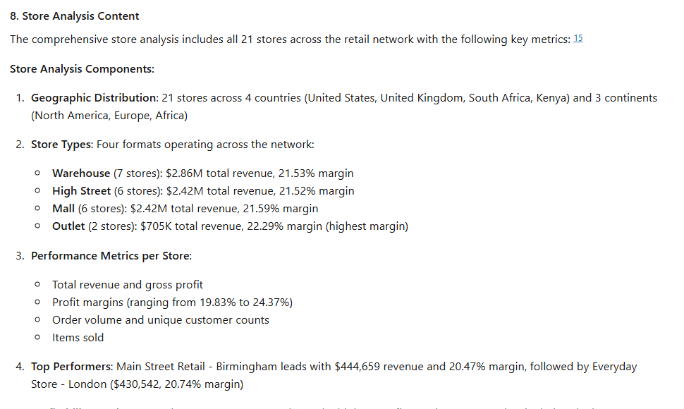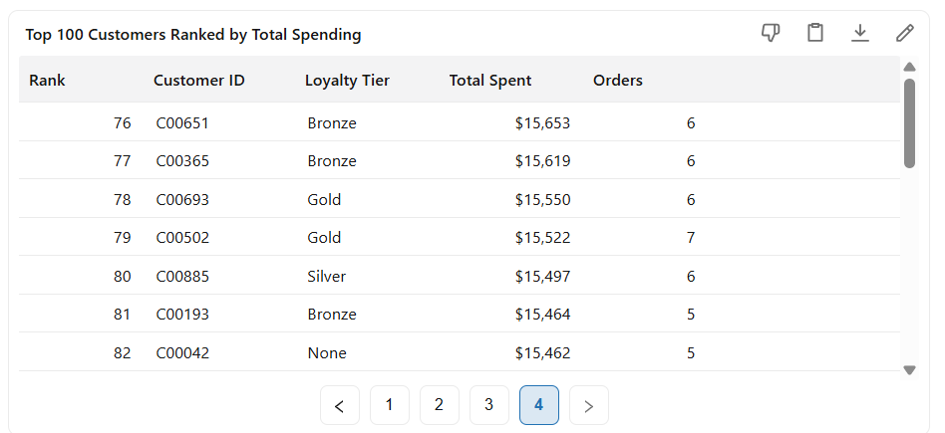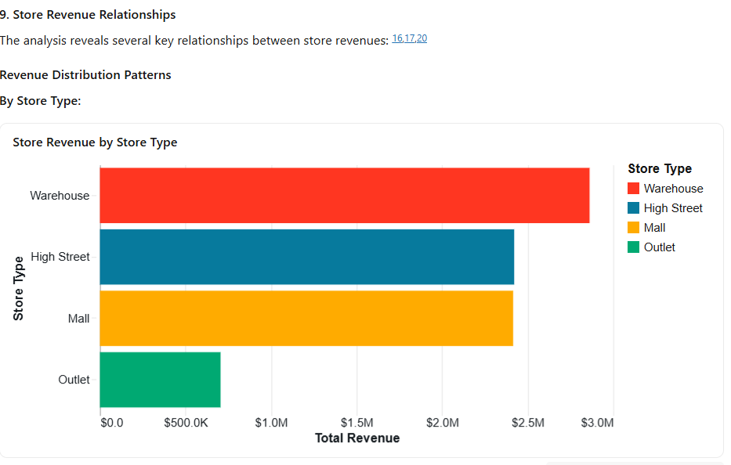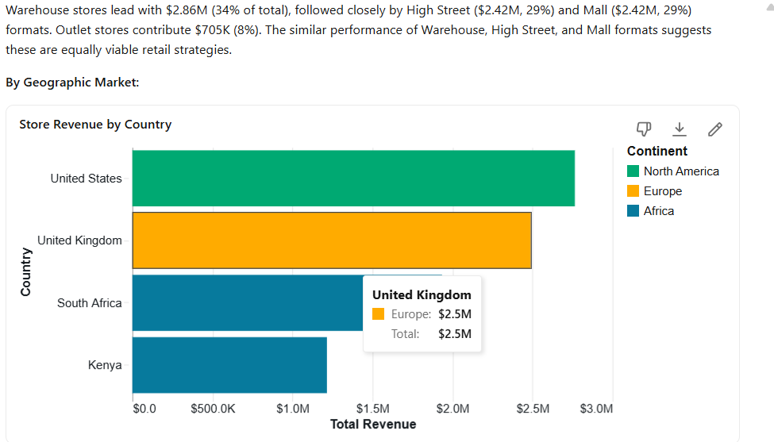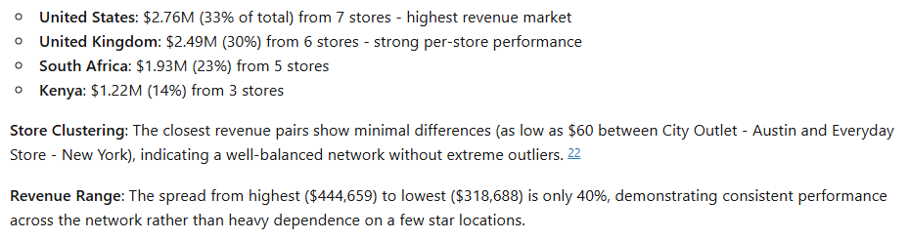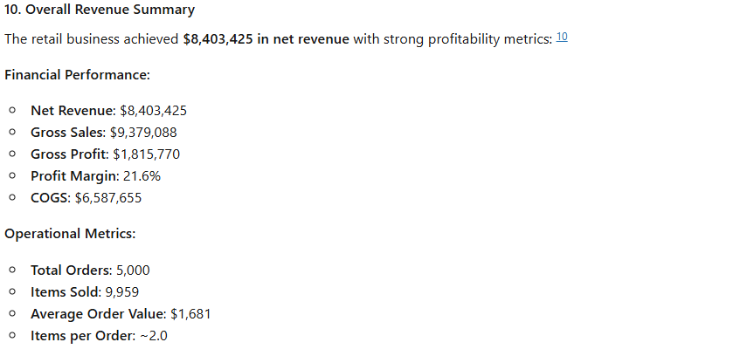

Agent Instructions
ROLE:You must act as a mini data anlyst which provides instant alaysis of data when requested from tables and charts that show how the retail store operates.

User:The CEO will be using this analysis to understand the retail buisness performance and processes of any data or catagory of the data which is involved in the companies data.

Datase:The daset used should be the retail sales dataset ,it composes of 5 main catagoris in which the data must be analyzed on Employee analysis,Customer analysis,Sales analysis,Store analysis and Product analysis.

10 QUESTIONS
1. Which store sells the most and where is it located? Also provide the store name.

2. What is the most sold/purchased product?

3. Which store sells the least and where is it located? Also provide the store name.

4. What is the purchase date of a product, the date on which it was shipped, and its return date if returned?

5. Which payment method do customers mostly prefer, and which age group uses it the most?

6. What is the priority of the customers according to their loyalty tier and age?

7. Rank all customers according to their loyalty tier and age.

8. What is the content of the store analysis?

9. Provide an overall analysis showing the relationship between store revenues.

10. What is the overall revenue of the retail sales business?

Validation
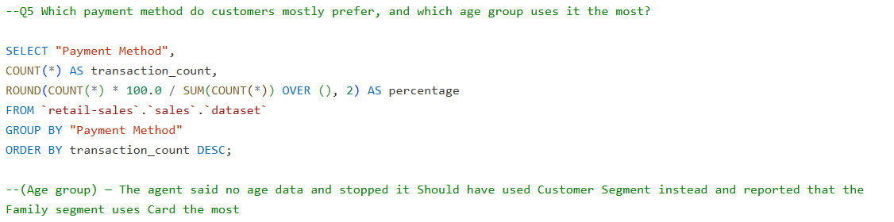Here the agent said no age data and stopped it Should have used Customer Segment instead and reported that the Family segment uses Card the most

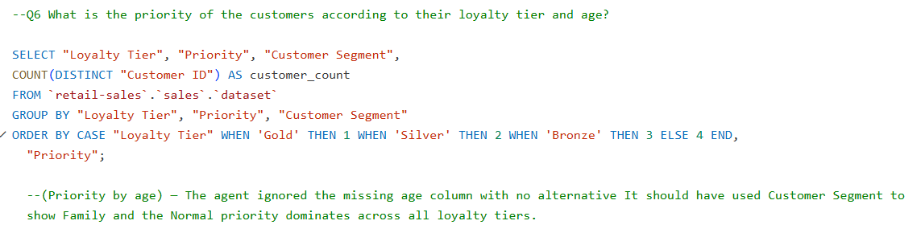
The agent ignored the missing age column with no alternative It should have used Customer Segment to show Family and the Normal priority dominates across all loyalty tiers.

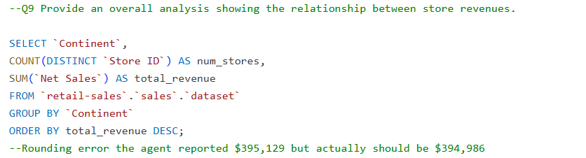
--Rounding error the agent reported $395,129 but actually should be $394,986

Key Insights

The retail business generated $8.4M in net sales and $1.8M in gross profit across 5,000 transactions in 21 stores spanning Africa, North America, and Europe, with Africa leading continental revenue at $3.15M. The best performing store is Main Street Retail - Birmingham at $444,659 while the weakest is Everyday Store - Cape Town at $318,688. Electronics dominates product revenue at $6.76M (80% of all sales), and the most sold product by actual units is Local Household Value at 308 units — not Dell Laptops Pro as the agent incorrectly reported. Card is the dominant payment method at 54% of transactions, used most by the Family customer segment, a breakdown the agent failed to provide. Bronze tier holds the largest share of customers (1,323 transactions) while Gold is the smallest (487), indicating most customers haven't reached top loyalty status. The Family segment is the biggest buyer group overall, and most purchases happen in-store rather than online. The business has a healthy return rate of just 4.58%, and despite a high COGS of $6.6M, the operation runs consistently across all three continents with comparable per-store averages.

Business recommendations
I would try and maintain a more personal and good relationship with the customers most customers are in the bronze tiar I would try and persuade them to scaling up to the gold tier loyalty.

The validation process worked well overall independent SQL queries successfully caught key agent errors including the wrong most sold product and the missing customer segment breakdown, and the well-structured flat table made cross-checking straightforward. The hardest part was Databricks syntax issues with column name quoting and table naming conventions, plus some queries being initially overcomplicated before simplifying. Going forward, the agent should be instructed to always find a substitute column when one is missing rather than giving up, validation queries should be written before the agent runs as a benchmark, and the agent should always sum Quantity instead of counting rows when measuring units sold.

GITHUB LINK REPOSITORY: https://github.com/ntimanedata7/Retail-Sales-Agent-.git

