**Slice level (2.5D ):**

In 2.5 D approach of slice level, the group of ct slices (3, 5, 7 slices) are fed to the model in the channels formulation to the model which is more effective when compared to 2D approach (1 slice). In the 2.5D with combination slices which will be more effective get the more approapiate features and also it maintains the continuity which will be helpful in the reduction of the FP.

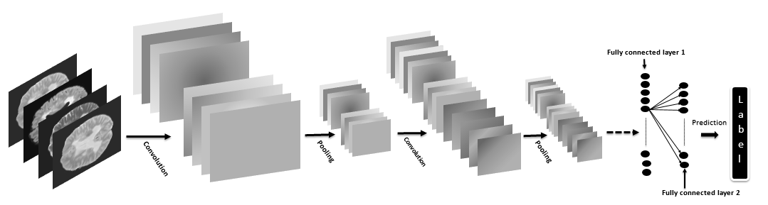

**Patient Level (3D approach):** In this 3D approach of patient level, the entire ct scan slices (100 slices) of the patient are fed to model with the Unet architecture while the model, with the lstm network used to obtain the continuity and also the helps in determining the whether the PE is present or not at the case level. This method is effective in the detection in continuity and also help to improving the specificity and sensitivity.

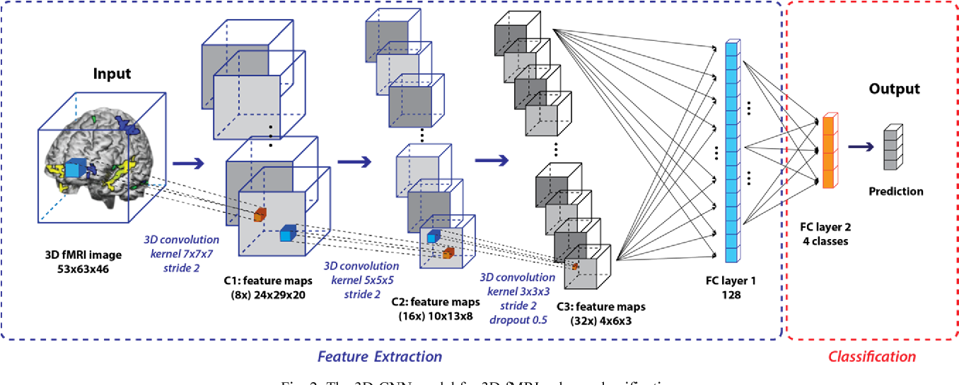

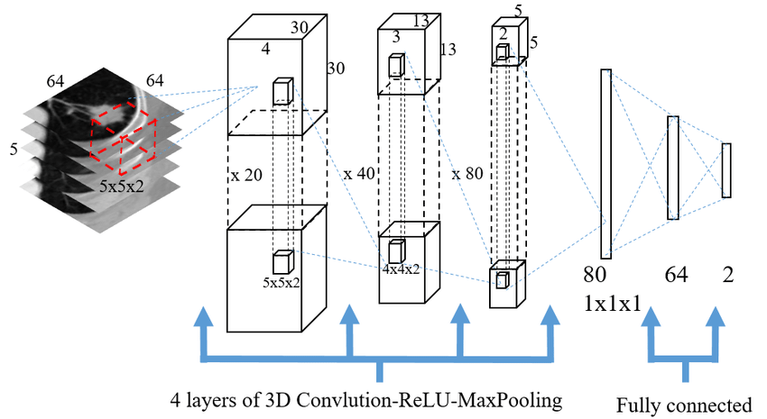

**Unet architecture**: In the unet architecture, which used to detect the anomaly with the use of the mask as the target.

Cons :

Scale Invariant.

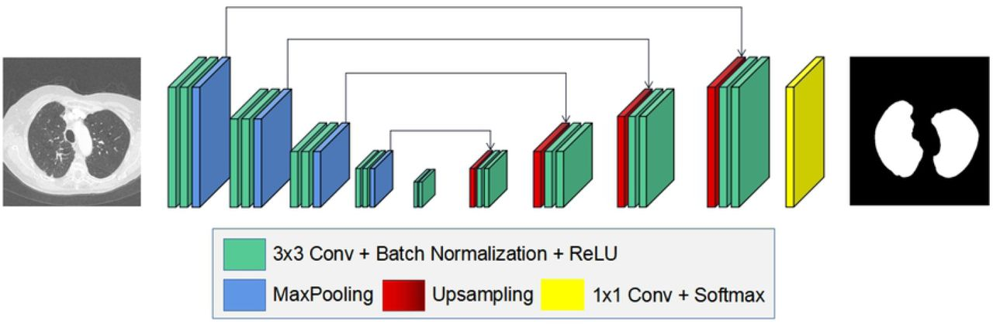

**Object detection**: In the object detection approach, the anomaly detection is developed at the regional proposals approach which will be used for the classification and also at the probability of the detected region.

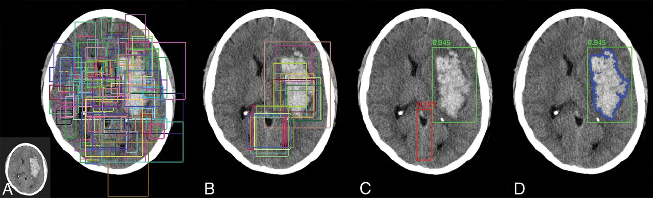

Cons :

Negative image training

**Competitor approach**:

PE Net : In this approach, they are using the 3d approach with the unet architecture for the detection of the PE. The AUC is 0.84, the source code is available in the pytorch.

<https://www.nature.com/articles/s41746-020-0266-y>

PI-PE CAD : In this approach, they are using the 2D approach with the unet architecture and using the LSTM at the patient level for the classification whether PE is available or not. The accuracy of the detection is 0.88, 4 NVIDIA GTX GPU, <https://ml4health.github.io/2019/pdf/286_ml4h_preprint.pdf>

Aidoc: In this approach mainly the detection is carried out with the use of 3d approach for the detection based on the two approaches with region proposals approach and false positive reduction.

# “Automated detection of pulmonary embolism in CT pulmonary angiograms using an AI-powered algorithm“ , the auc of detection is 0.91

Kaggle : Resnet with the same two stages of the detection ,

The object detection, false positive reduction with the use of 3d cnn.

Mainly the pulmonary embolism detection is carried out in two stages in which the detection can be carried out in two stages with the

object detection

False positive reduction.

We’re currently at the stage 1

Our approach : The model development up to so far is 2.5D approach with the object detection as it significantly with the object detection with the regional proposals network and mask detection, by using mask rcnn architecture.