Image data :

Network design :

process:
For the clacification the image is passed to few series of preprocess steps:
Image eligibilyty too much distortion in the image resulting , the preprocess steps includes the calculation of the variance , mean of the image, no of pixel of bright pixels(240 and above), ratio between the pixels count with non zeros pixel values - the same results to give a dull image flag
Distortion model is used for the detection of the distorion on the image
Using the binary local pattern is coverted into histogram values , for the distortion is simple calcification based on the histogram on the group of images a machine leanring model - svm model is trained for the distortion to classify the distortion image or not
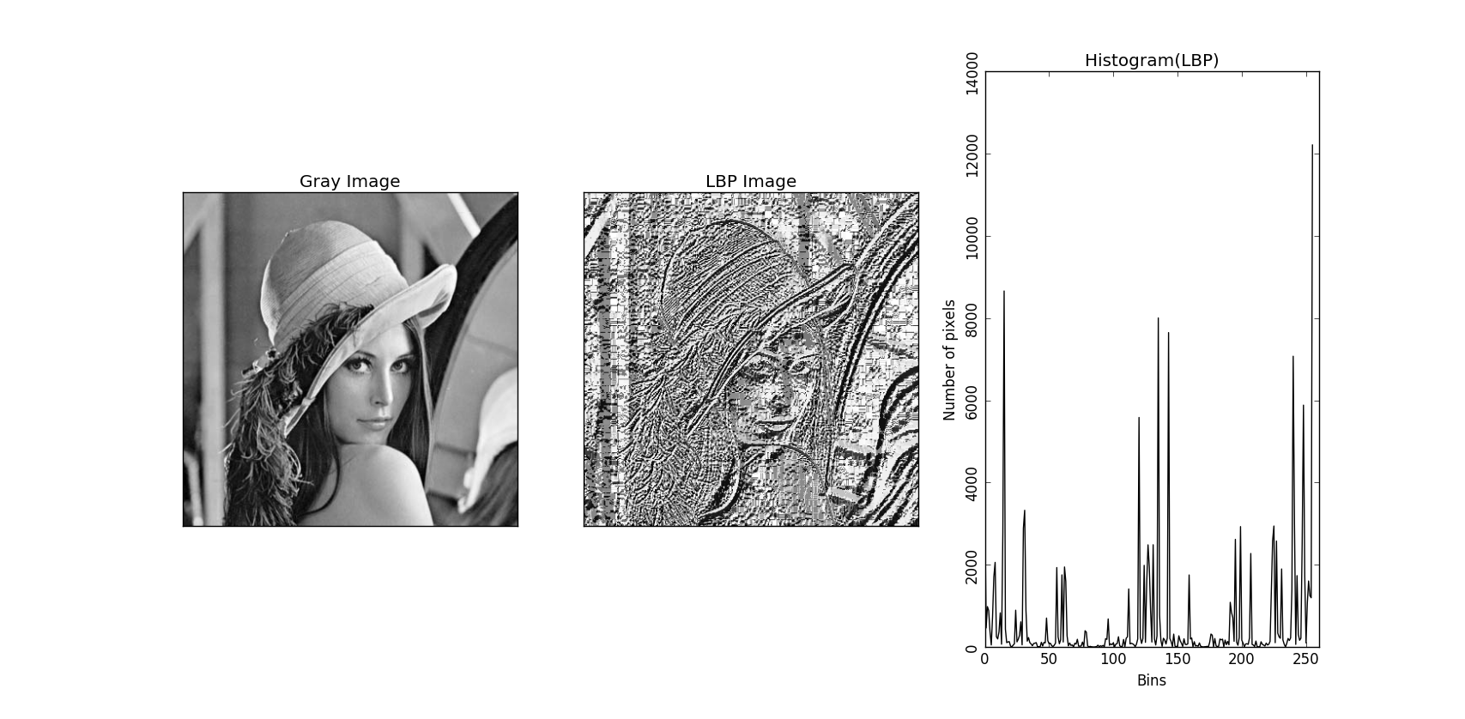

Adjust of gamma correction of the image for the dull image flag a 2.5adjust gamma is applied
After the gamma correction
Gaussian blur applied with the kernal size varying from the data, the higher contrast , noise images used the kernal size 7, 9 wiith the lower contrast and less noise the kernal of size 3,5 used.
Lapcian filter will give the edges/ contours on the image resulting the contours of the calcification are extracted

Calci distortion model(cd ) : its an svm machine learning model where the slice of images are taken into consideration and classified whether there is distortion or not .
The distortion model take a input of slice of image - 200*200
For the model the histogram of the pixel values are fed for the classification

Model training ;
The model is trained on the images of 500 of normal and distorted images, which are classified as normal and distotion

Images

For the each image, local binary pattern is taken
and the histogram values are passed to the model,
Svm model is used for classification based on the histgram values the distoriton is mentioned
From the traning data the images are represented.

calci binary : the model is cnn model with classfication architecture, the different filters are x , connected to a dense layer with single class output of softmax ,
with the x layers with the image size 200*200*1, two classes the image
The model specifies whether there is calci or not
Two classses : calci , Negative
Trained Images : 1078

Calci Ternary class : the model is cnn model with classfication architecture, the different filters are x , connected to a dense layer with single class output of softmax ,
with the x layers with the image size 200*200*1, three classes the image
Three classses : calci , streak , vascular
Trained Images : 2700

Calci mlti class : the model is cnn model with classfication architecture, the different filters are x , connected to a dense layer with single class output of softmax ,
with the x layers with the image size 200*200*1, seven classes the image
Seven classses : border, calci , corners, edges , None, streak, vasc
Trained Images : 1078

Calci cluster class : the model is cnn model with classfication architecture, the different filters are x , connected to a dense layer with single class output of softmax ,
with the x layers with the image size 200*200*1, two classes the image
Seven classses :cluster, negative
Trained Images : 1326

Vasular calcification : The model is cnn model with segmentation approach - 50 images , imags 256*256*1 , the architecture with down sampling and upsampling .

For the extraction of the macro : the size of >0.5 is considered of contours from lapcian contours imags , the roi of the desired region is taken and passed to different models for the output
Calci multi class - 7 class division from this
Calci ternary class - 3class division from this
Calci bianry class - 2 class division from this

For the extraction of the micro:
Calci multi class - 7 class division from this
Calci ternary class - 3class division from this
Calci bianry class - 2 class division from this

For the extraction of the cluster :
Sklearn Dbscan is used for assigning the cluster of the contours with greater than
Use the vascular calcification model for the extraction of vascular and remove them from it
the dbscan region roi of the desired region is taken and passed to different models for the output
Calci cluster class - 2 class division from this

Hyper parameters :
Both models trained on the loss function of binary_crossentropy, categorical_crossentropy with the learning rate of 1e-3 for the classification
Each model is trained for 200 and 100 epochs and results of epoch weights is tested on the few images for considered of the equalvent perfect pair in the classification of calci

The auc of the model detection under the radiologists evaluation is as follows

X cases are evalued these are FPx, FN x, TPx, TNx with the live data the results of the confustion matrix is below

Development :
During the development of the individual models to overcome the false positives of the following order of models developed in order

Binary, Ternary , Distortion , multi, cluster

