Brain Tumor Classification and Localization

Nick Titzler
University of Oregon
ntitzler@uoregon.edu
github repo:

Abstract

Brain tumors classification and localization is a critical task given to radiologists and neurologists for the treatment of neurological caners, but due to the scarcity of these professionals, classification/localization is expensive and impractical. My goal was to create a CNN which can both classify and localize four different kinds of brain tumors. In the end, the model achieved 75% across the test set. Localization was less successful, as I was not able to use a validation set to check the models precision, IOU, or mAP.

Final Model Accuracy per class:

Glioma tumor: 18.819 %
Meningioma tumor: 89.71 %
No tumor: 100.0%
Pituitary tumor: 54.4344%

Introduction
Currently, the identification and classification of brain tumors is only possible for highly trained radiologists, and neurologists, meaning a diagnosis is expensive and impractical. Additionally, there is few ways to check if the diagnosing physician is correct. These problems motivate the need for machine learning assistance in the diagnosis of brain tumors.
I experimented with several different image classification methods in order to create a model with the highest possible accuracy in diagnosing four different tumor types: Glioma, Meningioma, Pituitary, and No Tumor. For my image classification, I wrote an untrained CNN, and finetuned the parameters systematically to find the hyper parameters which would generate the highest possible accuracy.
I then experimented with tumor localization using selective search. I achieved interesting results for the dataset, which was used, but I was unable to evaluate the localization as the dataset did not contain localization annotations.

Tumor Explanation
A brain tumor is an abnormal mass of cells growing in the brain. If left untreated they will cause the brain to press against the skull, causing damage. There are four different kinds of tumors which the model will classify, they are Glioma, Meningioma, Pituitary, and No tumor. Glioma tumors occurs exclusively at the base of the brain. The meningioma Tumor grows from the meninges, and with time covers the brain and spinal cord. Pituitary tumors are localized on the Pituitary gland.

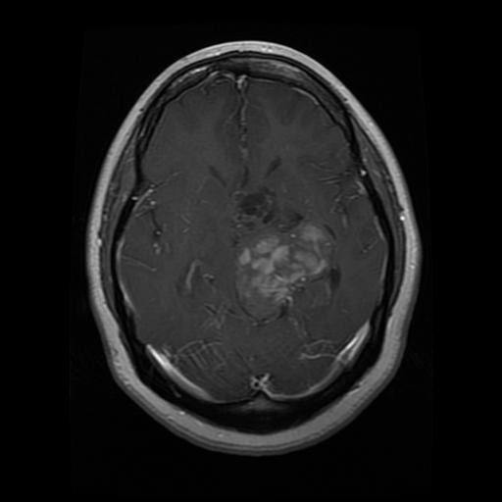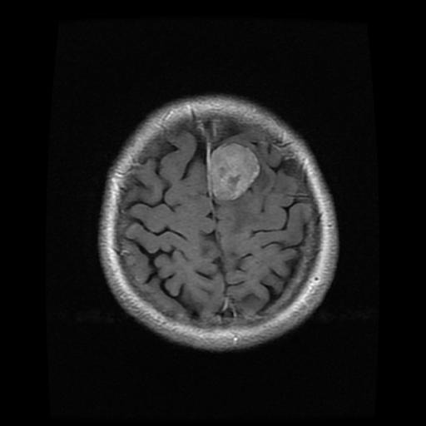
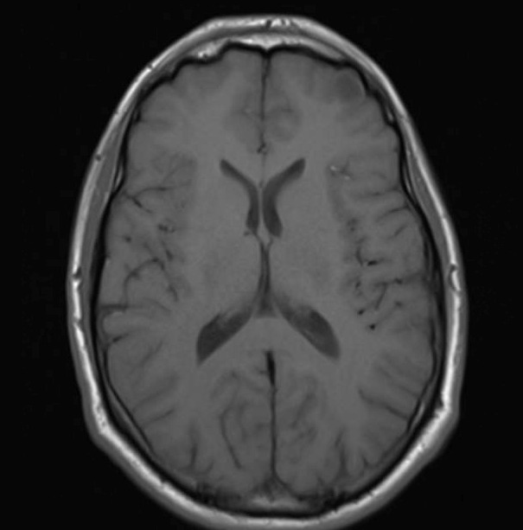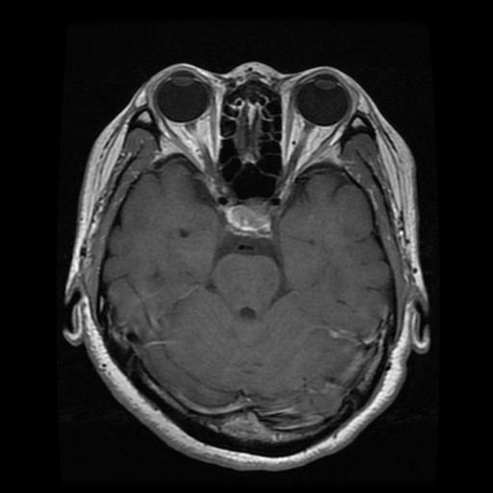

Figure 1: Four different brain tumor types. From top left, top right, bottom left, bottom right: Glioma, Meningioma, no tumor and Pituitary.

Dataset
Please I used a dataset that can be found https://www.kaggle.com/sartajbhuvaji/brain-tumor-classification-mri. It has pre segmented classes, and is split between the training and testing images. Image counts for training are as follows: glioma: 826. meningioma: 247, no tumor: 327, Pituitary: 827.
The data set contains different varieties of images. There are the top-down views pictures in Figure 1, as well as profile and front-to-back scans. These two scans can be viewed in Figure 2.
Image sizes in the dataset ranged from 300x300px, to 600x600px and were generally not uniform in their size. Additionally, some of the scans did not show the full brain, only cropped sections. I attempted to remove as many of these as possible so as to not confuse the model.

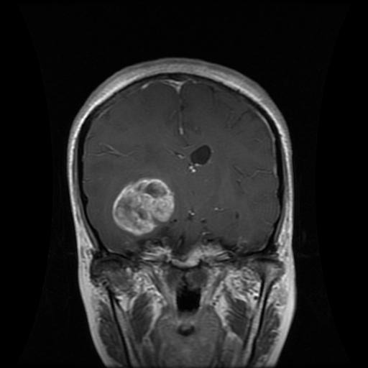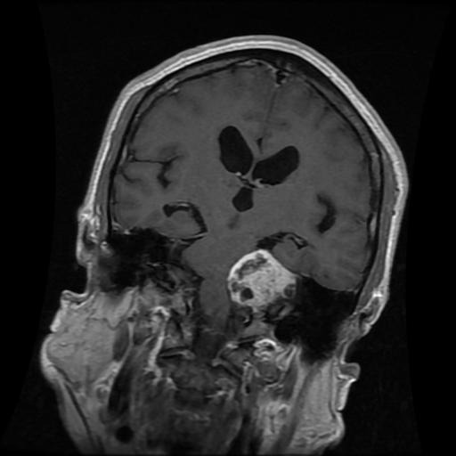

Figure 2: front-to-back scan vs profile scan.

2.0. Details of Approach and Results
To write the CNN, I tried out several different models initially, and then finetuned the one which appeared to be preforming the best. I first tried a ResNet, similar to the one from our first homework, and an untrained CNN also from our first homework.
After settling on using the untrained CNN, I began to adjust the hyper parameters systemically to find which combination would achieve highest overall accuracy.
Subsequently, I would experiment with two different localization algorithms: resnet101 object segmentation, and selective search.
In the following sections I will explain and show how I fine-tuned the models. I will go into more depth on my explanation for the traditional CNN, as I quickly abandoned the ResNet.

CNN’s experimented with
I first experimented with a ResNet, with two convolutional layers and two linear layers. While experimenting, referenced from [1]. I used image sizes ranging from [32x32, 232x232, and 432x432], and batch/epoch sizes ranging from [1-10], and a learning rate ranging from [0.01-0.00075]. Early accuracy with this model was almost ten percent lower than the traditional CNN, failing to rise above 55% accuracy. The ResNet was structured in the following way.

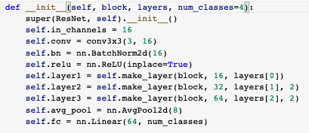

Figure 3: ResNet layers [1]

Because I saw the model was not improving, I decided to switch the model to a traditional CNN and began to tune the parameters. I first tried using a net similar to the one described in [2]. The net is as follows. The net went through the fine tunning process and I eventually also tried the model described here [3], which ended up being the model I would use until for the duration of the project. Figure 5 shows the model in its last form, however throughout fine tuning many of the parameters, and layer structure was altered.

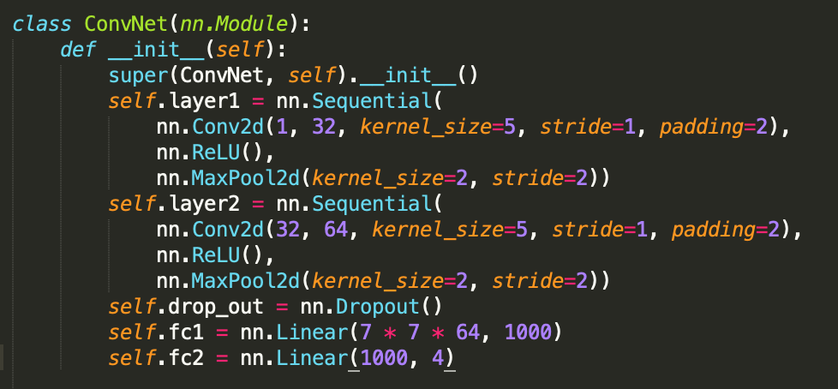

Figure 4: Conv Net [2]

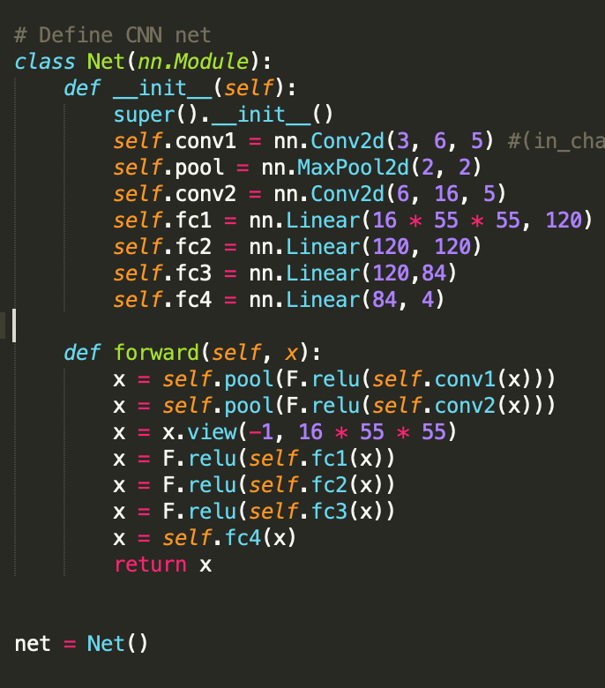

Figure 5: Conv Net [3]

Hyper parameters in the dataset
As I will be referencing these items later in the report, here is an example ‘base’ model demonstrating the hyper parameters.

Epochs = 3
Batch_size = 10
ReSize = 32 #image dimensions
CenterCrop = 32
Lr = .01

Linear layers (16*5*5, 120) -> (120,84) -> (84,4)
Conv2d Layers (3,6,5) -> (6,16,5)

Optimizer = Adam(…, weight_decay=0.01)
Criterion = CrossEntropyLoss()

  - Image size adjustment and linear layer adjustment

With each model, I first experimented changing the size of the input image, resizing from 32x32, to 232x232, and 432x432, and accordingly adjusting the linear layer sizes: (16*5*5, 120), (16*55*55), and (16*105*105) respectively.
I preformed the tests 2.4 - 2.6 on each of these image sizes respectively. For each image size I will touch on the effects that tuning that particular hyper parameter had on testing accuracy for the dataset at large.

Experiments with Epochs and Batch Sizes
For all image sizes, 432x432, 232x232 and 32x32, tuning with the lowest number of epochs and batch_size, 1 and 3 respectively, the model preformed at only ~21% overall accuracy. Increasing batch size to 6-20 while keeping epochs under five had the effect of raising accuracy up to ~43-56%.
However, in the case of all image sizes, overall accuracy was not greatly increased by increasing batch size. Model training speed was more than doubled from 6 to 20 minutes, even when epochs stayed below five. Additionally, while only tuning these two parameters, leaving the rest of the model the same as the default presented above, the model never broke a testing accuracy > 62%.
Overall, epochs had a greater impact on overall accuracy as compared to batch size.

2.5 Experiments with learning rate

For all image sizes learning rate played a large role in influencing model performance. To illustrate this point, the best model I was able to create:
Epochs = 5
Batch_size = 10
ReSize = 232 #image dimensions
CenterCrop = 232
Lr = 0.001

Linear layers (16*5*5, 120) -> (120,84) -> (84,4)
Conv2d Layers (3,6,5) -> (6,16,5)

Optimizer = Adam(…, weight_decay=0.01)
Criterion = CrossEntropyLoss()

Figure B: Highest Accuracy Model

Which had an overall accuracy of 0.75, was reduced to 0.58 when the learning rate was changed from 0.001 to 0.0001. Increase epochs with the new LR did not have the effect of achieving higher accuracy, as models for all image sizes could not achieve better results than 0.65 overall accuracy.
Additionally, changing the learning rate to 0.01 had the effect of reducing overall model accuracy to 29% with a final loss of 1.357, as compared to 0.75 and 0.038.

  - Experiments with adding linear layers

Changing the size and structure of the linear layers did not have a dramatic impact of overall accuracy but did allow for some optimization that pushed the model to its highest levels. Overall tuning the linear layers caused a ~2% boost to model accuracy, after all other parameters were also tuned.

I first tested using three linear layers with sizes of:
a) (x, 120) -> (120, 84) -> (84, 4)
b) (x, 120) -> (120,120) -> (120,84) -> (84, 4)
c) (x, 120) -> (120,120) -> (84, 4)
out of these layer adjustments, option C had the greatest impact on model performance raising accuracy consistently by ~1-2%. B had the least impact often lowering model accuracy, and A had no effect on model accuracy.

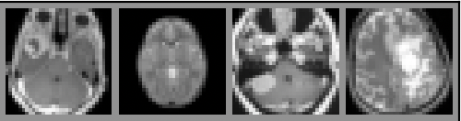
Figure A: tumor images resized and cropped to 32x32

  - Best Model Analysis

2.7. Notes on Interesting findings

While extremely counter intuitive to me, an overall accuracy of the model when image size was 32x32, was 73%. I had hypothesized that the larger the image size, the better the classification would be, but this was not the case in my experiments. In fact, the largest image size had the worst model accuracy performance, with a best score of 0.7. 232 had the highest accuracy.
A possible reason for this could be that the due to the simplification of the image, the tumors become more exaggerated and thus are easier to find.

2.8. Experiments with Localization

I experimented with a pretrained resnet101 object segmentation algorithm, to see if any of the tumors would be picked out. This experiment was a failure, as I thought it would be. The res net was only able to identify random, incorrect sections.
For the selective search I utilized the open-source library OpenCV, or cv2. Using the ‘createSelectiveSearchSegmentation’ function, I initialized a base image, and experimented with box the ‘Quality’ and ‘Fast’ search options.
Selecting the ‘Quality’ option on this Glioma tumor yielded the following object proposals.

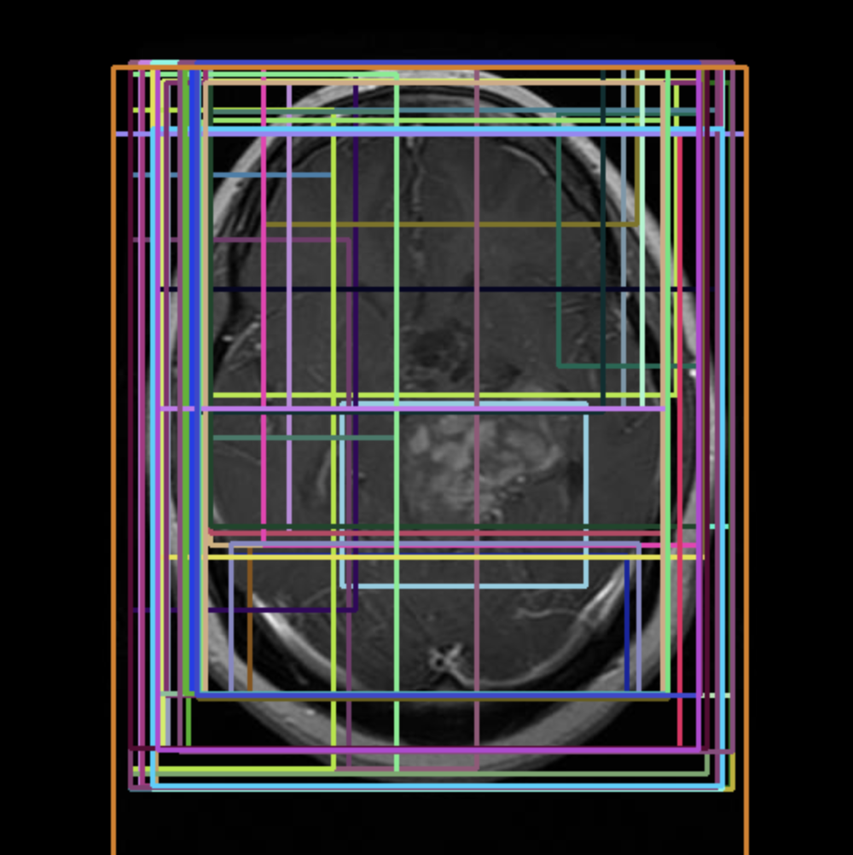

Figure 6: Selective search on Glioma Tumor

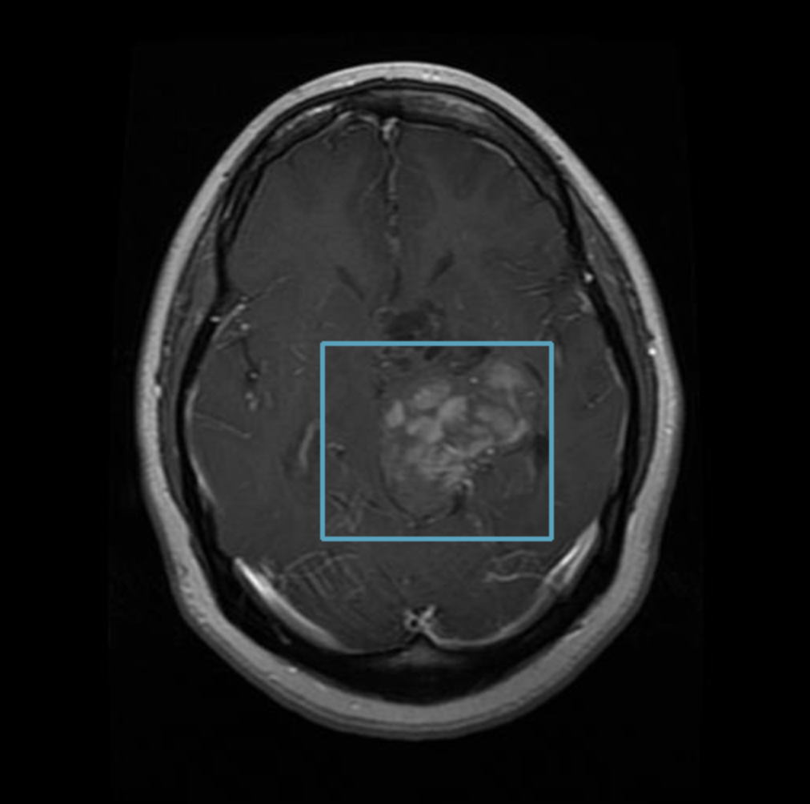

Figure 7: One region of Selective search

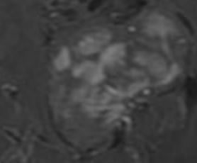

Figure 8: Localized cluster

It is interesting to note that the selective search algorithm often found the tumors in its search, as pictured in the comparison between figures 6 and 7, but due to the fact that I did not have an annotated tumor detection dataset at my disposal, I couldn’t create a true object detection algorithm.
Importantly, I found that selective search only worked effectively on images in the dataset that were shot from the top down. Profile images often ended looking like figure 8, where 1600 proposals would fall in approximately the same place. Additionally, tumors that were naturally smaller, such as the pituitary tumors, were recognized less often.

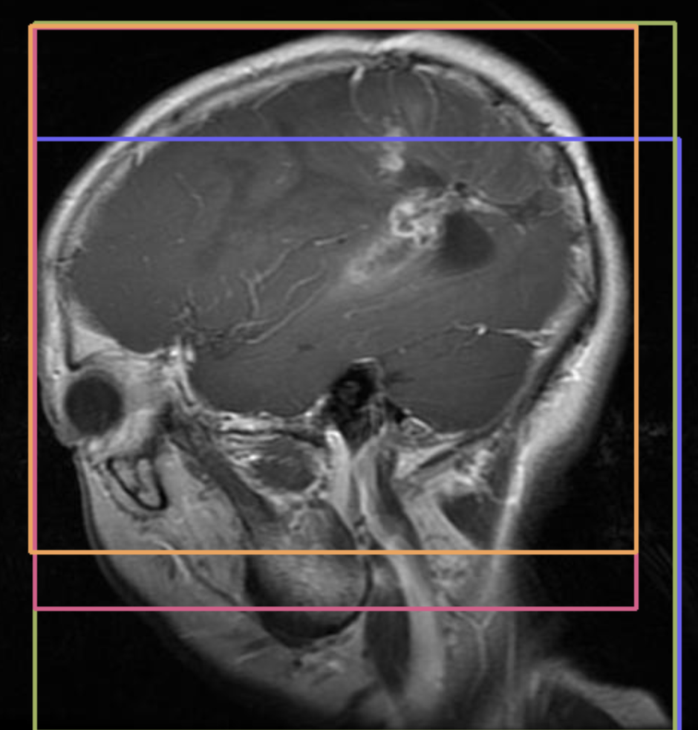

Figure 8: 1600 proposals represented on pituitary tumor

  - Results Summary

3.0. Discussion and Conclusions

HERE IS THE END OF THIS PAPER

4.0. Referenced Material:
[1]: https://pytorch-tutorial.readthedocs.io/en/latest/tutorial/chapter03_intermediate/3_2_2_cnn_resnet_cifar10/
[2]:https://adventuresinmachinelearning.com/convolutional-neural-networks-tutorial-in-pytorch/
[3]:https://pytorch.org/tutorials/beginner/blitz/cifar10_tutorial.html
[4]: Selective search: https://www.pyimagesearch.com/2020/06/29/opencv-selective-search-for-object-detection/

