Single robot scan result
Image: Real-world scenario 1
Scan real-world scenario 1

Time consumption and analysis
Image: Bar chart of single-frame processing time for the five parts of the project
In a runtime environment where the central control host has CPU: i7 12700H, GPU: RTX3060, and RAM: 24G DDR5 4800MHz, the time for robot control, image point cloud conversion, point cloud merging, projecting the point cloud into a 2D map, and path planning is measured.

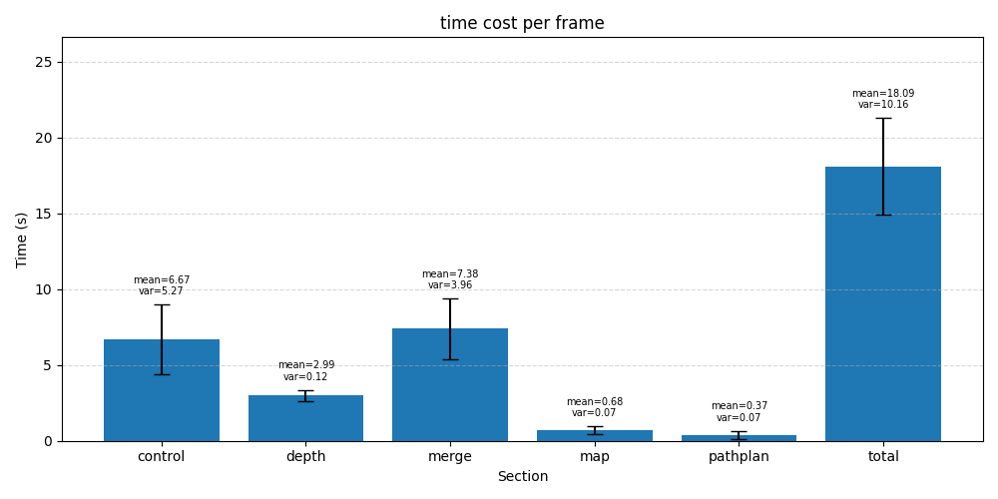
The average time is about 18.09 seconds per frame. The main time consumption is in robot control, image point cloud conversion, and point cloud merging.
The variance in the robot control part is relatively large. This is because for paths of different lengths or movement patterns, the robot’s actual running time will also vary.
The conversion of image point clouds is mainly constrained by GPU limitations. Since Depth Pro is based on GPU computation, the time consumption of this project is directly limited by GPU performance.
The merging of point clouds, on the other hand, requires handling a large amount of point cloud computation and throughput, so its efficiency is mainly limited by CPU and RAM (primarily the CPU).

图：pipline；图：总体扫描速度提升对比
Although this takes a long time, because they mainly use different devices, there is one advantage: during multi-robot parallel scanning, a state machine can be used to build pipeline parallel computation, thereby increasing throughput and overall scanning speed. Different robots can be in different states at the same time. For example, while robot 1 is moving, robot 2 can be using the GPU to convert images into point clouds, and robot 3 can use the CPU to merge point clouds.

使用pipline扫描速度将会有效提升，其理想提升如图所示，有 XX %！

Single-robot scene scanning experiment

扫描区域大小和扫描时间的关系
图片：a平方米的场景
图片：b平方米的场景
图片：c平方米的场景
图片：d平方米的场景
该项目中构建了4个场景，每一个场景都是在原场景的基础上扩展而来，且障碍密度尽可能相同，另外场景d会增加一个转角
图片：不同大小的场景不同的扫描时间
可以看到，扫描的时长于扫描场景的大小有关，但并非线性正比于扫描场景的大小！其中场景d的扫描时长有显著升高，这是由于增加了转角，小车在运行时更难获取到转角后的信息，因此小车寻路时更多会使用局部最优解，而非全局最优解。

扫描起始位置和扫描时间的关系
图片：小车不同的扫描位置
在c平方米的场景下，将小车放置于了不同的起始点，分别为点1，2，3，4，5，其中1234都是位于4个角落，而5则是位于中心。
图片：不同位置的扫描时间
可以看到，在位置5时，扫描时间和明显小于其他的位置，这是因为小车在开始扫描时往往倾向于自转一周（这可以使用最少的step获取最多的unknown），这时候，位于位置5可以获取到更多的全局信息，单步扫描到的unknown也最多。也因此可以更多使用全局最优解。另外，34也明显快于12起始点，因为3，4的起始点复杂度更低，可更快进行更大空间的探索。但1，2复杂度就更高，机器人往往会执行重复路径，甚至死循环，在该种情况下，由于对同一区域过度的反复扫描，这也会导致merge失败的概率更高，因此出现“散点云分裂”的情况。

扫描结果分析：
图片：c平方米的实体场景
图片：对该场景扫描的散点云
可以看到，虽然场景有点凌乱和碎片，但是总体而言，扫描结果可以大致表现出物体和物体之间的位置关系。其误差大约在±5~10cm/m 左右。

其中可以看到有如下一些错误：
图片：散点云分裂
图片：小障碍被平滑
图片：凭空生成的未知障碍
The main causes are as follows:
- Point cloud splitting:
- The error in converting point clouds from images at the same position is too large, making it impossible to merge
- To ensure correct merging of other feature positions, local merging errors occur
- Due to excessively large step sizes, the accumulated error in the vehicle’s pose is too large, making merging impossible
- Small obstacles are smoothed out:
- The obstacles are too small, or too close to or too similar to other objects, causing them to be merged.

- Unknown obstacles generated out of thin air:
- Due to image blur, the depth map around objects becomes unclear, forming a “speckle wall” caused by smooth transitions that cannot be sharpened and truncated.
- Unknown obstacles caused by excessive splitting

In addition, these issues can even reinforce each other:
- Small obstacles being smoothed out can make it harder to find feature points, leading to point cloud splitting
- Point cloud splitting may create nonexistent feature points, causing further splitting
- Artificially generated unknown obstacles can also create nonexistent feature points, leading to further splitting

Overall, these issues are caused by changes or loss of feature points. There are mainly two major reasons:
- Too many captures at the same location, and large errors in point cloud transformation across multiple captures, which further reinforce the errors.
- Too few captures at the same location, resulting in the inability to obtain effective and clear information.
They lead to the fact that both excessive and insufficient capturing are problematic. In comparison to the number of captures, the accuracy of point cloud transformation is actually more important, but this is difficult to guarantee.

多小车同时扫描

图片：1，2，3辆小车在,a,b,c,d大小的场景下使用的扫描时间

It can be seen that the carts and the scanning speed are not in a linear relationship. In some cases, having more carts can even lead to a lower scanning rate. This is because the data terminal has a limit on processing performance. When the number of carts reaches a threshold, the scanning by the carts will be blocked due to the terminal’s performance limits, so it cannot perform optimally.

In addition, to avoid scanning other carts and creating unknown feature points, the carts will avoid each other during pathfinding. Since the carts are dynamic and not synchronized, this puts higher demands on path planning. Sometimes they have to stay in place, may miss the optimal solution, and in some cases may even cause deadlock.

In short, the scanning quality and speed of the robot car are directly related to whether it can produce more globally optimal solutions. Because swarm-based systems are more widely distributed and have access to more scene information, they can more easily arrive at global optimal solutions, which is where their advantage lies. However, due to the increase in information, the cars in a swarm system are dynamically unsynchronized and need to avoid each other, making the processing more complex and more prone to deadlock situations.

