**DATA MIGRATION FUNCTION**

**CONTEXT**

Every day, a data file (.txt file) will be sent by a third-party company into "input" folder with format "data_file_yyyymmdd.txt". The file contains information about users in their company. We want to migrate that data into our system by building a database.txt file containing the latest information for all users.

The data file contains all existing/creating/updating information.

**REQUIREMENT**

Please build a function that reads the files and:

1. generates a “database.txt” file containing the latest information of all users. There are some requirements for the “database.txt”:

* The file should contain the information:
  + Id
  + Name
  + Date Of Birth: format: ‘DD-MM-YYYY'
  + Role
  + Email
  + Created date: the created date of the user, based on the date this information is received from the data file (specify in file’s name), format ‘DD-MM-YYYY’
  + Latest update date: the latest update date of the user, based on the date this information is received from the data file (specify in file’s name), format ‘DD-MM-YYYY’
* Just include only user information contained in the data file
* All information of 1 user is separated by “;” (e.g: id;name;….;email;….)
* The “Role” of user must be displayed like this:
  + DEVELOPER => Developer
  + BUSINESS_OWNER => Business Owner
  + PRODUCT_OWNER => Product Owner
  + Tester => Tester

*Note: In data file:

id : is unique number, each customer has 1 id

role : can only be DEVELOPER / BUSINESS_OWNER / TESTER / PRODUCT_OWNER

Example:

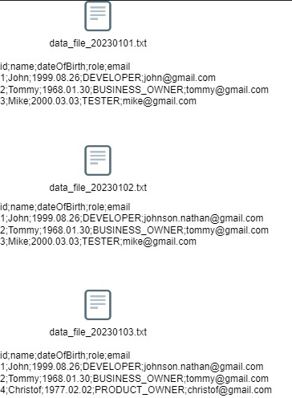

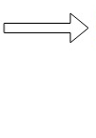

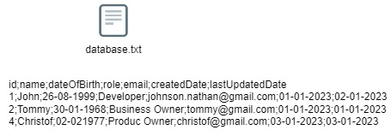

b. generates error file with format “error_file_yyyymmdd.txt” and put into “error” folder if information of user in data file is wrong format. This file contain all information of user in original data file and 1 additional column:

* + Id
  + Name
  + Date Of Birth
  + Role
  + Email
  + Invalid: contain all invalid information, each invalid information is separated by “,”

*Note: validation rule for email: local-part@domain

local-part syntax:

+ can contain characters a to z or A to Z, digits 0 to 9

+ can contain special characters _!#$%&’*+=?`{|}~^.-

+ maximum 64 characters, can not be empty

domain syntax:

+ can contain characters a to z or A to Z, digits 0 to 9

+ must start with characters a to z or A to Z

+ contain at least 1 dot, is not the last character

+ can not be empty

Example:

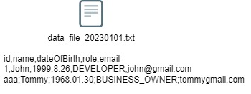



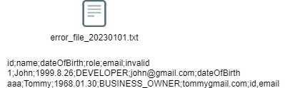

Please clone source project: <https://github.com/ntlong320/import_data.git>