**EPPO Datasheet: *Aecidium hydrangeae-paniculatae***

Last updated: 1970-01-01

**IDENTITY**

|  |  |
| --- | --- |
| **Preferred name:** *Aecidium hydrangeae-paniculatae* **Authority:** Dietel **Taxonomic position:** Fungi: Basidiomycota: Pucciniomycotina: Pucciniomycetes: Pucciniales **Common names in English:** rust of hydrangea [view more common names online...](https://gd.eppo.int/taxon/AECIHP/) **EPPO Code:** AECIHP |  |

**GEOGRAPHICAL DISTRIBUTION**

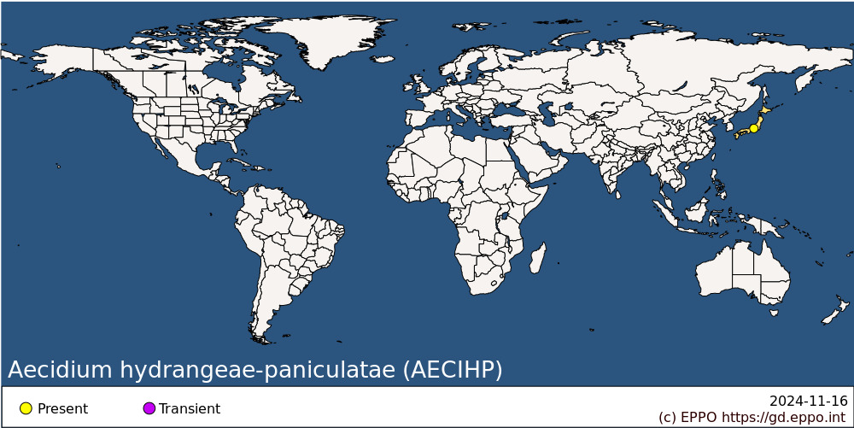 **Asia:** Japan

**How to cite this datasheet?**

EPPO (2024) *Aecidium hydrangeae-paniculatae*. EPPO datasheets on pests recommended for regulation. Available online. <https://gd.eppo.int>