**EPPO Datasheet: *Peridiopsora mori***

Last updated: 1970-01-01

**IDENTITY**

|  |  |
| --- | --- |
| **Preferred name:** *Peridiopsora mori* **Authority:** (Barclay) K.V. Prasad, B.R.D. Yadav & Sullia **Taxonomic position:** Fungi: Basidiomycota: Pucciniomycotina: Pucciniomycetes: Pucciniales **Other scientific names:** *Aecidium mori* (Barclay) Barclay, *Caeoma mori* Barclay **Common names in English:** red rust of mulberry [view more common names online...](https://gd.eppo.int/taxon/AECIMO/) **EPPO Code:** AECIMO |  |

**GEOGRAPHICAL DISTRIBUTION**

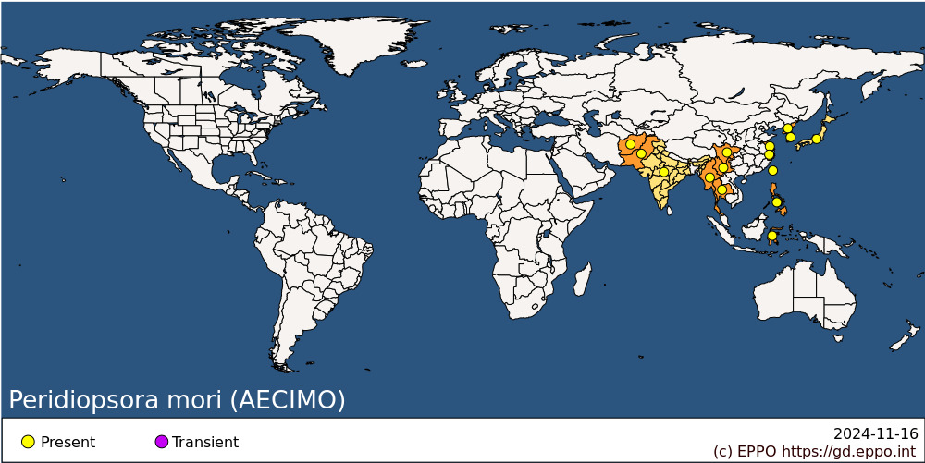 **Asia:** Afghanistan, China (Jiangsu, Sichuan, Yunnan, Zhejiang), India, Indonesia (Sulawesi), Japan, Korea Dem. People's Republic, Korea, Republic, Myanmar, Pakistan, Philippines, Taiwan, Thailand

**How to cite this datasheet?**

EPPO (2024) *Peridiopsora mori*. EPPO datasheets on pests recommended for regulation. Available online. <https://gd.eppo.int>