**EPPO Datasheet: *Rhizobium rhizogenes***

Last updated: 1970-01-01

**IDENTITY**

|  |  |
| --- | --- |
| **Preferred name:** *Rhizobium rhizogenes* **Authority:** (Riker, Banfield, Wright, Keitt & Sagen) Young, Kuykendall, Martinez-Romero, Kerr & Sawada **Taxonomic position:** Bacteria: Proteobacteria: Alphaproteobacteria: Rhizobiales: Rhizobiaceae **Other scientific names:** *Agrobacterium rhizogenes* (Riker, Banfield, Wright, Keitt & Sagen) Conn, *Pseudomonas rhizogenes* Riker **Common names in English:** hairy root, hairy root of apple [view more common names online...](https://gd.eppo.int/taxon/AGRBRH/) **EPPO Categorization:** A1/A2 (formerly) [view more categorizations online...](https://gd.eppo.int/taxon/AGRBRH/categorization) **EPPO Code:** AGRBRH |  |

**GEOGRAPHICAL DISTRIBUTION**

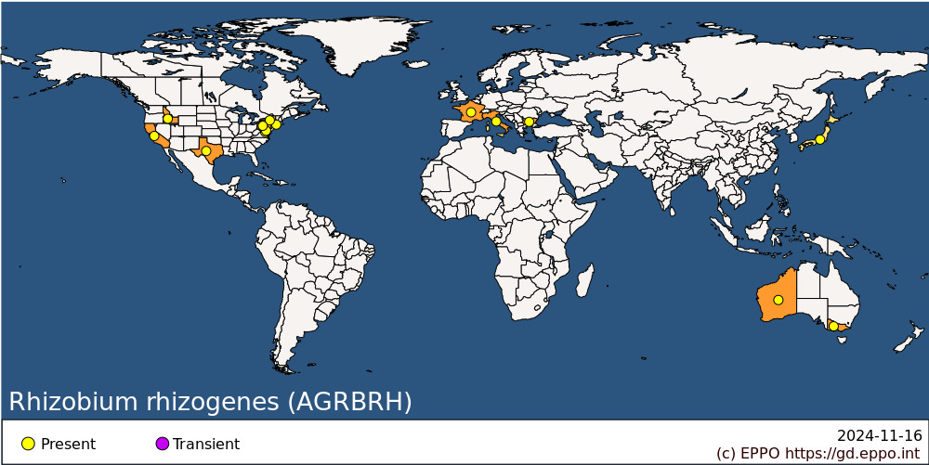 **EPPO Region:** Bulgaria, France (mainland), Italy (mainland) **Asia:** Japan **North America:** United States of America (California, Connecticut, District of Columbia, Idaho, Maryland, New York, Pennsylvania, Texas) **Oceania:** Australia (Victoria, Western Australia)

**How to cite this datasheet?**

EPPO (2024) *Rhizobium rhizogenes*. EPPO datasheets on pests recommended for regulation. Available online. <https://gd.eppo.int>