**EPPO Datasheet: *Agrobacterium tumefaciens***

Last updated: 1970-01-01

**IDENTITY**

|  |  |
| --- | --- |
| **Preferred name:** *Agrobacterium tumefaciens* **Authority:** (Smith & Townsend) Conn **Taxonomic position:** Bacteria: Proteobacteria: Alphaproteobacteria: Rhizobiales: Rhizobiaceae **Other scientific names:** *Achromobacter radiobacter* (Beijerinck & van Delden) Bergey, *Agrobacterium radiobacter var. radiobacter* (Beijerinck & van Delden) Conn, *Agrobacterium radiobacter subsp. tumefaciens* (Beijerinck & van Delden) Conn, *Alcaligenes radiobacter* (Beijerinck & van Delden) Conn, *Bacillus radiobacter* Beijerinck & van Delden, *Bacterium radiobacter* Loehnis, *Bacterium tumefaciens* E.F.Smith & Townsend, *Pseudomonas radiobacter* (Beijerinck & van Delden) Bergey, *Pseudomonas tumefaciens* (Smith & Townsend) Duggar, *Rhizobium radiobacter* (Beijerinck & van Delden) Young, Kuykendall, Martinez-Romero, Kerr & Sawada **Common names in English:** bacterial gall, bacterial gall, crown gall, hairy root of apple [view more common names online...](https://gd.eppo.int/taxon/AGRBTU/) **EU Categorization:** RNQP (Annex IV) [view more categorizations online...](https://gd.eppo.int/taxon/AGRBTU/categorization) **EPPO Code:** AGRBTU |  |

**GEOGRAPHICAL DISTRIBUTION**

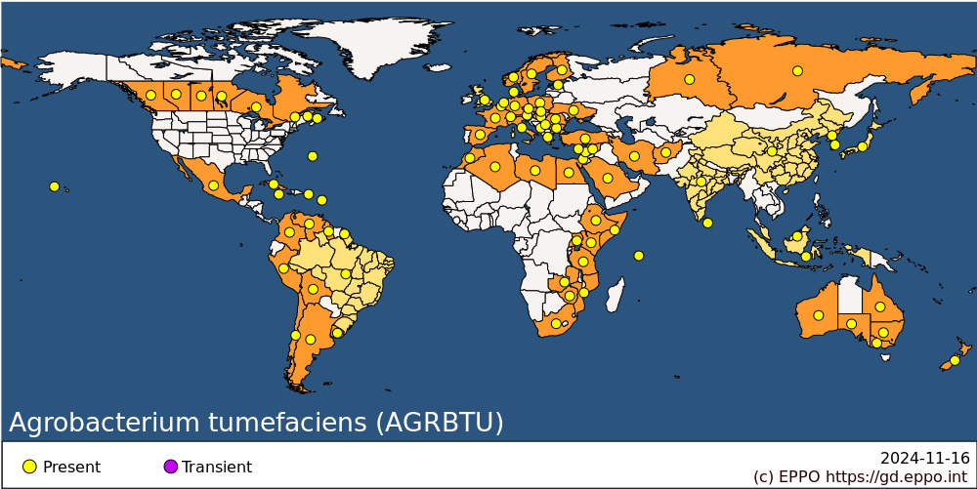 **EPPO Region:** Algeria, Austria, Belgium, Bulgaria, Cyprus, Czech Republic, Denmark, Estonia, Finland, France (mainland), Germany, Greece (mainland), Hungary, Israel, Italy (mainland), Montenegro, Morocco, Netherlands, Norway, Poland, Romania, Russia (Eastern Siberia, European Russia, Western Siberia), Serbia, Slovakia, Spain (mainland), Sweden, Switzerland, Türkiye, Ukraine, United Kingdom **Africa:** Algeria, Egypt, Ethiopia, Kenya, Libya, Morocco, Mozambique, Seychelles, Somalia, South Africa, Tanzania, Uganda, Zambia, Zimbabwe **Asia:** Afghanistan, China, India, Indonesia, Iran, Israel, Japan, Korea Dem. People's Republic, Korea, Republic, Lebanon, Malaysia, Saudi Arabia, Sri Lanka, Syria **North America:** Canada (Alberta, British Columbia, Manitoba, New Brunswick, Ontario, Prince Edward Island, Québec, Saskatchewan), Mexico, United States of America (Hawaii) **Central America and Caribbean:** Bermuda, Cuba, Guadeloupe, Jamaica, Puerto Rico **South America:** Argentina, Bolivia, Brazil, Chile, Colombia, French Guiana, Guyana, Peru, Uruguay, Venezuela **Oceania:** Australia (New South Wales, Queensland, South Australia, Victoria, Western Australia), New Zealand

**How to cite this datasheet?**

EPPO (2024) *Agrobacterium tumefaciens*. EPPO datasheets on pests recommended for regulation. Available online. <https://gd.eppo.int>