**EPPO Datasheet: *Alternaria brassicae***

Last updated: 1970-01-01

**IDENTITY**

|  |  |
| --- | --- |
| **Preferred name:** *Alternaria brassicae* **Authority:** (Berkeley) Saccardo **Taxonomic position:** Fungi: Ascomycota: Pezizomycotina: Dothideomycetes: Pleosporomycetidae: Pleosporales: Pleosporaceae **Other scientific names:** *Alternaria brassicae var. macrospora* Saccardo, *Alternaria herculea* (Ellis & G.Martin) Elliott, *Macrosporium brassicae* Berkeley **Common names in English:** black spot of rape, brown rot of cauliflower, dark leaf spot of cabbage, dark spot of crucifers, grey leaf spot of cabbage, grey leaf spot of crucifers, head browning of crucifers, leaf blight of crucifers, pod spot of rape, silique mould of rape [view more common names online...](https://gd.eppo.int/taxon/ALTEBA/) **EPPO Code:** ALTEBA | 16926.jpg [more photos...](https://gd.eppo.int/taxon/ALTEBA/photos) |

**GEOGRAPHICAL DISTRIBUTION**

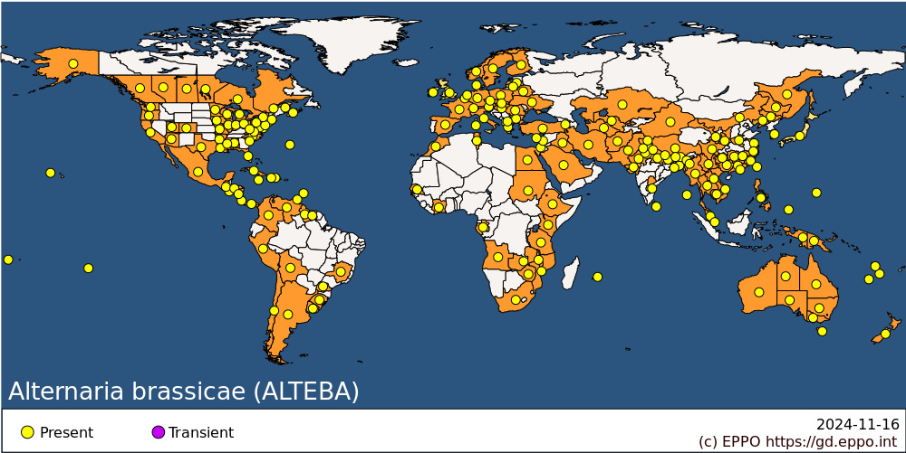 **EPPO Region:** Armenia, Austria, Belarus, Belgium, Bulgaria, Cyprus, Czech Republic, Denmark, Finland, France (mainland), Germany, Greece (mainland), Hungary, Ireland, Israel, Italy (mainland, Sardegna), Kazakhstan, Latvia, Lithuania, Morocco, Netherlands, North Macedonia, Norway, Poland, Romania, Russia (European Russia, Far East), Slovakia, Spain (mainland), Sweden, Switzerland, Tunisia, Türkiye, Ukraine, United Kingdom, Uzbekistan **Africa:** Angola, Cote d'Ivoire, Egypt, Ethiopia, Gabon, Kenya, Malawi, Mauritius, Morocco, Mozambique, Senegal, South Africa, Sudan, Tanzania, Tunisia, Zambia, Zimbabwe **Asia:** Afghanistan, Bangladesh, Bhutan, Cambodia, China (Fujian, Gansu, Guangdong, Guangxi, Guizhou, Heilongjiang, Henan, Hunan, Jiangsu, Jiangxi, Jilin, Liaoning, Neimenggu, Shaanxi, Sichuan, Xianggang (Hong Kong), Xinjiang, Xizhang, Yunnan, Zhejiang), India (Andaman and Nicobar Islands, Andhra Pradesh, Assam, Bihar, Delhi, Gujarat, Haryana, Himachal Pradesh, Jammu & Kashmir, Manipur, Punjab, Rajasthan, Sikkim, Uttarakhand, Uttar Pradesh, West Bengal), Indonesia (Irian Jaya), Iran, Iraq, Israel, Japan, Kazakhstan, Korea, Republic, Laos, Lebanon, Malaysia (West), Myanmar, Nepal, Pakistan, Philippines, Saudi Arabia, Singapore, Sri Lanka, Taiwan, Thailand, Turkmenistan, Uzbekistan, Vietnam **North America:** Canada (Alberta, British Columbia, Manitoba, New Brunswick, Nova Scotia, Ontario, Québec, Saskatchewan), Mexico, United States of America (Alabama, Alaska, Arizona, Arkansas, California, Colorado, Connecticut, Delaware, Florida, Hawaii, Illinois, Indiana, Iowa, Louisiana, Maryland, Massachusetts, Michigan, Minnesota, Mississippi, Missouri, New Jersey, New York, North Carolina, Ohio, Oregon, Pennsylvania, South Carolina, Texas, Utah, Virginia, Washington, West Virginia, Wisconsin) **Central America and Caribbean:** Barbados, Bermuda, Costa Rica, Cuba, Dominican Republic, El Salvador, Guatemala, Haiti, Honduras, Jamaica, Nicaragua, Panama, Trinidad and Tobago **South America:** Argentina, Bolivia, Brazil (Minas Gerais, Parana, Rio Grande do Sul), Chile, Colombia, Guyana, Peru, Suriname, Uruguay, Venezuela **Oceania:** Australia (New South Wales, Northern Territory, Queensland, South Australia, Tasmania, Victoria, Western Australia), French Polynesia, Guam, New Caledonia, New Zealand, Niue, Palau, Papua New Guinea, Vanuatu, Wallis and Futuna Islands

**How to cite this datasheet?**

EPPO (2024) *Alternaria brassicae*. EPPO datasheets on pests recommended for regulation. Available online. <https://gd.eppo.int>