**EPPO Datasheet: *Alternaria brassicicola***

Last updated: 1970-01-01

**IDENTITY**

|  |  |
| --- | --- |
| **Preferred name:** *Alternaria brassicicola* **Authority:** (Schweinitz) Wiltshire **Taxonomic position:** Fungi: Ascomycota: Pezizomycotina: Dothideomycetes: Pleosporomycetidae: Pleosporales: Pleosporaceae **Other scientific names:** *Alternaria circinans* (Berkeley & Curtis) Bolle, *Alternaria oleracea* Milbrath, *Helminthosporium brassicicola* Schweinitz, *Macrosporium circinans* Berkeley & Curtis **Common names in English:** black spot of cabbage, black spot of crucifers, brown rot of cabbage, dark leaf spot of cabbage, head browning of crucifers, pod spot of rape, silique mould of rape, wirestem [view more common names online...](https://gd.eppo.int/taxon/ALTEBI/) **EPPO Code:** ALTEBI |  |

**GEOGRAPHICAL DISTRIBUTION**

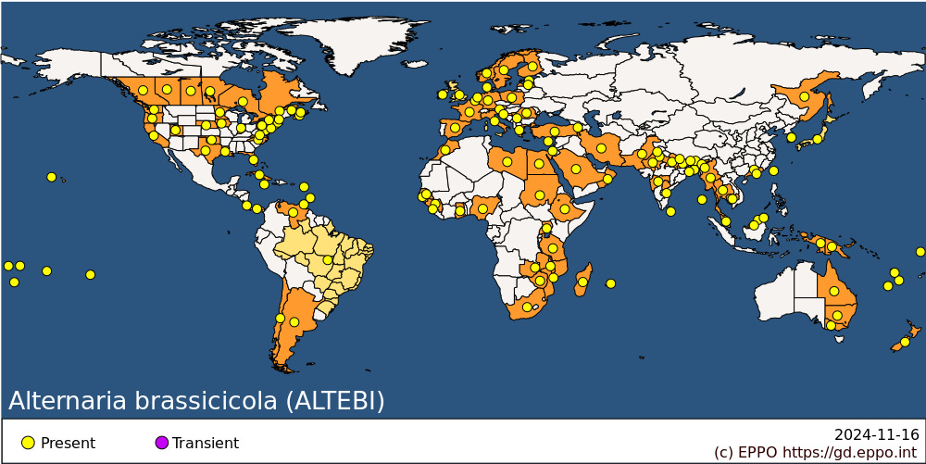 **EPPO Region:** Armenia, Austria, Belgium, Croatia, Cyprus, Denmark, Estonia, Finland, France (mainland), Germany, Greece (mainland), Ireland, Israel, Italy (mainland), Latvia, Morocco, Netherlands, Norway, Poland, Romania, Russia (Far East), Serbia, Spain (mainland), Sweden, Türkiye, United Kingdom **Africa:** Egypt, Ethiopia, Gambia, Ghana, Guinea, Libya, Madagascar, Malawi, Mauritius, Morocco, Mozambique, Nigeria, Senegal, Sierra Leone, South Africa, Sudan, Tanzania, Uganda, Zambia, Zimbabwe **Asia:** Bangladesh, Bhutan, Brunei Darussalam, Cambodia, China (Guangdong, Xianggang (Hong Kong)), India (Andaman and Nicobar Islands, Andhra Pradesh, Assam, Bihar, Haryana, Maharashtra, Manipur, Punjab, Rajasthan, Sikkim, Uttar Pradesh, West Bengal), Indonesia (Irian Jaya), Iran, Israel, Japan, Korea, Republic, Malaysia (Sabah, Sarawak, West), Myanmar, Nepal, Oman, Pakistan, Saudi Arabia, Sri Lanka, Taiwan, Thailand **North America:** Canada (Alberta, British Columbia, Manitoba, New Brunswick, Nova Scotia, Ontario, Prince Edward Island, Québec, Saskatchewan), United States of America (California, Connecticut, Florida, Hawaii, Indiana, Iowa, Louisiana, Maryland, Massachusetts, Minnesota, Nebraska, New Hampshire, New Jersey, New York, North Carolina, Oklahoma, Oregon, Pennsylvania, Texas, Utah, Virginia, Washington) **Central America and Caribbean:** Antigua and Barbuda, Barbados, Costa Rica, Cuba, Jamaica, Panama, Trinidad and Tobago **South America:** Argentina, Brazil, Chile, Venezuela **Oceania:** Australia (New South Wales, Queensland, Victoria), Cook Islands, French Polynesia, New Caledonia, New Zealand, Niue, Papua New Guinea, Samoa, Tonga, Tuvalu, Vanuatu, Wallis and Futuna Islands

**How to cite this datasheet?**

EPPO (2024) *Alternaria brassicicola*. EPPO datasheets on pests recommended for regulation. Available online. <https://gd.eppo.int>