**EPPO Datasheet: *Alternaria citri***

Last updated: 1970-01-01

**IDENTITY**

|  |  |
| --- | --- |
| **Preferred name:** *Alternaria citri* **Authority:** Ellis & Pearce **Taxonomic position:** Fungi: Ascomycota: Pezizomycotina: Dothideomycetes: Pleosporomycetidae: Pleosporales: Pleosporaceae **Common names in English:** black rot of citrus, brown spot of citrus, core rot of citrus, fruit rot of citrus [view more common names online...](https://gd.eppo.int/taxon/ALTECI/) **EPPO Code:** ALTECI |  |

**GEOGRAPHICAL DISTRIBUTION**

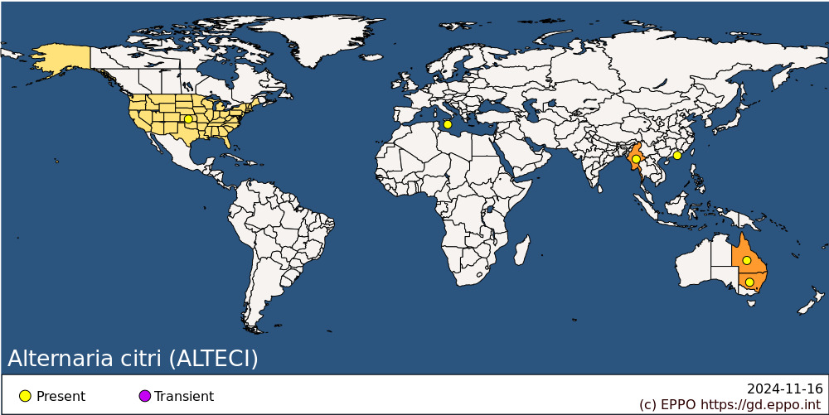 **EPPO Region:** Malta **Asia:** China (Xianggang (Hong Kong)), Myanmar **North America:** United States of America **Oceania:** Australia (New South Wales, Queensland)

**How to cite this datasheet?**

EPPO (2024) *Alternaria citri*. EPPO datasheets on pests recommended for regulation. Available online. <https://gd.eppo.int>