**EPPO Datasheet: *Alternaria gaisen***

Last updated: 2017-08-08

**IDENTITY**

|  |  |
| --- | --- |
| **Preferred name:** *Alternaria gaisen* **Authority:** Nagano **Taxonomic position:** Fungi: Ascomycota: Pezizomycotina: Dothideomycetes: Pleosporomycetidae: Pleosporales: Pleosporaceae **Other scientific names:** *Alternaria kikuchiana* Tanaka, *Alternaria nashi* Miura, *Alternaria nashii* Miura **Common names in English:** black spot of Japanese pear [view more common names online...](https://gd.eppo.int/taxon/ALTEKI/) **EPPO Code:** ALTEKI | 37.jpg [more photos...](https://gd.eppo.int/taxon/ALTEKI/photos) |

**Notes on taxonomy and nomenclature**

*A. gaisen* belongs to the *A. alternata* (E.M. Fries) Keissler group and is distinguished on certain morphological criteria (see Morphology) and on its pathogenicity towards certain cultivars of *Pyrus pyrifolia*. It is also capable of producing a host-specific toxin, AK toxin (Cavanni *et al.,* 1992; Park *et al*., 1992), but this toxigenicity is not exclusive to *A. gaisen* (Simmons & Roberts, 1993). According to Nishimura *et al.* (1978), *A. gaisen* may be treated as a *forma specialis* of *A. alternata,*and the fungushas, in the past, been referred to as the pear pathotype of *A. alternata*. The morphological and nomenclatural aspects have been extensively investigated by Simmons (1993) and the pathogenicity by Simmons & Roberts (1993). A similar situation arises in the case of the apple pathogen *A. mali* (EPPO/CABI, 1996).

**HOSTS**

The main host of *A. gaisen* is Japanese pear (*Pyrus pyrifolia*). The fungus has not specifically been recorded from European pear (*Pyrus communis*). Dickens & Cook (1995) found that, out of a number of pear isolates of *Alternaria*, only two (from Italy and the Korea Republic) infected leaves of pear, and only of *P. pyrifolia*; these two were also identified as*A. gaisen.* Japanese pears, or nashis, were planted as a novelty crop in southern Europe in the 1980s and these new orchards are the potential host in Europe. *A. alternata,* the related non-specific secondary parasite, has a very wide host range, including many plant families. It has been recorded from a range of species of *Pyrus*.

**Host list:** *Chimonanthus praecox*, *Pyrus pyrifolia*

**GEOGRAPHICAL DISTRIBUTION**

*A. gaisen* has been recorded in very few countries, while *A. alternata* is extremely widespread, having been recorded on *Malus* and *Pyrus* in most parts of the world.

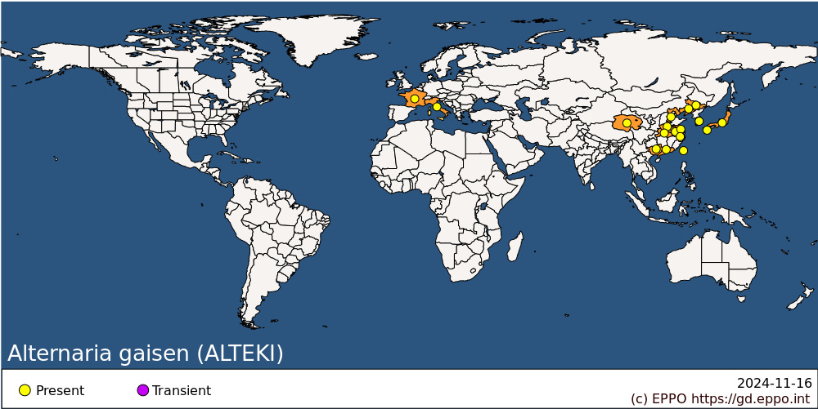 **EPPO Region:** France (mainland), Italy (mainland) **Asia:** China (Anhui, Guangdong, Guangxi, Hebei, Henan, Hubei, Jiangsu, Jilin, Liaoning, Qinghai, Zhejiang), Japan (Honshu, Kyushu), Korea, Republic, Taiwan

**BIOLOGY**

*A. gaisen* survives adverse conditions as resting bodies (microsclerotia) or resting spores (chlamydospores) in the soil. Under favourable conditions (warm and moist), masses of conidia are produced on leaf debris, from which they are disseminated by wind and rain. Conidia landing on senescent floral parts can cause an infection which is later manifested in the fruit. *A. gaisen* can invade young fruit and leaves via lenticels and stomata, causing numerous black spots. Estimates of the optimal growth temperature of the fungus in culture range from 23°C (Hsieh & Chiu, 1974) to 28°C (Tanaka, 1933). The maximum temperature for growth is 40°C, at which temperature the fungus is unable to form conidia, but can still form chlamydospores (Tanaka, 1933). High humidities favour infection, which is restricted at less than 90% RH *in vitro*. Disease incidence has been observed to increase where trees are grown under polythene covers to promote early flowering. The covers increase air temperature by 8-10°C, and average soil temperature by 3-5°C (Hong *et al.*, 1988).

It may be noted that*A. alternata,* a very common saprophyte on dead plant tissues, has been recorded on pears only causing a fruit rot.

**DETECTION AND IDENTIFICATION**

**Symptoms**

The disease occurs on the fruit, young leaves and young shoots of Pyrus pyrifolia, but never on old leaves and branches. On fruits, infection first appears as small black specks in early summer. These expand into characteristic round black/brown spots, with conspicuous black concentric rings. The fruit subsequently begins to rot. In serious outbreaks under rainy conditions, the spots rapidly enlarge and coalesce into a large irregular lesion. Enlargement of the spots causes uneven growth and often cracking of the affected fruit. In advanced stages of the disease, dirty-white mycelium and black spore masses can be seen. Disease progress appears to be relatively retarded in ripe fruit on the tree. On leaves, small dark-brown or black/brown specks appear in early summer and slowly enlarge. Concentric rings appear on the lesions, which coalesce into large irregular patches under favourable conditions. Severely affected leaves can turn brown and fall. On young shoots, small black specks develop into oblong streaks and finally cause shoot death. Lesions are slightly shrunken with slight concentric rings. For illustrations of symptoms, see Tanaka (1933).

**Morphology**

Simmons & Roberts (1993) have characterized A. gaisen as corresponding to their group 2 within A. alternata sensu lato based on the gross appearance of conidial chains (as illustrated in Simmons, 1993) and on the use of consistent cultural conditions on a range of simple media. A full description of the fungus is given in Tanaka (1933) and in David (1988). Conidia are olive-brown, smooth or sometimes verrucose, oblong-ovate or rarely obclavate, with one to 10 longitudinal and one to three transverse septa, short-beaked. These authors give conidial dimensions as 10-70 x 6-22 µm, but Simmons & Roberts (1993) are more precise, specifying that A. gaisen has relatively large conidia, in short, usually unbranched, chains of 5-8.

Maximum conidial dimensions are 45(-55) x 15(-18) µm. Dickens & Cook (1995) confirmed that, among a group of Alternaria isolates from pear, the two pathogenic isolates were A. gaisen by the above criteria, while all others were in group 4 of Simmons & Roberts (1993), i.e. A. alternata sensu stricto.

**PATHWAYS FOR MOVEMENT**

*A. gaisen* is spread by means of conidia and its dispersal is particularly favoured by rainfall. However, this natural dispersal is only local. Internationally, possibilities for spread are fairly limited. The fungus is not liable to be carried on dormant planting material (without leaves). It could be carried in fruits but, since infection occurs on the young fruit, it is relatively unlikely that infected fruits would be harvested and traded.

**PEST SIGNIFICANCE**

**Economic impact**

While A. alternata is, in Europe, a very minor fruit-rotting fungus on pears, affecting only fruits which are already damaged, black spot due to A. gaisen is a widespread and serious disease of Pyrus pyrifolia in Japan and Korea Republic. According to Sakuma (1990), it has been important since the very susceptible cv. Nijisseiki was widely planted in the early part of this century. Its importance arises from the fact that it is both a leaf and a fruit disease. The fact that control measures are actively taken (see below) against A. gaisen in the Far East is the main practical indication of its impact.

**Control**

Control of A. gaisen is through the use of resistant cultivars and fungicides. Modern cultivars of Pyrus pyrifolia reported to show resistance include Shinsei (Machida et al., 1984), Whangkeum Bae (Kim et al., 1985), Chuwhang Bae (Kim et al., 1986) and Shugyoko (Kozaki, 1987). Many cultivars have some degree of resistance, which is believed to be determined largely by one pair of genes, resistance being homozygous recessive (Kozaki, 1974). Chemical control of A. gaisen has been reported with captafol (Adachi & Fujita, 1984) and guazatine (Yagura et al., 1984).

**Phytosanitary risk**

A. gaisen is currently being assessed as a quarantine pest by EPPO, but no other regional plant protection organization has specifically rated it as of quarantine significance. Since it has now been recorded in two EPPO countries (France, Italy; the record of black spot in Greece appears to be attributable to A. alternata), A. gaisen could only be added to the A2 list of EPPO. A. alternata, widespread and only of secondary importance on apples and pears, is evidently not of quarantine significance. Whether it is a separate species or a form of A. alternata, A. gaisen clearly differs from A. alternata by its capacity to cause damaging leaf diseases of its host. No such alternaria disease of pears occurs in the EPPO region at the present time, apart from one record of A. alternata causing black spot on P. communis in Greece (Thanassopoulos et al., 1990). A. gaisen did, when first considered as a quarantine pest for Europe, present a certain threat to the establishment of the newly developing Pyrus pyrifolia production in Europe. However, the fact that the pest has now been introduced into two of the countries most concerned with this production, without very serious consequences, clearly affects its possible future status as a quarantine pest. Further, Japanese pear production remains of minor importance and indeed has largely failed on the consumer market. Since there is no direct evidence to show that European pears are susceptible to the fungus or particularly threatened, it is not clear that A. gaisen now presents a significant risk. It is in any case favoured by much warmer and wetter conditions than are usual in the pear production regions of Europe.

**PHYTOSANITARY MEASURES**

Any planting material of *Pyrus* imported from countries where *A. gaisen* occurs should be in dormancy, and not carry any leaves or plant debris. Fruits from these countries should be free from symptoms and of good commercial quality.

**How to cite this datasheet?**

EPPO (2024) *Alternaria gaisen*. EPPO datasheets on pests recommended for regulation. Available online. <https://gd.eppo.int>