**EPPO Datasheet: *Alternaria mali***

Last updated: 2017-08-08

**IDENTITY**

|  |  |
| --- | --- |
| **Preferred name:** *Alternaria mali* **Authority:** Roberts **Taxonomic position:** Fungi: Ascomycota: Pezizomycotina: Dothideomycetes: Pleosporomycetidae: Pleosporales: Pleosporaceae **Common names in English:** alternaria blotch of apple, cork spot of apple, leaf spot of apple, storage rot of apple [view more common names online...](https://gd.eppo.int/taxon/ALTEMA/) **EPPO Categorization:** A1 list [view more categorizations online...](https://gd.eppo.int/taxon/ALTEMA/categorization) **EPPO Code:** ALTEMA | 38.jpg [more photos...](https://gd.eppo.int/taxon/ALTEMA/photos) |

**HOSTS**

The main host of *A. mali* is apples, cultivated (*Malus pumila*) and wild (*M. sylvestris*). *A. alternata,* the related non-specific secondary parasite, has a very wide host range, including many plant families. It has been recorded from a range of species of *Malus*.

**Host list:** *Malus domestica*, *Malus sylvestris*, *Malus*

**GEOGRAPHICAL DISTRIBUTION**

*A. mali* has been recorded in only a limited number of countries (see also Notes on taxonomy and nomenclature), while *A. alternata* is extremely widespread, having been recorded on *Malus* and *Pyrus* in most parts of the world. Recent outbreaks, since 1987, in North Carolina (USA) (Filajdic & Sutton, 1991) seem to be of the Asian fungus, presumably introduced and different from the *A. mali* present elsewhere in North America.

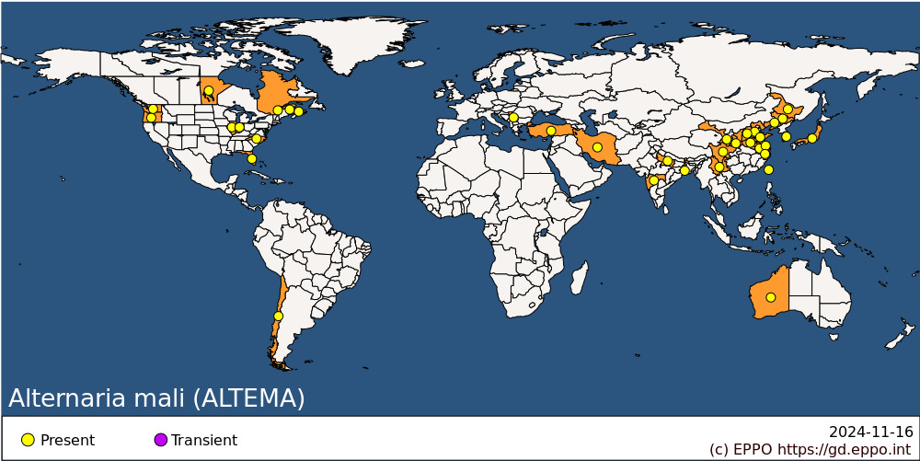 **EPPO Region:** Serbia, Türkiye **Asia:** China (Anhui, Gansu, Hebei, Heilongjiang, Henan, Jiangsu, Jilin, Liaoning, Shaanxi, Shandong, Shanxi, Sichuan, Yunnan, Zhejiang), India (Maharashtra, Uttar Pradesh, West Bengal), Iran, Japan (Honshu), Korea, Republic, Taiwan **North America:** Canada (Manitoba, New Brunswick, Prince Edward Island, Québec), United States of America (Florida, Illinois, Indiana, North Carolina, Oregon, Washington) **South America:** Chile **Oceania:** Australia (Western Australia)

**BIOLOGY**

The fungus infects mainly leaves of apple. According to Sawamura (1990), it does not typically infect fruits, except the very susceptible cv. Indo, which shows fruit-spotting but not subsequent rotting on the tree or in storage.

Disease spread is favoured by rainfall and high temperatures. A model of the relationship between the temperature threshold for infection and the influence of rainfall has been developed to predict the severity of the disease (Kim *et al.*, 1986). It may be noted that*A. alternata,* a very common saprophyte on dead plant tissues, has been recorded on apple causing only a fruit rot. For more information, see Sawamura (1972).

**DETECTION AND IDENTIFICATION**

**Symptoms**

The fungus causes leaf spots, which enlarge in zonate circular or crescent-shaped rings. Hyphae are normally scant or lacking on the host surface, but abundant light-grey mycelium can be produced on the surface under moist storage conditions. The fungus also infects the fruit, causing a soft rot, particularly where the skin is already damaged through other causes (it is not clear whether this fruit rot occurs any more frequently or seriously than non-specific A. alternata rot).

**Morphology**

The cultural characteristics, conidial size and septation of A. alternata are highly variable, so that the morphological characters supposed to distinguish A. mali from it are not very useful for routine diagnosis. However, Dickens & Cook (1995) report that two isolates of toxigenic A. mali included in their comparative study appeared to correspond to group 1 of Simmons & Roberts (1993), within A. alternata sensu lato. A full description of the fungus is given in Roberts (1924). Hyphal segments are short, mostly unbranched and without constrictions at their septa and 3-8 µm wide. Conidia are produced in chains of 3-9 and average 28 x 12 µm (maximum 29 x 13 µm). They are similar to those of A. gaisen (EPPO/CABI, 1996) but smaller. They are typically 3-septate, with transverse and longitudinal septa, with constrictions at the septa, especially when old. Conidiophores are usually fasciculate on apple leaves, are of variable length and show a dark-coloured scar at the point of attachment of the conidium. Dickens & Cook (1995) confirmed that, among a group of Alternaria isolates from apple, two pathogenic isolates were A. mali by the above criteria, while the others fell into various other groups (3, 4 and 6 ) of Simmons & Roberts (1993).

**PATHWAYS FOR MOVEMENT**

*A. mali* is spread by means of conidia and its dispersal is particularly favoured by rainfall. However, this natural dispersal is only local. Internationally, possibilities for spread are fairly limited. The fungus is not liable to be carried on dormant planting material (without leaves). It could be carried in fruits but, since infection occurs on the young fruit, it is relatively unlikely that infected fruits would be harvested and traded.

**PEST SIGNIFICANCE**

**Economic impact**

While A. alternata is, in Europe, a very minor fruit-rotting fungus on apples, affecting only fruits which are already damaged, A. mali is important in the Far East because it causes both a leaf and a fruit disease. It can infect up to 85% of leaves on susceptible cultivars, compared with less than 1% on resistant cultivars (Yoon & Lee, 1987). The fact that control measures are actively taken against A. mali in the Far East (see below) is the main practical indication of its impact. In the USA, the disease is only important where Asian A. mali has been introduced (North Carolina); disease assessment methods have been described by Filajdic & Sutton (1994).

**Control**

Control of A. mali is through the use of resistant cultivars and fungicides. Apple cultivars can be ranked in order of increasing resistance (Sawamura, 1990) as follows: Indo, Red Gold, Raritan, Delicious, Fuji, Golden Delicious, Ralls, Toko, Tsugaru, Mutsu, Jonagold, Jonathan. Yellow Newtown, American Summer Pearmain, McIntosh, Ben Davis and Stayman Winesap are other resistant cultivars, to which Shin et al. (1986) would add Gala, Honey Gold and Mollie's Delicious. Resistant cultivars are homozygous for the recessive gene alt alt. Certain Malus spp. are highly resistant, e.g. M. asiatica, M. baccata and M. robusta, but resistance in these species is controlled by a single dominant gene, epistatic to the dominant gene controlling susceptibility (Saito & Niizeki, 1988). Chemical control of A. mali can be achieved through use of fungicides such as iprodione, mancozeb and captan (although some isolates have developed tolerance of these fungicides) (Lee & Kim, 1986; Osanai et al., 1987; Asari & Takahashi, 1988). In Japan, it is one of the most serious diseases of apple, requiring specific and regular control measures. Applications of protectant fungicides are made after petal fall: mancozeb, ziram, thiram, oxine-copper, iminoctadine, polyoxins etc. (Sekita et al., 1994). Only iprodione was found to be effective for control of A. mali in North Carolina (USA) (Filajdic & Sutton, 1992a). The predictive model developed in the Korea Republic (Kim et al., 1986) has been evaluated in the USA (Filajdic & Sutton, 1992b).

**Phytosanitary risk**

A. mali has recently been added to the EPPO A1 list, but no other regional plant protection organization has specifically rated this fungus as a quarantine pest. A. alternata, widespread and only of secondary importance on apples and pears, is evidently not of quarantine significance. Whether it is a separate species or a form of A. alternata, A. mali clearly differs from A. alternata by its capacity to cause damaging leaf diseases of its hosts. No such alternaria disease of apples occurs in the EPPO region at the present time. Unlike A. gaisen, which attacks only the Japanese pear species Pyrus pyrifolia, A. mali presents a direct risk to the main apple crop in the EPPO region. Indeed, it has an even wider host range, extending to fruiting and ornamental Malus, and on this basis presents a greater risk than A. gaisen. However, A. mali is favoured by much warmer and wetter conditions than are usual in the apple production regions of Europe. In addition, there is no very obvious existing pathway for introduction of the fungus into Europe. Asian A. mali has been recently introduced into the USA, which shows that it does have the potential to spread. In North Carolina, it encounters conditions somewhat more similar to those of southern Europe. A. mali is principally damaging on certain susceptible cultivars, and current cultivar ratings mainly relate to those grown in Asia or North America. So the status of European cultivars in relation to the disease needs to be assessed. Dickens & Cook (1995) found that American isolates of "toxigenic" A. mali only infected leaves of cvs Indo and Red Gold, and not the European cultivars tested. Of the cultivars mentioned under Control, Golden Delicious (widely grown in Europe) is ranked as moderately resistant. It may finally be noted that A. mali was recently recorded for the first time in the EPPO region, in Yugoslavia. The consequences of this new record have not yet been assessed.

**PHYTOSANITARY MEASURES**

Any planting material of *Malus* imported from countries where *A. mali* occurs should be in dormancy, and not carry any leaves or plant debris. Fruits from these countries should be free from symptoms and of good commercial quality.

**How to cite this datasheet?**

EPPO (2024) *Alternaria mali*. EPPO datasheets on pests recommended for regulation. Available online. <https://gd.eppo.int>