**EPPO Datasheet: *Ascochyta gossypiicola***

Last updated: 1970-01-01

**IDENTITY**

|  |  |
| --- | --- |
| **Preferred name:** *Ascochyta gossypiicola* **Authority:** Bedlan **Taxonomic position:** Fungi: Ascomycota: Pezizomycotina: Dothideomycetes: Pleosporomycetidae: Pleosporales: Didymellaceae **Other scientific names:** *Ascochyta gossypii* Sydow & P.Sydow **Common names in English:** blight of cotton, boll rot of cotton, stem canker of cotton, wet-weather blight of cotton [view more common names online...](https://gd.eppo.int/taxon/ASCOGO/) **EPPO Code:** ASCOGO |  |

**GEOGRAPHICAL DISTRIBUTION**

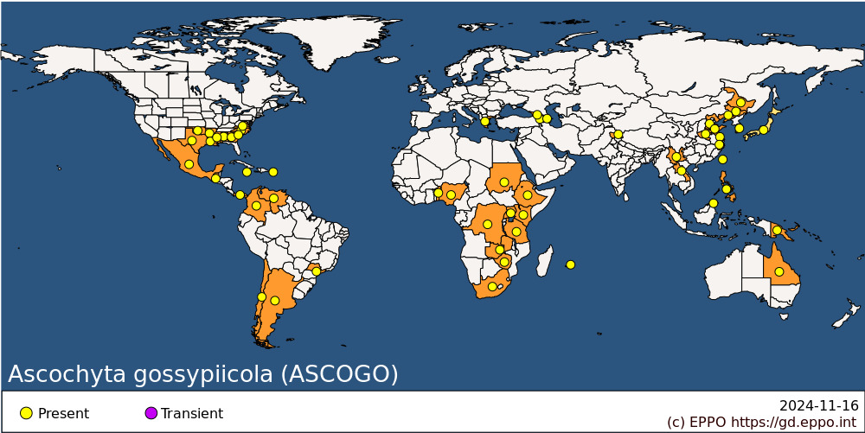 **EPPO Region:** Armenia, Azerbaijan, Georgia, Greece (mainland) **Africa:** Benin, Congo, Democratic republic of the, Ethiopia, Kenya, Mauritius, Nigeria, South Africa, Sudan, Tanzania, Uganda, Zambia, Zimbabwe **Asia:** China (Hebei, Heilongjiang, Henan, Jiangsu, Jilin, Liaoning, Shandong, Yunnan, Zhejiang), India (Jammu & Kashmir), Japan, Korea, Republic, Laos, Malaysia (Sabah), Philippines, Taiwan **North America:** Mexico, United States of America (Alabama, Arkansas, Georgia, Louisiana, Mississippi, North Carolina, Oklahoma, South Carolina, Texas, Virginia) **Central America and Caribbean:** Guatemala, Jamaica, Panama, Puerto Rico **South America:** Argentina, Brazil (Sao Paulo), Chile, Colombia, Venezuela **Oceania:** Australia (Queensland), Papua New Guinea

**How to cite this datasheet?**

EPPO (2024) *Ascochyta gossypiicola*. EPPO datasheets on pests recommended for regulation. Available online. <https://gd.eppo.int>