**EPPO Datasheet: *Asperisporium caricae***

Last updated: 1970-01-01

**IDENTITY**

|  |  |
| --- | --- |
| **Preferred name:** *Asperisporium caricae* **Authority:** (Spegazzini) Maublanc **Taxonomic position:** Fungi: Ascomycota: Pezizomycotina: Dothideomycetes: Dothideomycetidae: Mycosphaerellales: Mycosphaerellaceae **Other scientific names:** *Cercospora caricae* Spegazzini, *Fusicladium caricae* (Spegazzini) Saccardo, *Scolicotrichum caricae* Ellis & Everhart **Common names in English:** black spot of papaya, leaf blight of papaya, leaf spot of papaya [view more common names online...](https://gd.eppo.int/taxon/ASPRCA/) **EPPO Code:** ASPRCA |  |

**GEOGRAPHICAL DISTRIBUTION**

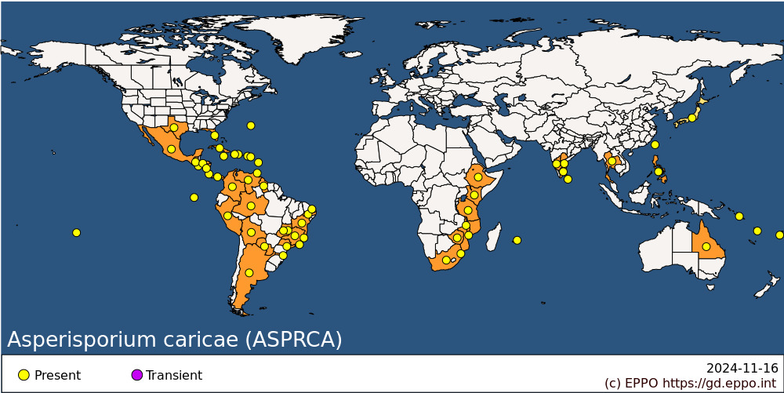 **Africa:** Eswatini, Ethiopia, Kenya, Malawi, Mauritius, Mozambique, South Africa, Tanzania, Zimbabwe **Asia:** India (Andhra Pradesh, Karnataka, Tamil Nadu), Japan, Philippines, Sri Lanka, Taiwan, Thailand **North America:** Mexico, United States of America (Florida, Texas) **Central America and Caribbean:** Bermuda, Costa Rica, Cuba, Dominica, Dominican Republic, El Salvador, Guatemala, Haiti, Honduras, Jamaica, Nicaragua, Panama, Puerto Rico, Trinidad and Tobago, Virgin Islands (US) **South America:** Argentina, Bolivia, Brazil (Amazonas, Bahia, Distrito Federal, Espirito Santo, Goias, Minas Gerais, Pernambuco, Rio de Janeiro, Rio Grande do Norte, Santa Catarina, Sao Paulo), Colombia, Ecuador (Galapagos), Guyana, Paraguay, Peru, Venezuela **Oceania:** Australia (Queensland), Fiji, French Polynesia, Solomon Islands, Vanuatu

**How to cite this datasheet?**

EPPO (2024) *Asperisporium caricae*. EPPO datasheets on pests recommended for regulation. Available online. <https://gd.eppo.int>