**EPPO Datasheet: *Atropellis pinicola***

Last updated: 2022-10-14

**IDENTITY**

|  |  |
| --- | --- |
| **Preferred name:** *Atropellis pinicola* **Authority:** Zeller & Goodding **Taxonomic position:** Fungi: Ascomycota: Pezizomycotina: Leotiomycetes: Helotiales: Godroniaceae **Other scientific names:** *Godronia zelleri* Seaver **Common names in English:** branch canker of pine, trunk canker of pine, twig blight of pine [view more common names online...](https://gd.eppo.int/taxon/ATRPPC/) **EPPO Categorization:** A1 list [view more categorizations online...](https://gd.eppo.int/taxon/ATRPPC/categorization) **EPPO Code:** ATRPPC | 252.jpg [more photos...](https://gd.eppo.int/taxon/ATRPPC/photos) |

**Notes on taxonomy and nomenclature**

*Atropellis pinicola* is one of four native North American species of the genus *Atropellis.* The following species have also been reported on *Pinus*: *A. apiculata* Lohman *et al.*, *A. tingens* Lohman & Cash, *A. piniphila* (Weir) M.L. Lohman & E.K. Cash and *A. pinicola* Zeller & Goodd. *A. treleasei* (Saccardo) Zeller & Goodding has been transferred to *Discocainia* as *D. treleasei* (Saccardo) J. Reid & Funk. (Thomas and Pickel, 2010). The differentiation between *Atropellis* species is based on their morphological and cultural characteristics.

**HOSTS**

*Pinus contorta*(lodgepole pine) is the most common host on which *A. pinicola* can cause branch and trunk canker. *P. albicaulis* (whitebark pine) and *Pinus monticola* (western white pine) can also be damaged by *A. pinicola*(Scharpf, 1993). In addition, the fungus can affect and form minor canker on *Pinus lambertiana*(sugar pine) and *P. strobus*(eastern white pine). Minor incidental twig blights caused by *A. pinicola* were found on *P. nigra* (black pine) and *P. sylvestris*(Scots pine) (Scharpf, 1993; Sinclair and Lyon, 2005).

Some species of *Pinus*, such as *P. sylvestris*, *P. contorta*, and *P. nigra*, are widely present in Europe as forest trees, and many other pines have been introduced into Europe as ornamental trees. The susceptibility of pine species native to Europe and Eurasia (such as *Pinus brutia, P. cembra, P. mugo, P. peuce, P. pinaster*, and *P. sibirica*) to infection by *A. pinicola* is not known.

**Host list:** *Pinus albicaulis*, *Pinus contorta*, *Pinus lambertiana*, *Pinus monticola*, *Pinus nigra*, *Pinus ponderosa*, *Pinus strobus*, *Pinus sylvestris*

**GEOGRAPHICAL DISTRIBUTION**

*Atropellis* *pinicola* was commonly found in western North America (Canada and USA), where the fungus mainly infects branches of young, weakened trees and shaded lower branches of larger healthy trees (CABI, 1981; Scharpf, 1993, Cerezke *et al*., 2014). No information was found in the literature and databases concerning the presence of *A. pinicola*in other continents.

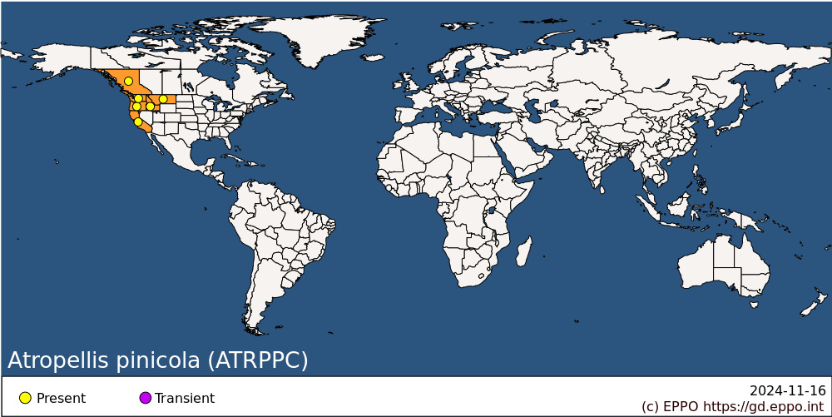 **North America:** Canada (British Columbia), United States of America (California, Idaho, Montana, Oregon, Washington)

**BIOLOGY**

The life cycle of *A. pinicola* is similar to all other *Atropellis* species (Lightle, 1973). Trees can be infected by ascospores. Ascospores are the primary source of infection and responsible for spreading the disease. They are released from the upper surface of the apothecia within a few hours of being moistened sufficiently by rain and they are primarily air-disseminated (Hopkins and Callan, 1991). The ascospores may be ejected from early spring to mid-fall, and perhaps for an even longer period in southern regions and coastal British Columbia (Hopkins and Callan, 1991). The mycelium penetrates undamaged bark or needles of susceptible hosts, gradually extending into the wood where blue-black streaks develop. The fungus causes cankers and produces stromata containing conidia and apothecia in the central sunken canker zone. Conidia are released as a creamy, sticky mass (Lightle, 1973; Lockman, 2005). Apothecial production may continue each year for the life of the canker while the spore production can continue for a year or two on standing dead trees that remain shaded (Hopkins and Callan 1991). Generally, apothecia appear within 4 years of infection and continue to form on the canker. Although relatively more cankers are found on pines in wet habitats, the greatest amount of inoculum is produced by stem cankers in dry sites. *A. pinicola* infection occurs through uninjured bark or leaf scars, or in the case of trunk cankers, at the branch bases (Sinclair and Lyon, 2005). Infection can be asymptomatic for a long time, and apothecia with ascospores can form after a period of 2–5 years on branches and stems of infected trees (Sinclair and Lyon, 2005) and it may even take 20 or more years for emergence of stem infections in particular on large healthy trees (Tainter and Baker, 1996; Lockman, 2005). Apothecia and ascospores production continue each year until a few years after death of the host although in the case of clear-cutting, ascospores formation may continue within a year, rarely up to three years on logs in heavy shaded places (Hopkins, 1963; Lockman 2005). The mycelium grows more rapidly in the xylem than the bark, but rarely invades the pith. Infections commence only in tissues which are more than 5 but less than 30 years old.

For further details see also Anon. (1963), Hopkins (1963), Sinclair and Lyon (2005), EFSA (2014, 2017).

**DETECTION AND IDENTIFICATION**

**Symptoms**

Infection can remain asymptomatic for a long time and the first visual signs of infection can appear in 2–5 years on small branches and stems of young, stressed trees or 20 and more years for stem of large, vigorous trees (Sinclair and Lyon, 2005). Newly forming cankers show no external sign of the underlying infection. Dark-brown, necrotic spots, 5 mm in diameter, occur within the bark, possibly enclosed by a single layer of wound tissue. The first typical visual symptoms and signs of *Atropellis* canker are a resin droplet on the bark surface, which further results in huge amounts of fresh resin at the margin of cankers (Lockman, 2005). Cankers generally expand each year, modifying the damaged stem in resin‐soaked and blue-stained wood. The fungus penetrates sapwood rapidly, but goes into heartwood more slowly. At canker tips, a reddish‐brown stain often develops in the sapwood between the bark and the nearest invaded (blue‐black) sapwood. Furrowing develops longitudinally on the stem and is deepest on the most vigorous trees. Bark is often cracked at the margins of cankers. Ascospores are formed in ascomata that are produced in stromata on the surface of the bark over the cankers, in the central sunken canker zone (Hopkins and Callan, 1991).

Cankers are elongated and flattened, but deep and covered with bark which is cracked; they occur particularly at the branch whorls on young branches. Multiple stem cankers may be found. The mean annual rate of canker development was estimated to be about 45 mm long and 6 mm wide (Kamp, 1994). Needles on attacked trees may become chlorotic in summer.

The disease is frequently associated with the stem rust caused by *Cronartium coleosporioides* in the Pacific north-west of the USA (EPPO/CABI, 1996).

For additional information see also Hopkins (1963), Hopkins and Callan (1991), EFSA (2014, 2017).

**Morphology**

Perennial cankers are rare and found on the main stem as smooth, elongated, narrow, flattened depressions covered with bark.

Apothecia are very small (2–4 mm in diameter), black, erumpent, sessile or with a very short central stalk, and it is composed of light-brown to dark-walled densely interwoven hyphae (Reid and Funk, 1966). Asci clavate, interspersed with hair-like paraphyses 74–178 x 8–13 µm. Ascospores non-apiculate, filiform to acicular-clavate, 1–6-celled, hyaline; 32.0–63.0 x 1.5–3.2 (average 40 x 2) µm (Reid and Funk, 1966). The fungus produces black pycnidial stromata, 1 mm across, on killed bark before emergence of apothecia (Sinclair and Lyon, 2005). The spores are non-infectious narrowly ellipsoid, rod shaped,1-celled, hyaline and measure  4–8 x 0.5–0.7 µm, which function as gametes (Sinclair and Lyon, 2005).

For further details see, Reid and Funk (1966), Synclair and Lyon (2005).

**Detection and inspection methods**

The presence of the elongated canker is the main symptom for disease identification. Massive resin flow can be seen emerging from stem cankers, as well as dark blue or black staining in sapwood under a canker, small black cup-shaped apothecia on canker margins, the vertical seams on stem because stems seem ridged and dead flagged branches occur throughout an infected tree (Dunham, 2008).

*Atropellis* spp. may be identified using a colorimetric test: a fragment of apothecia turns 5% aqueous KOH a bluish green colour (*Atropellis pinicola, A. piniphila*,and*A. tingens*). *A. apiculata* will turn the solution chocolate brown. *Atropellis*species can be differentiated from one another by the shape, size and number of cells of their hyaline ascospores (Diller, 1961). Ascospores of *A. pinicola* are filiform (please see morphology details above), longer and narrower (Lohman, 1940). There are no nucleotide sequences for *A. pinicola* in GenBank NCBI (https://www.ncbi.nlm.nih.gov/nucleotide/: accessed 10 June 2022). Currently, differentiation of *Atropellis* species is based on the morphological and cultural characteristics listed above (Diller, 1961).

Imported timber of *Pinus* from countries where the disease occurs should have had the bark removed before inspection. However, it is possible that removal of bark may be ineffective as a safeguard to prevent *Atropellis* spp. invasion, in particular if it does not eliminate superficial or deep cankers which may contain mycelium or apothecia, and so any material with canker lesions should be carefully inspected. Particular attention should be paid to the younger branches and twigs of growing material of *Pinus* consignments from countries where the disease occurs (Webster and Weber, 2007).

**PATHWAYS FOR MOVEMENT**

*A. pinicola* can spread with plants, wood, isolated bark (EFSA, 2017).

Under natural conditions, *Atropellis* canker spreads by ascospore dispersal within pine stands. Ascospores are formed in ascomata that are produced in stromata on the surface of the bark over the cankers, in the central canker zone (Hopkins and Callan, 1991). Under wet conditions, ascospores are forcibly ejected into the air and are disseminated, primarily by wind, over up to 100 m from the inoculum source (Lockman, 2005; NAPPO, 2014). Therefore, debarked wood, even though it is affected by *A. pinicola*, cannot transfer the pest by ascospores. In international trade, logs with the bark attached may contain ascospores or traces of mycelium, as may cankers on younger branches and twigs of growing material. Under artificial conditions when infected wood (without bark) was placed in contact with another piece of wood, mycelium could colonize the new piece of wood. (Hopkins, 1963). However, there is no evidence that this could happen during transportation (EFSA, 2014; Cobb and Metz, 2017). *Atropellis* canker is not known to be transmitted by *Pinus* fruit or seeds. *Atropellis* canker may also spread over long distances by movement of infected host plants for planting, cut branches, wood or isolated bark (EFSA, 2014).

**PEST SIGNIFICANCE**

**Economic impact**

*Atropellis pinicola* is an important pest on *P. contorta* on which it can cause extensive branch and stem cankers leading to malformation and consequent lowering of wood quality. It is seldom important on other pines, and generally never sufficiently severe to cause death of numerous trees.

For additional information see also Baranyay *et al.* (1973), EFSA (2014).

**Control**

Cultural methods such as thinning of overcrowded stands, use a mix of species or alternative, non-susceptible species for reforestation purposes, removal and burning of infected trees with cankers or high levels infection (Thomas and Pickel, 2010). A buffer zone (at least 100 m) between previously-infected trees and areas of regeneration or reforestation may help to prevent infection. No chemical or biological control methods have been developed (Thomas and Pickel, 2010; EFSA, 2014).

**Phytosanitary risk**

*Atropellis pinicola* is a North American fungal pine pathogen which has not yet been reported in the EPPO region. Under the current regulatory situation of the European Union (i.e. imports of *Pinus* material from North America are strictly regulated), the risk of entry of *A. pinicola* into the EU was assessed by the EFSA Panel (EFSA, 2017) as close to zero. Nevertheless, if *A. pinicola* was to be introduced to the EU (or to the EPPO region), the same or higher impacts as those observed in North America are to be expected; the main uncertainty is due to the lack of knowledge on the susceptibility of some native and exotic pines such as *P. contorta*, *P. strobus*, *P. nigra*, and *P. sylvestris*, which are important in the EPPO region (Cannon *et al*., 2016).

**PHYTOSANITARY MEASURES**

EPPO member countries are recommended to regulate *A. pinicola* as quarantine pest of Coniferae (EPPO A1 List; EPPO, 2022). Imported plant material for planting (*Pinus*), cut branches (including cut Christmas trees without roots or soil), isolated bark and round wood (except packaging wood) of *Pinus*should come from *Atropellis pinicola* free area (EPPO, 2018). Importing countries may prohibit plants, wood with bark and isolated bark of *Pinus* from North America.

For the EU countries, Annex II of Regulation (EU) 2016/2031 prescribes that for all types of wood or isolated bark originating in Canada and the USA, an official statement (phytosanitary certificate) shall certify that the consignment has undergone a heat treatment, or chemical pressure impregnation, or fumigation. If wood with bark of *Pinus* is imported from Canada and North America, the consignment must have been debarked. The introduction into the EU (and circulation within) of plants of *Pinus*, which are host plants for *Atropellis* spp., originating from non-European countries, is forbidden.

**How to cite this datasheet?**

EPPO (2024) *Atropellis pinicola*. EPPO datasheets on pests recommended for regulation. Available online. <https://gd.eppo.int>

**Datasheet history**

This datasheet was first published in the EPPO Bulletin in 1979 and revised in the two editions of 'Quarantine Pests for Europe' in 1992 and 1997, as well as in 2022. It is now maintained in an electronic format in the EPPO Global Database. The sections on 'Identity', ‘Hosts’, and 'Geographical distribution' are automatically updated from the database. For other sections, the date of last revision is indicated on the right.

CABI/EPPO (1992/1997) *Quarantine Pests for Europe* *(1st and 2nd edition).* CABI, Wallingford (GB).

EPPO (1979) Data sheets on quarantine organisms No 5: *Atropellis*spp. *EPPO Bulletin* **9**(2), 23-28.  <https://doi.org/10.1111/j.1365-2338.1979.tb02447.x>

