**EPPO Datasheet: *Atropellis piniphila***

Last updated: 2022-12-09

**IDENTITY**

|  |  |
| --- | --- |
| **Preferred name:** *Atropellis piniphila* **Authority:** (Weir) Lohmann & Cash **Taxonomic position:** Fungi: Ascomycota: Pezizomycotina: Leotiomycetes: Helotiales: Godroniaceae **Other scientific names:** *Atropellis arizonica* Lohman & Cash, *Cenangium piniphilum* Weir **Common names in English:** branch canker of pine, trunk canker of pine, twig blight of pine [view more common names online...](https://gd.eppo.int/taxon/ATRPPP/) **EPPO Categorization:** A1 list [view more categorizations online...](https://gd.eppo.int/taxon/ATRPPP/categorization) **EPPO Code:** ATRPPP | 254.jpg [more photos...](https://gd.eppo.int/taxon/ATRPPP/photos) |

**Notes on taxonomy and nomenclature**

*Atropellis piniphila* is one of four native North American species of the genus *Atropellis*. The following species have been reported on *Pinus*: *A. apiculata* Lohman *et al.*, *A. tingens* Lohman & Cash, *A. piniphila* (Weir) M.L. Lohman & E.K. Cash and *A. pinicola* Zeller & Goodding. *Atropellis treleasei* (Saccardo) Zeller & Goodding has been transferred to *Discocainia* as *D. treleasei* (Saccardo) J. Reid & Funk. The differentiation between *Atropellis* species is based on their morphological and cultural characteristics.

**HOSTS**

*Pinus contorta*(lodgepole pine) is the major host, but *A. piniphila* can also attack *P. albicaulis*(whitebark pine), *P. banksiana*(jack pine), *P. densiflora*(Japanese red pine), *P. echinata*(shortleaf pine)*, P. jeffreyi*(Jeffrey pine), *P. monticola*(western white pine), *P. nigra*(black pine), *P. ponderosa*(ponderosa pine), *P. taeda* (lobolly pine), and *P. virginiana*(Virginian pine) (Sandoval *et al*., 1979; Sinclair & Lyon, 2005).

**Host list:** *Pinus albicaulis*, *Pinus banksiana*, *Pinus contorta*, *Pinus densiflora*, *Pinus echinata*, *Pinus jeffreyi*, *Pinus monticola*, *Pinus nigra*, *Pinus ponderosa*, *Pinus taeda*, *Pinus virginiana*

**GEOGRAPHICAL DISTRIBUTION**

*Atropellis piniphila* was commonly found in North America, where it occurs from British Columbia and Saskatchewan to California and New Mexico, except central Rocky Mountain region and, occasionally in South Dakota and southeastern USA. The fungus mainly attacks branches and main stems, causing elongate cankers on stems of young trees (Sinclair and Lyon, 2005; Cerezke *et al*., 2014). No information was found in the literature and databases concerning the presence of *A. piniphila*in other continents.

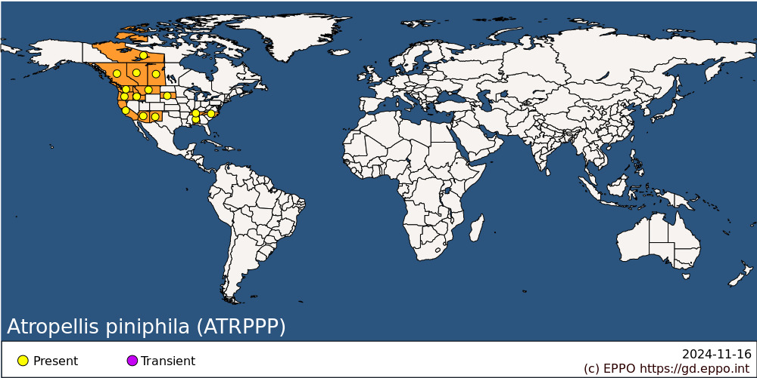 **North America:** Canada (Alberta, British Columbia, Northwest Territories, Saskatchewan), United States of America (Alabama, Arizona, California, Idaho, Montana, New Mexico, North Carolina, Oregon, South Dakota, Tennessee, Washington)

**BIOLOGY**

The life cycle of *A. piniphila* is similar to those of all *Atropellis* species (Lightle, 1973). Trees can be infected by *A. piniphila* through ascospores. Ascospores can penetrate undamaged bark or needles of susceptible hosts and start to germinate. The fungus causes cankers and produces stromata containing conidia and apothecia in the central sunken canker zone. Conidia are released as a creamy, sticky mass (Sinclair and Lyon, 2005; Lockman 2005). Apothecia may appear up to 4 years of infection and continue to form on the canker. Ascospores are dispersed by wind, mainly in summer to early autumn. Ascospores can infect stem wounds and young branches (Sinclair and Lyon, 2005).  Infection can be asymptomatic for a long time, and apothecia with ascospores can form after a period of 2–5 years on branches and stems of infected trees (Sinclair and Lyon, 2005). Latent infection can even last for a period of up to 25 years (Hiratsuka, 1987; Lockman, 2005). Apothecia and ascospores production continue each year until a few years after death of the host on logs in heavy shaded places (Hopkins, 1969; Lockman 2005).

For further details, see also Anon. (1963), Hopkins (1963), Sinclair and Lyon (2005), EFSA (2014, 2017).

**DETECTION AND IDENTIFICATION**

**Symptoms**

Infection can remain asymptomatic for a long time and the first visual signs of infection can appear in 2–5 years on small branches and stems of young, slightly and severely weakened trees, or 20 or more years in large, vigorous trees (Sinclair and Lyon, 2005). Incipient cankers show no external sign of the underlying infection. Dark-brown, necrotic spots, 5–10 mm in diameter, occur within the bark, possibly enclosed by a single layer of wound tissue. The first visual typical symptoms and signs of all *Atropellis* species canker are a resin droplet on the bark surface, and subsequently huge amounts of fresh resin at the margin of cankers (Lockman, 2005). Cankers generally expand each year, modifying the damaged wood which becomes resin‐soaked and blue-stained. The fungus penetrates sapwood rapidly but goes into heartwood more slowly. At canker tips a reddish‐brown stain often develops in the sapwood between the bark and the nearest invaded (blue‐black) sapwood. Bark is often cracked at the margins of cankers. Ascospores of *A. piniphila* are formed in ascomata that are produced in stromata on the surface of the bark over the cankers, in the central sunken canker zone (Hopkins and Callan, 1991). On *P. contorta*, the larger the diseased stem is, the longer the fruiting of *A. piniphila* takes and it may be delayed from 4–5 years on small stems to 25 years or more on large ones (Sinclair and Lyon, 2005).

Cankers caused by *A. piniphila* are elongated and flattened, but deep and covered with bark which is cracked; they occur on stem and young branches. Multiple stem cankers may be found quite often. Fast growing *A. piniphila* cankers on ponderosa pine can exceed 3 m in length and the elongation rate of cankers has been estimated at about 5 cm per year (Hopkins and Callan, 1991).

For additional information see also Boyce (1961), Anon. (1963), Hopkins (1963), Hopkins and Callan (1991), Sinclair and Lyon (2005), EFSA (2014, 2017).

**Morphology**

There is a characteristic blue-black staining of the wood beneath cankers. A red or brown discoloration is usually present in the xylem at the edge of the blue-black zone.

Apothecia of *A. piniphila* are small, 2–4 mm in diameter, cuplike, erumpent, black on the outside, with a brown interior, irregularly disc-shaped with a short central stalk, arising initially on cankers 2 and more year old and developing annually thereafter on bark stem (Sinclair and Lyon, 2005). Ascospores hyaline, fusiform, one or two cells, 16–28 x 4.7 µm. The spores are rod shaped, very thin-walled, hyaline, aseptate, cylindrical, rounded at the ends and possess a mucilaginous coat; 4–6 x 1.0–1.5 µm (Sinclair and Lyon, 2005).

For further details see Reid and Funk (1966), Sinclair and Lyon (2005).

**Detection and inspection methods**

Most stem cankers start as infections on undamaged bark in the vicinity of branch whorls (Hopkins & Callan, 1991). The presence of the elongated canker is the main symptom for disease identification. Massive resin flow can be seen emerging from stem cankers, as well as dark blue or black staining in sapwood under a canker, small black cup-shaped apothecia on canker margins, the vertical seams on stem because stems seem ridged, dead flagged branches occur throughout an infected tree (Dunham 2008). Infections are most numerous on the northern sides of stems; very few cankers develop on the southern sides of stems (Hopkins & Callan, 1991). *Atropellis* spp. may be identified using a colorimetric test: a fragment of apothecia turns 5% aqueous KOH a bluish green colour (*Atropellis pinicola, A. piniphila*,and*A. tingens*). *A. apiculata* will turn the solution chocolate brown (Lochman and Cash, 1940).

*Atropellis*species can be differentiated from one another by the shape, size and number of cells of their hyaline ascospores. Ascospores of *A. piniphila* are fusiform, one or two cells, 16–28 x 4.7 µm (see section on morphology above). There is one nucleotide sequence for an *A. piniphila*strain (isolate CBS 197.64, registration date 20 September 2019, [DOE Joint Genome Institute](http://jgi.doe.gov/)) in [GenBank](http://gd.eppo.int/(https%3A//www.ncbi.nlm.nih.gov/Taxonomy/Browser/wwwtax.cgi?mode=Info&id=2614604) ; accessed 13 June 2022). Currently, differentiation of *Atropellis* species is based on the morphological and culture characteristics listed above.

Imported timber of *Pinus* spp. from countries where the disease occurs should have had the bark removed before inspection. However, it is possible that removal of bark may be ineffective as a safeguard if it does not eliminate superficial or deep cankers which may contain mycelium and/or apothecia, and so any material with canker lesions should be carefully inspected. Particular attention should be paid to the younger branches and twigs of growing material of *Pinus* consignments from countries where the disease occurs (Webster and Weber, 2007).

**PATHWAYS FOR MOVEMENT**

*A. piniphila* spreads with plants, wood, and isolated bark (EFSA, 2017).

Under natural conditions, *Atropellis* spp. spread by ascospore dispersal within pine stands. Ascospores are formed in ascomata that are produced in stromata on the surface of the bark over the cankers, in the central canker zone (Hopkins and Callan, 1992). Under wet conditions, ascospores are forcibly ejected into the air and are disseminated, primarily by wind, over up to 100 m from the inoculum source (Allen, 1994; Lockman, 2005). Therefore, debarked wood, even though it is affected by *A. piniphila*, cannot transfer the pest by ascospores. In international trade, logs with the bark attached may contain ascospores or traces of mycelium, as may cankers on younger branches and twigs of growing material. Under artificial conditions when infected wood (without bark) was placed in contact with another piece of wood, mycelium could colonize a new piece of wood (Hopkins, 1963). However, there is no evidence that this could happen during transport (EFSA, 2014; Cobb and Metz, 2017). The canker caused by *Atropellis*spp. is not known to be transmitted by *Pinus* fruit or seeds. It may also spread over long distances by movement of infected host plants for planting, cut branches, wood or isolated bark (EFSA, 2014).

**PEST SIGNIFICANCE**

**Economic impact**

*A. piniphila* and *A. pinicola* are two species of economic importance, however *A. piniphila*is the most important pathogen among *Atropellis* spp. The fungus causes a serious resinous canker of *P. contorta*, particularly in trees 5–25 years old in overcrowded, pure stands. Trunk cankers on *P. contorta* reduce the value of trees for timber and paper pulp. On *P. ponderosa*, *A. piniphila* causes long cankers while on other pines, only a minor twig blight occurs. In addition to deformation, infected bark adheres to the underlying wood, so preventing effective debarking. Damage caused by *A. piniphila*is most common in young dense forests of *P. contorta* where the fungus can kill and deform numerous trees (Sinclair and Lyon, 2005).

**Control**

Cultural methods such as thinning of overcrowded stands, use of a mix of species or an alternative, non-susceptible species for reforestation purposes, removal and burning of infected trees with cankers or high level of infection (Thomas and Pickel, 2010). Buffer zone (at least 100 m) between previously infected trees and regeneration may help to prevent infection, but no chemical or biological control methods have been developed (Thomas and Pickel, 2010; EFSA, 2014).

**Phytosanitary risk**

*A. piniphila* is a North American fungal pine pathogen which has not yet been reported in the EPPO region. Its risk of entry (for the EU) was assessed by the EFSA Panel (EFSA, 2017) as close to zero under the current regulatory situation. Nevertheless, while *A. piniphila* may be introduced in the EU, the same or higher impacts as those observed in North America are to be expected, mainly due to the lack of knowledge on the susceptibility of some native and exotic pines such as *P. contorta*, *P. taeda*, and *P. nigra* which are important in the EPPO region (EFSA, 2017).

**PHYTOSANITARY MEASURES**

EPPO member countries are recommended to regulate *A. pinicola* as quarantine pest of Coniferae (EPPO A1 List) (EPPO, 2021). Importing countries may prohibit plants, wood with bark, and isolated bark of *Pinus* spp. from North America. For EU countries, wood or isolated bark originating in Canada and the USA, Annex II of Regulation (EU) 2016/2031 prescribes that an official statement shall certify that consignment has undergone heat treatment, or chemical pressure impregnation, or fumigation. If wood of *Pinus* spp. is imported from North America, the consignment must have been debarked or processed (EPPO, 2018). The introduction into the EU (and circulation within) of plants of *Pinus*spp., which are host plants for *Atropellis* spp., originating from non-European countries, is forbidden.

**How to cite this datasheet?**

EPPO (2024) *Atropellis piniphila*. EPPO datasheets on pests recommended for regulation. Available online. <https://gd.eppo.int>

**Datasheet history**

This datasheet was first published in the EPPO Bulletin in 1979 and revised in the two editions of 'Quarantine Pests for Europe' in 1992 and 1997, as well as in 2022. It is now maintained in an electronic format in the EPPO Global Database. The sections on 'Identity', ‘Hosts’, and 'Geographical distribution' are automatically updated from the database. For other sections, the date of last revision is indicated on the right.

CABI/EPPO (1992/1997) *Quarantine Pests for Europe* *(1st and 2nd edition).* CABI, Wallingford (GB).

EPPO (1979) Data sheets on quarantine organisms No 5: *Atropellis*spp. *EPPO Bulletin* **9**(2), 23-28. <https://doi.org/10.1111/j.1365-2338.1979.tb02447.x>

