**EPPO Datasheet: *Discosphaerina fulvida***

Last updated: 1970-01-01

**IDENTITY**

|  |  |
| --- | --- |
| **Preferred name:** *Discosphaerina fulvida* **Authority:** (Sanderson) Sivanesan **Taxonomic position:** Fungi: Ascomycota: Pezizomycotina: Dothideomycetes: Dothideomycetidae: Dothideales: Dothioraceae **Other scientific names:** *Aureobasidium lini* (Lafferty) Hermanides-Nijhof, *Aureobasidium pullulans var. lini* (Lafferty) Cooke, *Guignardia fulvida* Sanderson, *Kabatiella lini* (Lafferty) Karakulin, *Polyspora lini* Lafferty **Common names in English:** browning of flax, stem-break of flax [view more common names online...](https://gd.eppo.int/taxon/AUREPL/) **EPPO Code:** AUREPL |  |

**GEOGRAPHICAL DISTRIBUTION**

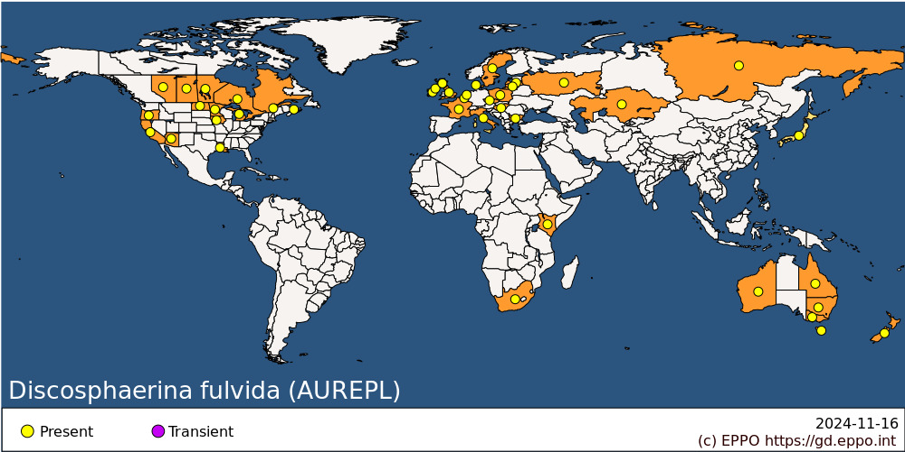 **EPPO Region:** Belgium, Bulgaria, Czech Republic, Denmark, France (mainland), Hungary, Ireland, Italy (mainland), Kazakhstan, Latvia, Lithuania, Netherlands, Poland, Russia (Central Russia, Eastern Siberia), Sweden, United Kingdom (England, Northern Ireland, Scotland) **Africa:** Kenya, South Africa **Asia:** Japan, Kazakhstan **North America:** Canada (Alberta, Manitoba, Ontario, Prince Edward Island, Québec, Saskatchewan), United States of America (Arizona, California, Iowa, Louisiana, Michigan, Minnesota, North Dakota, Oregon) **Oceania:** Australia (New South Wales, Queensland, Tasmania, Victoria, Western Australia), New Zealand

**How to cite this datasheet?**

EPPO (2024) *Discosphaerina fulvida*. EPPO datasheets on pests recommended for regulation. Available online. <https://gd.eppo.int>