**EPPO Datasheet: *Balansia oryzae***

Last updated: 1970-01-01

**IDENTITY**

|  |  |
| --- | --- |
| **Preferred name:** *Balansia oryzae* **Authority:** (Sydow) Narasimhan & Thirumalachar **Taxonomic position:** Fungi: Ascomycota: Pezizomycotina: Sordariomycetes: Hypocreomycetidae: Hypocreales: Clavicipitaceae **Other scientific names:** *Balansia oryzae-sativae* Hashioka, *Ephelis oryzae* Sydow **Common names in English:** black choke of rice, false ergot, incense rod, udbatta disease of rice [view more common names online...](https://gd.eppo.int/taxon/BALAOS/) **EPPO Code:** BALAOS |  |

**GEOGRAPHICAL DISTRIBUTION**

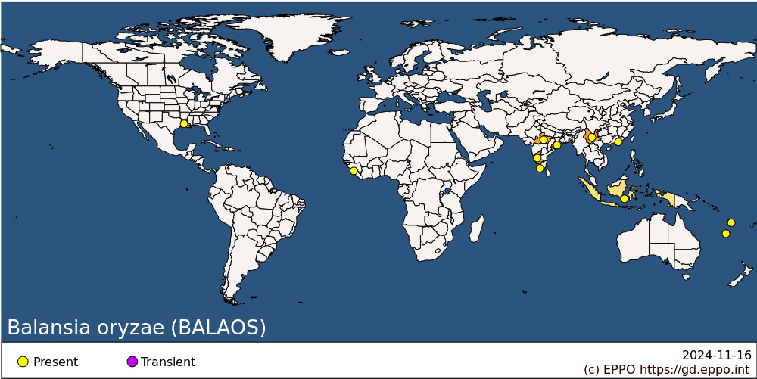 **Africa:** Sierra Leone **Asia:** China (Xianggang (Hong Kong), Yunnan), India (Karnataka, Kerala, Madhya Pradesh, Odisha), Indonesia **North America:** United States of America (Louisiana) **Oceania:** New Caledonia, Vanuatu

**How to cite this datasheet?**

EPPO (2024) *Balansia oryzae*. EPPO datasheets on pests recommended for regulation. Available online. <https://gd.eppo.int>