**EPPO Datasheet: *Ciborinia allii***

Last updated: 1970-01-01

**IDENTITY**

|  |  |
| --- | --- |
| **Preferred name:** *Ciborinia allii* **Authority:** (Sawada) L.M. Kohn **Taxonomic position:** Fungi: Ascomycota: Pezizomycotina: Leotiomycetes: Helotiales: Sclerotiniaceae **Other scientific names:** *Botryotinia allii* (Sawada) Yamamoto, *Botrytis byssoidea* J.C.Walker, *Sclerotinia allii* Sawada **Common names in English:** mycelial neck rot of onion, sclerotinia disease of Welsh onion [view more common names online...](https://gd.eppo.int/taxon/BOTRBY/) **EPPO Code:** BOTRBY |  |

**GEOGRAPHICAL DISTRIBUTION**

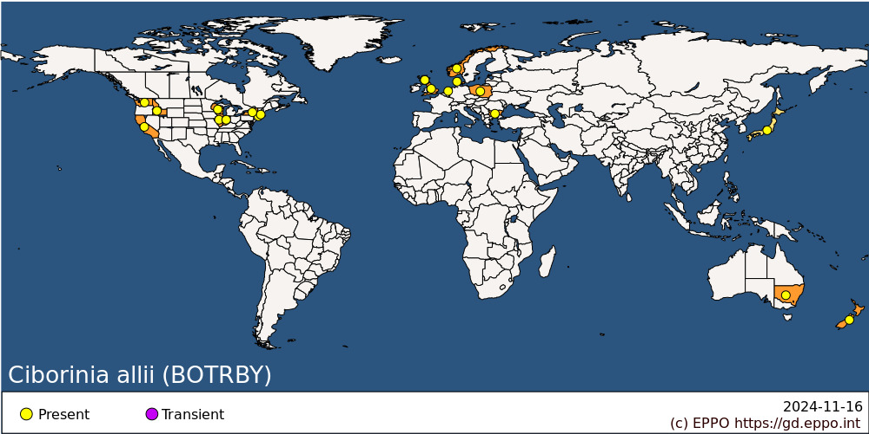 **EPPO Region:** Bulgaria, Denmark, Netherlands, Norway, Poland, United Kingdom (England, Scotland) **Asia:** Japan **North America:** United States of America (California, Connecticut, Idaho, Illinois, Indiana, Massachusetts, New York, Washington, Wisconsin) **Oceania:** Australia (New South Wales), New Zealand

**How to cite this datasheet?**

EPPO (2024) *Ciborinia allii*. EPPO datasheets on pests recommended for regulation. Available online. <https://gd.eppo.int>