**EPPO Datasheet: *Bremia lactucae***

Last updated: 1970-01-01

**IDENTITY**

|  |  |
| --- | --- |
| **Preferred name:** *Bremia lactucae* **Authority:** Regel **Taxonomic position:** Chromista: Oomycota: Oomycetes: Peronosporales: Peronosporaceae **Other scientific names:** *Peronospora gangliformis* de Bary **Common names in English:** downy mildew of lettuce [view more common names online...](https://gd.eppo.int/taxon/BREMLA/) **EPPO Code:** BREMLA |  |

**GEOGRAPHICAL DISTRIBUTION**

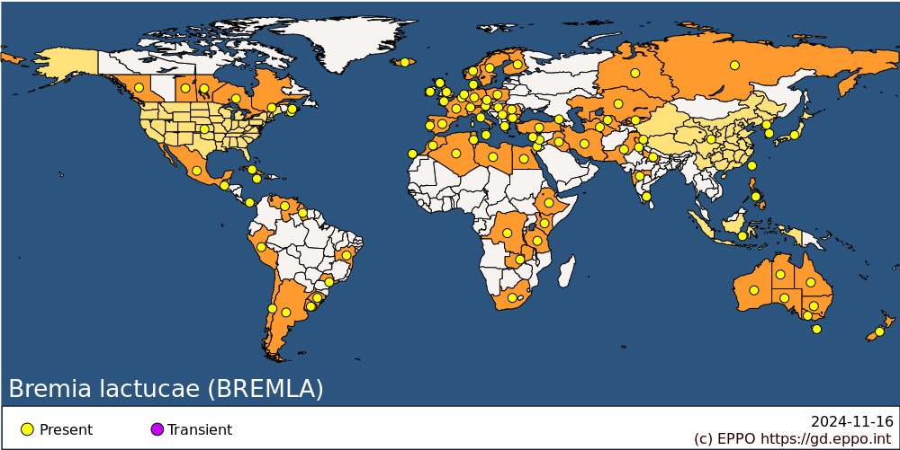 **EPPO Region:** Algeria, Austria, Belgium, Bulgaria, Cyprus, Czech Republic, Denmark, Finland, France (mainland), Georgia, Germany, Greece (mainland), Hungary, Ireland, Israel, Italy (mainland), Kazakhstan, Kyrgyzstan, Malta, Morocco, Netherlands, Norway, Poland, Portugal (mainland), Romania, Russia (Eastern Siberia, European Russia, Western Siberia), Serbia, Spain (mainland, Islas Canárias), Sweden, Switzerland, Tunisia, Türkiye, United Kingdom (Channel Islands, England, Scotland), Uzbekistan **Africa:** Algeria, Congo, Democratic republic of the, Egypt, Ethiopia, Kenya, Libya, Morocco, South Africa, Tanzania, Tunisia, Zambia **Asia:** China, India (Jammu & Kashmir, Maharashtra, Punjab, Tamil Nadu, Uttar Pradesh), Indonesia, Iran, Iraq, Israel, Japan, Kazakhstan, Korea Dem. People's Republic, Korea, Republic, Kyrgyzstan, Lebanon, Pakistan, Philippines, Taiwan, Turkmenistan, Uzbekistan **North America:** Canada (British Columbia, Manitoba, Nova Scotia, Ontario, Prince Edward Island, Québec, Saskatchewan), Mexico, United States of America **Central America and Caribbean:** Cuba, Guatemala, Jamaica, Panama **South America:** Argentina, Brazil (Bahia, Rio Grande do Sul, Sao Paulo), Chile, Guyana, Peru, Uruguay, Venezuela **Oceania:** Australia (New South Wales, Northern Territory, Queensland, South Australia, Tasmania, Victoria, Western Australia), New Zealand

**How to cite this datasheet?**

EPPO (2024) *Bremia lactucae*. EPPO datasheets on pests recommended for regulation. Available online. <https://gd.eppo.int>