**EPPO Datasheet: *Albonectria rigidiuscula***

Last updated: 1970-01-01

**IDENTITY**

|  |  |
| --- | --- |
| **Preferred name:** *Albonectria rigidiuscula* **Authority:** (Berkeley & Broome) Rossmann & Samuels **Taxonomic position:** Fungi: Ascomycota: Pezizomycotina: Sordariomycetes: Hypocreomycetidae: Hypocreales: Nectriaceae **Other scientific names:** *Calonectria rigidiuscula* (Berkeley & Broome) Saccardo, *Fusarium colorans* (De Jonge) Appel & Wollenweber, *Fusarium decemcellulare* Brick, *Fusarium rigidiusculum* W.C. Snyder & H.N. Hansen, *Fusarium spicaria-colorantis* Saccardo & Trott, *Nectria rigidiuscula* Berkeley & Broome, *Spicaria colorans* de Jonge **Common names in English:** canker of cocoa, cushion gall of cocoa, dieback of cocoa [view more common names online...](https://gd.eppo.int/taxon/CALORI/) **EPPO Code:** CALORI |  |

**GEOGRAPHICAL DISTRIBUTION**

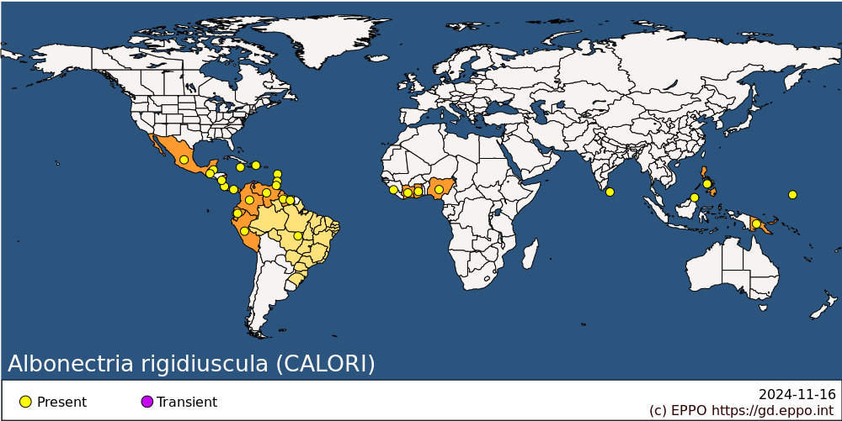 **Africa:** Cote d'Ivoire, Ghana, Nigeria, Sierra Leone **Asia:** Malaysia (Sabah), Philippines, Sri Lanka **North America:** Mexico **Central America and Caribbean:** Belize, Costa Rica, Dominica, Dominican Republic, Grenada, Guatemala, Jamaica, Nicaragua, Panama, Trinidad and Tobago **South America:** Brazil, Colombia, Ecuador, Guyana, Peru, Suriname, Venezuela **Oceania:** Micronesia, Papua New Guinea

**How to cite this datasheet?**

EPPO (2024) *Albonectria rigidiuscula*. EPPO datasheets on pests recommended for regulation. Available online. <https://gd.eppo.int>