**EPPO Datasheet: *Ceratocystis fimbriata***

Last updated: 1970-01-01

**IDENTITY**

|  |  |
| --- | --- |
| **Preferred name:** *Ceratocystis fimbriata* **Authority:** Ellis & Halsted **Taxonomic position:** Fungi: Ascomycota: Pezizomycotina: Sordariomycetes: Hypocreomycetidae: Microascales: Ceratocystidaceae **Other scientific names:** *Ceratostomella fimbriata* (Ellis & Halsted) Elliott, *Endoconidiophora fimbriata* (Ellis & Halsted) R.W.Davidson, *Ophiostoma fimbriatum* (Ellis & Halsted) Nannfeldt **Common names in English:** black rot of sweet potato, blight of mango, canker of coffee, mouldy rot of rubber [view more common names online...](https://gd.eppo.int/taxon/CERAFI/) **EPPO Code:** CERAFI |  |

**GEOGRAPHICAL DISTRIBUTION**

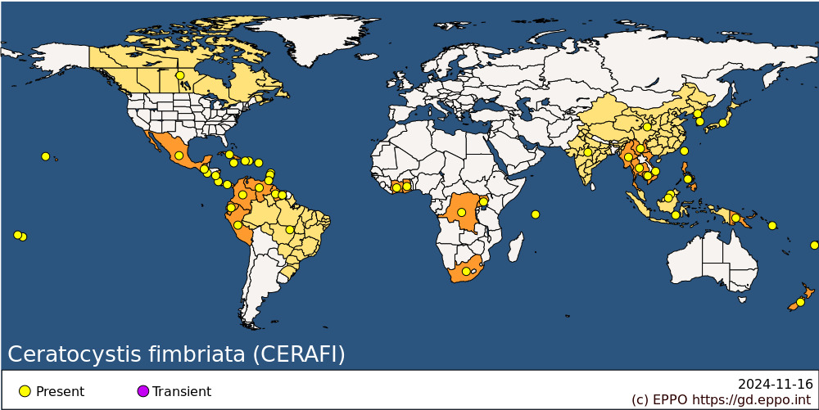 **Africa:** Congo, Democratic republic of the, Cote d'Ivoire, Ghana, Seychelles, South Africa, Uganda **Asia:** Brunei Darussalam, Cambodia, China (Yunnan), India, Indonesia, Japan, Korea Dem. People's Republic, Korea, Republic, Malaysia, Myanmar, Philippines, Taiwan, Thailand, Vietnam **North America:** Canada, Mexico, United States of America (Hawaii) **Central America and Caribbean:** Costa Rica, Cuba, Dominican Republic, El Salvador, Grenada, Guatemala, Haiti, Jamaica, Nicaragua, Panama, Puerto Rico, Saint Lucia, St Vincent and the Grenadines, Trinidad and Tobago **South America:** Brazil, Colombia, Ecuador, Guyana, Peru, Suriname, Venezuela **Oceania:** American Samoa, Fiji, New Zealand, Papua New Guinea, Samoa, Solomon Islands

**How to cite this datasheet?**

EPPO (2024) *Ceratocystis fimbriata*. EPPO datasheets on pests recommended for regulation. Available online. <https://gd.eppo.int>