**EPPO Datasheet: *Ophiostoma piceae***

Last updated: 1970-01-01

**IDENTITY**

|  |  |
| --- | --- |
| **Preferred name:** *Ophiostoma piceae* **Authority:** (Münch) Sydow & P.Sydow **Taxonomic position:** Fungi: Ascomycota: Pezizomycotina: Sordariomycetes: Sordariomycetidae: Ophiostomatales: Ophiostomataceae **Other scientific names:** *Ceratocystis piceae* (Münch) Bakshi, *Pesotum piceae* Crane & Schoknecht **Common names in English:** vascular mycosis of oak, wood decay of spruce [view more common names online...](https://gd.eppo.int/taxon/CERAPC/) **EPPO Categorization:** A1/A2 (formerly) [view more categorizations online...](https://gd.eppo.int/taxon/CERAPC/categorization) **EPPO Code:** CERAPC |  |

**GEOGRAPHICAL DISTRIBUTION**

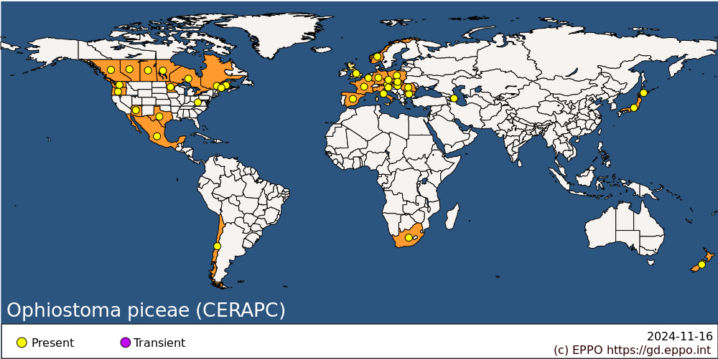 **EPPO Region:** Austria, Azerbaijan, Belgium, Bulgaria, Czech Republic, France (mainland), Germany, Hungary, Italy (mainland), Norway, Poland, Romania, Russia (European Russia), Slovakia, Slovenia, Spain (mainland), United Kingdom **Africa:** South Africa **Asia:** Japan (Hokkaido, Honshu) **North America:** Canada (Alberta, British Columbia, Manitoba, New Brunswick, Ontario, Québec, Saskatchewan), Mexico, United States of America (Arizona, Maine, Minnesota, Oregon, Texas, Washington, West Virginia) **South America:** Chile **Oceania:** New Zealand

**How to cite this datasheet?**

EPPO (2024) *Ophiostoma piceae*. EPPO datasheets on pests recommended for regulation. Available online. <https://gd.eppo.int>