**EPPO Datasheet: *Ophiostoma ulmi***

Last updated: 1970-01-01

**IDENTITY**

|  |  |
| --- | --- |
| **Preferred name:** *Ophiostoma ulmi* **Authority:** (Buisman) Nannfeldt **Taxonomic position:** Fungi: Ascomycota: Pezizomycotina: Sordariomycetes: Sordariomycetidae: Ophiostomatales: Ophiostomataceae **Other scientific names:** *Ceratocystis ulmi* (Buisman) C.Moreau, *Ceratostomella ulmi* Buisman, *Graphium ulmi* M.B.Schwartz, *Pesotum ulmi* (Schwarz) Crane & Schoknecht **Common names in English:** Dutch elm disease [view more common names online...](https://gd.eppo.int/taxon/CERAUL/) **EPPO Categorization:** A1/A2 (formerly) [view more categorizations online...](https://gd.eppo.int/taxon/CERAUL/categorization) **EPPO Code:** CERAUL | 2935.jpg [more photos...](https://gd.eppo.int/taxon/CERAUL/photos) |

**GEOGRAPHICAL DISTRIBUTION**

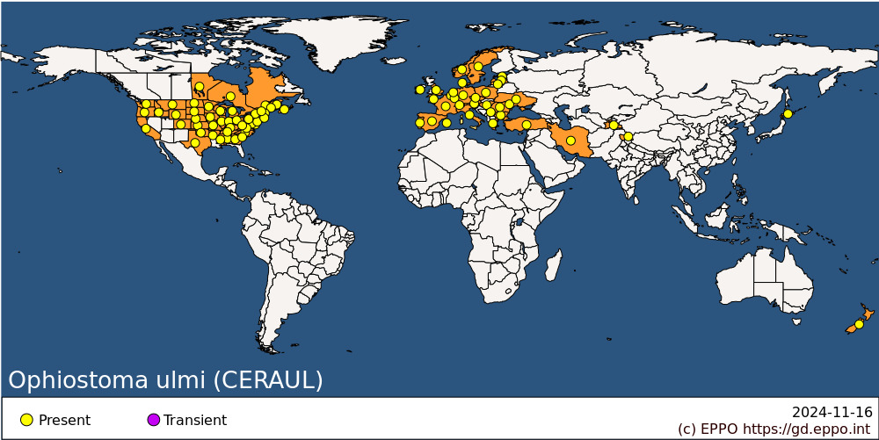 **EPPO Region:** Austria, Belgium, Bulgaria, Czech Republic, Denmark, Estonia, France (mainland), Germany, Greece (mainland), Hungary, Ireland, Italy (mainland), Latvia, Lithuania, Luxembourg, Moldova, Netherlands, Norway, Poland, Portugal (mainland), Romania, Russia (European Russia), Serbia, Spain (mainland, Islas Baleares), Sweden, Switzerland, Türkiye, Ukraine, United Kingdom (Channel Islands, England) **Asia:** India (Jammu & Kashmir), Iran, Japan (Hokkaido), Tajikistan **North America:** Canada (Manitoba, New Brunswick, Nova Scotia, Ontario, Québec), United States of America (Alabama, Arkansas, California, Colorado, Connecticut, Delaware, Georgia, Idaho, Illinois, Indiana, Iowa, Kansas, Kentucky, Maine, Maryland, Massachusetts, Michigan, Minnesota, Mississippi, Missouri, Montana, Nebraska, New Hampshire, New Jersey, New York, North Carolina, North Dakota, Ohio, Oklahoma, Oregon, Pennsylvania, Rhode Island, South Carolina, South Dakota, Tennessee, Texas, Vermont, Virginia, Washington, West Virginia, Wisconsin, Wyoming) **Oceania:** New Zealand

**How to cite this datasheet?**

EPPO (2024) *Ophiostoma ulmi*. EPPO datasheets on pests recommended for regulation. Available online. <https://gd.eppo.int>