**EPPO Datasheet: *Davidsoniella virescens***

Last updated: 2017-08-08

**IDENTITY**

|  |  |
| --- | --- |
| **Preferred name:** *Davidsoniella virescens* **Authority:** (R.W. Davidson) Z.W. de Beer, T.A. Duong & M.J. Wingfield **Taxonomic position:** Fungi: Ascomycota: Pezizomycotina: Sordariomycetes: Hypocreomycetidae: Microascales: Ceratocystidaceae **Other scientific names:** *Ceratocystis virescens* (Davidson) Moreau, *Endoconidiophora virescens* Davidson, *Ophiostoma virescens* (R.W. Davidson) Arx **Common names in English:** sapstreak disease of maple [view more common names online...](https://gd.eppo.int/taxon/CERAVI/) **EU Categorization:** A1 Quarantine pest (Annex II A) [view more categorizations online...](https://gd.eppo.int/taxon/CERAVI/categorization) **EPPO Code:** CERAVI | 354.jpg [more photos...](https://gd.eppo.int/taxon/CERAVI/photos) |

**HOSTS**

As a pathogen, the fungus is found on *Acer saccharum*. There is a single record from *Liriodendron tulipifera*. It has also been found as a saprophyte on logs of a number of other woody species. *Acer* spp. (*A. campestris*, *A. platanoides* and *A. pseudoplatanus*) are quite widespread in natural vegetation in the EPPO region, but without a very significant amenity value. Various ornamental forms of the first two species are widely planted, together with numerous introduced ornamental species and hybrids.

**Host list:** *Acer saccharum*, *Liriodendron tulipifera*

**GEOGRAPHICAL DISTRIBUTION**

*C. virescens* is indigenous to North America and has not spread to other areas.

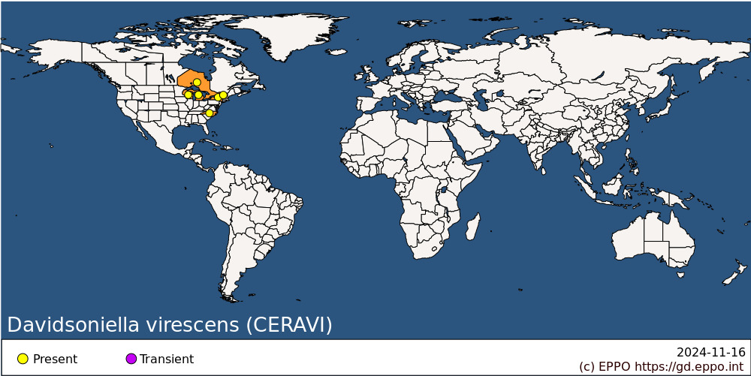 **North America:** Canada (Ontario), United States of America (Michigan, New York, North Carolina, Vermont, Wisconsin)

**BIOLOGY**

The biology of the fungus is not fully understood. According to Mielke & Charette (1989), wounds appear to be a precondition for infection and it is thought that wounds at or near ground level are the most important. This may mean that ground-traversing insects act as vectors or that environmental conditions near the ground are favourable for infection. Ascospores and conidia produced on the mycelium seem likely to form the inoculum.

**DETECTION AND IDENTIFICATION**

**Symptoms**

The principal external symptoms are the yellowing and dwarfing of leaves on one or more major branches. This leads to local dieback. The entire tree dies within 2-4 years. If an affected tree is cut down, it will be found that, at the base, most of the cross-section is occupied by a zone of yellow-green water-soaked wood. This is most pronounced at the centre of the tree and radiates outwards to give a more or less star-shaped pattern. At the margins blackish-green flecks can be found. If a diseased tree is cut down, a dark-grey mat of the fungus may form on the cut surface within a few days. Endoconidiophores will be present and perithecia may form.

**Morphology**

Xylem chips taken from the stained wood should yield the fungus in culture. A full description can be found in Davidson (1944). There are two types of endoconidia ­microconidia which are hyaline, cylindrical and variable in length (6-25 x 2-3 µm) and short barrel-shaped endoconidia which are 5-9 x 5-6.5 µm. Growth on malt agar is rapid. The mycelium is coarse, dark greenish-grey, with a musty penetrating odour.

**Detection and inspection methods**

The stain in affected wood is a conspicuous yellow-green when fresh but changes quickly on drying to light-brown (Houston, 1986) and may thus be difficult to detect on wood cut from diseased trees.

**PATHWAYS FOR MOVEMENT**

Apart from possible local spread on insects, the most likely means of disease dissemination is on wood cut from diseased trees. Houston (1986) reported briefly on a study in which diseased trees were felled in October 1984 and then cut into boards and sticker-piled. *C. virescens* sporulated next to stain streaks on some boards and the fungus was still being isolated from surface myceliumafter 2 months and from stained wood after 5 months.

**PEST SIGNIFICANCE**

**Economic impact**

In North America, damage is on a small scale at present. The disease is principally found in "sugar bushes", i.e. stands of Acer saccharum being tapped for maple sap. However, Kessler (1978) described it as a serious threatto A. saccharum forest. Infected trees do not recoverand timber salvage value is low because of the discoloration of the wood.

**Control**

No control measures are practised.

**Phytosanitary risk**

C. virescens has not been considered to be a quarantine pest by EPPO or any other regional plant protection organization. Other Ceratocystis and Ophiostomaspecies cause serious diseases of forest trees (e.g. C. fagacearum, EPPO/CABI, 1996). There is not apparently any direct evidence that C. virescens is able to attack Acer spp. other than A. saccharum, which is in itself of negligible importance for the EPPO region. European Acer spp. may conceivably face a risk, lackingadaptation to a Ceratocystis disease, but the relative unimportance of the disease in North America and the lack of any records on other Acer spp. make this very hypothetical. In any case, the species is very close to, and thought by many to be synonymous with, C. coerulescens, a fungus which is widespread in the EPPO region as a harmless saprophyte.

**PHYTOSANITARY MEASURES**

Kiln-drying is a method recommended for treating wood against certain quarantine pests, including *C. fagacearum*, and may be effective against *C. virescens*, though there is no direct information on this.

**How to cite this datasheet?**

EPPO (2024) *Davidsoniella virescens*. EPPO datasheets on pests recommended for regulation. Available online. <https://gd.eppo.int>