**EPPO Datasheet: *Pseudocercospora angolensis***

Last updated: 2017-08-08

**IDENTITY**

|  |  |
| --- | --- |
| **Preferred name:** *Pseudocercospora angolensis* **Authority:** (Carvalho & Mendes) Crous & Braun **Taxonomic position:** Fungi: Ascomycota: Pezizomycotina: Dothideomycetes: Dothideomycetidae: Mycosphaerellales: Mycosphaerellaceae **Other scientific names:** *Cercospora angolensis* Carvalho & Mendes, *Phaeoramularia angolensis* (Carvalho & Mendes) P.M.Kirk, *Pseudophaeoramularia angolensis* (Carvalho & Mendes) Braun **Common names in English:** fruit spot of citrus, leaf spot of citrus [view more common names online...](https://gd.eppo.int/taxon/CERCAN/) **EPPO Categorization:** A1 list **EU Categorization:** A1 Quarantine pest (Annex II A) [view more categorizations online...](https://gd.eppo.int/taxon/CERCAN/categorization) **EPPO Code:** CERCAN | 10703.jpg [more photos...](https://gd.eppo.int/taxon/CERCAN/photos) |

**HOSTS**

Apparently restricted to species of *Citrus*, including grapefruits (*C. paradisi*), limes (*C. aurantifolia*), mandarins (*C. reticulata*), oranges (*C. sinensis*), rangpur limes (*C. limonia*), rough lemons (*C. jambhiri*) and sour oranges (*C. aurantium*).

**Host list:** *Citrus reticulata*, *Citrus x aurantiifolia*, *Citrus x aurantium var. paradisi*, *Citrus x aurantium var. sinensis*, *Citrus x aurantium*, *Citrus x limonia var. jambhiri*, *Citrus x limonia*, *Citrus*

**GEOGRAPHICAL DISTRIBUTION**

Said to have spread from Angola and Mozambique (where it was first described in the 1950s) to countries further north (Whiteside *et al*., 1988), but the spread does not appear to be clearly documented.

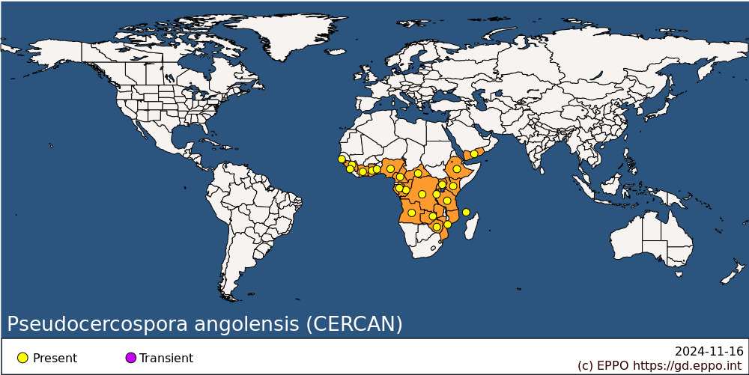 **Africa:** Angola, Burundi, Cameroon, Central African Republic, Comoros, Congo, Congo, Democratic republic of the, Cote d'Ivoire, Ethiopia, Gabon, Gambia, Ghana, Guinea, Kenya, Mozambique, Nigeria, Rwanda, Sierra Leone, Tanzania, Togo, Uganda, Zambia, Zimbabwe **Asia:** Yemen

**BIOLOGY**

Infection of the leaves and fruit is most likely by conidia although the mechanism involved is unknown. The fungus is only known from its anamorph. If the teleomorph exists, it is likely to belong to the Dothideales, possibly a species of *Mycosphaerella*.

**DETECTION AND IDENTIFICATION**

**Symptoms**

Leaf symptoms initially appear as greenish-yellow patches. At maturity the leaf spots are amphigenous, mainly hypophyllous, 4-10 mm or more in diameter, pale-brown to brown, blackish-brown when sporulation is dense, surrounded by a dark-brown margin and a yellow halo, the centre often becoming detached resulting in a shot-hole spot. Generalized foliar necrosis, caused by coalescence of several lesions, can result in defoliation. During wet weather the lesions sporulate and become black.

On young fruits, brown necrotic lesions form. These are usually circular, slightly sunken, with a surrounding ring of raised epicarp, giving the fruit a blistered appearance. During wet weather, the lesions sporulate and become black. In young fruits, a generalized necrosis sometimes forms, resulting in premature abscission of the fruit.

Fruits and leaves are much more susceptible than stems, on which symptoms are rare. When infection of stems occurs, the lesions are dark-brown and usually occur as extensions of petiole lesions. They may coalesce resulting in stem die-back or the formation of corky internodal regions.

**Morphology**

Conidiophores macronematous, mononematous and fasciculate or forming loose synnemata 12-45 µm wide, arising from a usually large stroma (30-60 µm in diameter), simple, septate, smooth, pale-brown to brown, (60-) 120-240 µm high, 4.5-7 µm wide. Conidiogenous cells integrated, terminal, sympodial, slightly geniculate, cicatrized. Conidia acrogenous, becoming acropleurogenous, solitary or catenate, borne in simple or branched chains of 2-4 conidia, cylindrical to narrowly obclavate, rounded at the apex, truncate at the base, straight or slightly flexuous to more or less curved, smooth, hyaline to very pale-brown, (1)-3-4(-6)-septate, 24-79 µm long, 4-5 (-6.5) µm wide at the base, the basal and, when present, the apical scar slightly thickened and pigmented. For more information, see Carvalho & Mendes (1953) and Kirk (1986).

**PATHWAYS FOR MOVEMENT**

Under natural conditions, *P. angolensis* probably spreads by air-borne conidia, although the possibility of transfer by insects cannot be discounted. Internationally, transfer on the leaves of planting material or on fruits seems the most likely pathway.

**PEST SIGNIFICANCE**

**Economic impact**

Infected fruits are unsaleable. Severe infection of trees can result in defoliation through fall of young leaves. The disease is supposed to be most serious at altitudes over 600 m.

**Control**

Copper fungicide sprays have been used (Brun, 1972).

**Phytosanitary risk**

P. angolensis has not been listed as a quarantine pest by EPPO or any other regional plant protection organization. While there is a possibility that it might damage citrus in the EPPO region, it has attracted rather limited attention in the literature, without any reference to control methods, so that its real importance is doubtful. Its distribution points to a preference for warm and humid conditions, which implies at least superficially that it would not be well adapted to the Mediterranean climate. Among related fungi, Mycosphaerella spp. (e.g. M. citri Whiteside or M. horii Hara) seem as good or better candidates for A1 quarantine pest status.

**PHYTOSANITARY MEASURES**

The highly restrictive measures already taken by most citrus-growing countries in the EPPO region for the import of plants of citrus from outside the region would certainly also protect against the introduction of *P. angolensis*. Restrictions on the import of citrus fruits from countries where *P. angolensis* occurs would protect against possible introduction by that pathway.

**How to cite this datasheet?**

EPPO (2024) *Pseudocercospora angolensis*. EPPO datasheets on pests recommended for regulation. Available online. <https://gd.eppo.int>