**EPPO Datasheet: *Passalora manihotis***

Last updated: 1970-01-01

**IDENTITY**

|  |  |
| --- | --- |
| **Preferred name:** *Passalora manihotis* **Authority:** (Stevens & Solheim) Braun & Crous **Taxonomic position:** Fungi: Ascomycota: Pezizomycotina: Dothideomycetes: Dothideomycetidae: Mycosphaerellales: Mycosphaerellaceae **Other scientific names:** *Cercospora caribaea* Ciferri, *Phaeoramularia manihotis* (Stevens & Solheim) Ellis **Common names in English:** white leaf spot of cassava [view more common names online...](https://gd.eppo.int/taxon/CERCCB/) **EPPO Code:** CERCCB |  |

**GEOGRAPHICAL DISTRIBUTION**

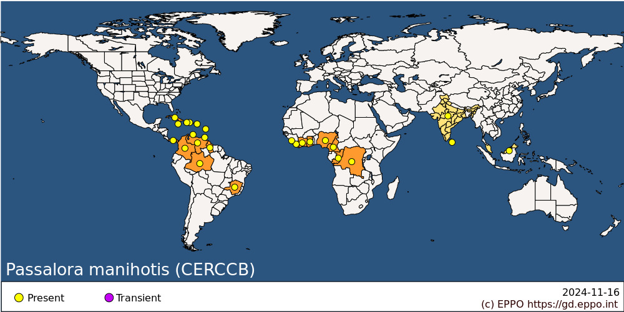 **Africa:** Cameroon, Congo, Congo, Democratic republic of the, Cote d'Ivoire, Ghana, Liberia, Nigeria, Sierra Leone **Asia:** India, Malaysia, Sri Lanka **Central America and Caribbean:** Cuba, Dominica, Dominican Republic, Haiti, Jamaica, Netherlands Antilles, Panama, Puerto Rico, Trinidad and Tobago **South America:** Brazil (Amazonas, Minas Gerais), Colombia, Guyana, Venezuela

**How to cite this datasheet?**

EPPO (2024) *Passalora manihotis*. EPPO datasheets on pests recommended for regulation. Available online. <https://gd.eppo.int>