**EPPO Datasheet: *Uwemyces elaeidis***

Last updated: 1970-01-01

**IDENTITY**

|  |  |
| --- | --- |
| **Preferred name:** *Uwemyces elaeidis* **Authority:** (Steyaert) M. Hernandez-Restrepo, G.A. Sarria & Crous **Taxonomic position:** Fungi: Ascomycota: Pezizomycotina: Dothideomycetes: Dothideomycetidae: Mycosphaerellales: Mycosphaerellaceae **Other scientific names:** *Cercospora elaeidis* Steyaert **Common names in English:** freckle of oil palm, leaf spot of oil palm [view more common names online...](https://gd.eppo.int/taxon/CERCEL/) **EPPO Code:** CERCEL |  |

**GEOGRAPHICAL DISTRIBUTION**

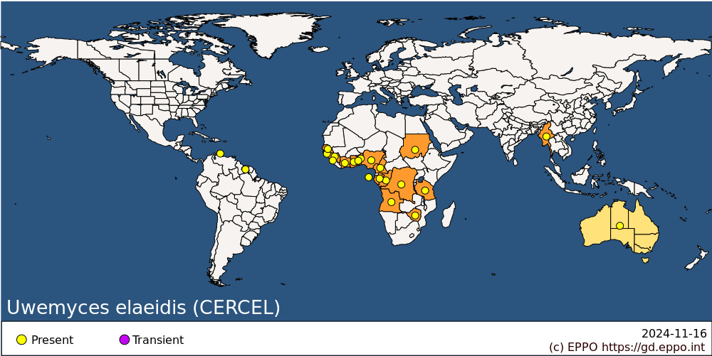 **Africa:** Angola, Benin, Cameroon, Congo, Congo, Democratic republic of the, Cote d'Ivoire, Gabon, Ghana, Guinea, Guinea-Bissau, Nigeria, Sao Tome & Principe, Senegal, Sierra Leone, Sudan, Tanzania, Togo, Zimbabwe **Asia:** Myanmar **Central America and Caribbean:** Netherlands Antilles **South America:** Suriname **Oceania:** Australia

**How to cite this datasheet?**

EPPO (2024) *Uwemyces elaeidis*. EPPO datasheets on pests recommended for regulation. Available online. <https://gd.eppo.int>