**EPPO Datasheet: *Pseudocercospora fuligena***

Last updated: 1970-01-01

**IDENTITY**

|  |  |
| --- | --- |
| **Preferred name:** *Pseudocercospora fuligena* **Authority:** (Roldan) Deighton **Taxonomic position:** Fungi: Ascomycota: Pezizomycotina: Dothideomycetes: Dothideomycetidae: Mycosphaerellales: Mycosphaerellaceae **Other scientific names:** *Cercospora fuligena* Roldan **Common names in English:** cercospora leaf mould of tomato, leaf mould of tomato, leaf spot of tomato [view more common names online...](https://gd.eppo.int/taxon/CERCFU/) **EPPO Code:** CERCFU |  |

**GEOGRAPHICAL DISTRIBUTION**

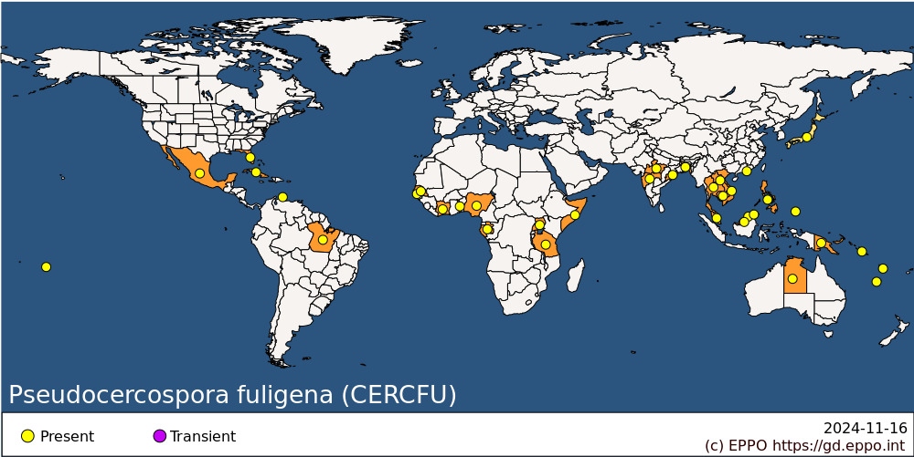 **Africa:** Cote d'Ivoire, Gabon, Gambia, Nigeria, Senegal, Somalia, Tanzania, Togo, Uganda **Asia:** Bangladesh, Brunei Darussalam, Cambodia, China (Xianggang (Hong Kong)), India (Madhya Pradesh, Maharashtra, Odisha), Japan, Laos, Malaysia (Sabah, Sarawak, West), Philippines, Thailand, Vietnam **North America:** Mexico, United States of America (Florida) **Central America and Caribbean:** Cuba, Netherlands Antilles **South America:** Brazil (Para) **Oceania:** Australia (Northern Territory), Cook Islands, New Caledonia, Palau, Papua New Guinea, Solomon Islands, Vanuatu

**How to cite this datasheet?**

EPPO (2024) *Pseudocercospora fuligena*. EPPO datasheets on pests recommended for regulation. Available online. <https://gd.eppo.int>