**EPPO Datasheet: *Cercospora kikuchii***

Last updated: 1970-01-01

**IDENTITY**

|  |  |
| --- | --- |
| **Preferred name:** *Cercospora kikuchii* **Authority:** (Matsumoto & Tomoyasu) Gardner **Taxonomic position:** Fungi: Ascomycota: Pezizomycotina: Dothideomycetes: Dothideomycetidae: Mycosphaerellales: Mycosphaerellaceae **Other scientific names:** *Cercosporina kikuchii* Matsumoto & Tomoyasu **Common names in English:** purple blotch of soybean, purple seed stain of soybean, purple speck of soybean [view more common names online...](https://gd.eppo.int/taxon/CERCKI/) **EPPO Code:** CERCKI |  |

**GEOGRAPHICAL DISTRIBUTION**

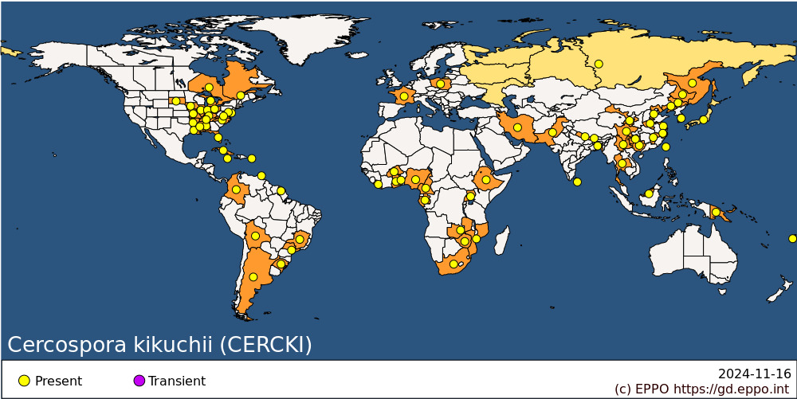 **EPPO Region:** France (mainland), Poland, Russia (Far East) **Africa:** Burkina Faso, Cameroon, Ethiopia, Gabon, Ghana, Liberia, Mozambique, Nigeria, South Africa, Togo, Uganda, Zambia, Zimbabwe **Asia:** Bangladesh, China (Gansu, Guangxi, Guizhou, Hebei, Heilongjiang, Henan, Jiangsu, Jiangxi, Jilin, Liaoning, Sichuan, Yunnan, Zhejiang), India (Sikkim), Iran, Japan, Korea, Republic, Malaysia (Sarawak), Nepal, Pakistan, Sri Lanka, Taiwan, Thailand **North America:** Canada (Ontario, Québec), United States of America (Alabama, Arkansas, Delaware, Florida, Illinois, Indiana, Iowa, Kentucky, Louisiana, Maryland, Michigan, Mississippi, Missouri, North Carolina, Ohio, South Dakota, Tennessee, Virginia) **Central America and Caribbean:** Cuba, Jamaica, Puerto Rico, Trinidad and Tobago **South America:** Argentina, Bolivia, Brazil (Minas Gerais, Rio Grande do Sul, Sao Paulo), Colombia, French Guiana **Oceania:** Fiji, Papua New Guinea

**How to cite this datasheet?**

EPPO (2024) *Cercospora kikuchii*. EPPO datasheets on pests recommended for regulation. Available online. <https://gd.eppo.int>