1/ User Case

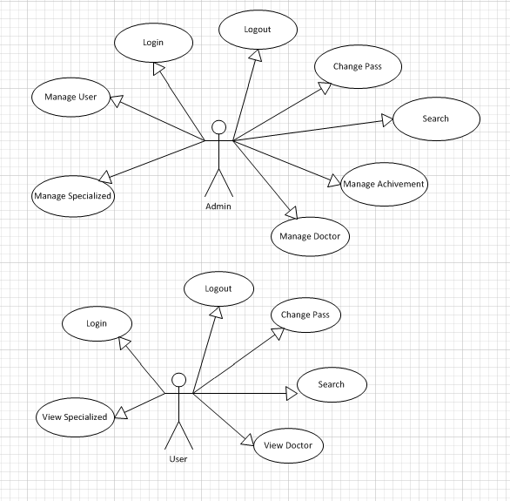

2/ List of Actors

|  |  |  |
| --- | --- | --- |
| No. | Actors | Comment |
| 1 | Admin | Manage system |
| 2 | Users | View information system |

3/ List of User-Case

|  |  |
| --- | --- |
| No. | User-Case |
| 1 | Login |
| 2 | Add User |
| 3 | View Specialized |
| 4 | View Doctor |
| 5 | View Achievement |
| 7 | Change pass |
| 7 | Search |
| 8 | Logout |

4/ Description

4.1 / Login

|  |  |
| --- | --- |
| Use Case | Login |
| Summary | Allows user login to system with corresponding powers |
| Major Events : | Step 1 : When user start application form login will be displayed  Step 2 : User enter their Username and Password  Step 3: Press button “Login” program will check Username and Password in database.  Step 4 : If exist program will display a confirmation message “Login Successful”  Else program will display a confirmation message “Login Failed”  Step 5 : User press button “Exit” to exit this form |

4.2 / Manage User

|  |  |
| --- | --- |
| Use Case | Manage User |
| Summary | User management |
| Major Events : | Sep1: If the login is admin. From admin will appear  Setp2: View User, Add User, Delete User, Role is Admin or User.  Setp3: If successfully implemented in the "success " , failed in an error "error " |

4.3/ View Specialized

|  |  |
| --- | --- |
| Use Case | View Specialized |
| Summary | Present Specialized. |
| Major Events: | Step1: Specialized from out. View Specialized.  Step 2: if the admin login, Add Specialized, delete Specialized, update Specialized.  Step3: When successfully implemented, print "success ". Upon failure, print "error ". |

4.4/ View Doctor

|  |  |
| --- | --- |
| Use Case | View Doctor |
| Summary | Present Doctor. |
| Major Events: | Step1: Doctor from out. View doctor.  Step 2: if the admin login , add doctor, delete doctor , update doctor.  Step3: When successfully implemented, print "success ". Upon failure, print "error ". |

4.5/ View Achievement

|  |  |
| --- | --- |
| Use Case | View Achievement |
| Summary | Present Achievements. |
| Major Events: | Step1: Achievement from out, view Achievement.  Step 2: if the admin login, add achievement, delete achievement, update Achievement.  Step3: When successfully implemented, print "success ". Upon failure, print "error ". |

4.6/ Search

|  |  |
| --- | --- |
| Use Case | Search |
| Summary | Search engine rankings faster |
| Major Events: | Search Combo box ( Doctor name, Specialized name, Hospital name)  press the Enter key begins search |

4.7/ Change pass

|  |  |
| --- | --- |
| Use Case | Change pass |
| Summary | Make more secure passwords |
| Major Events: | Step1: Change pass from out.  Step2: when press Ok if successful. Cancel button if you want the most satisfactory.  Step3: When successfully implemented, print "success ". Upon failure, print "error ". |

4.8/ Logout

|  |  |
| --- | --- |
| Use Case | Logout |
| Summary | Help user logout the program |
| Major Events: | Step 1 : When user want to out click "Logout" on the program interface  Step 2: Program will display a confirmation message “Do you want to sign out”  Step 3 : If click “Yes” user will exit program and disconnect with database  If click “No” user will turn back application interface |