

Employee Transfer Management
Class : 0910E
- TeamLeader : Nguyen Tan Cong
- Members :
+ Tran Huu Loc
+ Nguyen Thanh Luu
+ Nguyen Thi Hong Anh
+ Nguyen Dinh Bien

- Project Plan

Tasks | Date | Status
Project Analysis | From 1/2/2011 To 1/7/2011 | Finished
Design Database | From 1/7/2011 To 1/12/2011 | Finished
Coding | From 1/12/2011 To 1/27/2011 | Actived
Test and debug | From 1/27/2011 To 2/2/2011 | Pending

- Work Allowcation

Project Ref. No. |  | Project Name:  Employee Transfer Management | Date of Preparation of Activity Plan
Sr.  No. | Task | Description | Start  Date | Complete Date | Team member | Status
01 | Project Analysis | Problem Definition | 01-02-2010 | 01-07-2010 | All of the team | Completed
02 | Project Analysis | Analysis and propose solution | 01-02-2010 | 01-07-2010 | All of the team | Completed
03 | Project Analysis | Use Case | 01-02-2010 | 01-07-2010 | All of the team | Completed
04 | Design Database | Entity Relationship Diagram | 01-07-2010 | 01-12-2010 | All of the team | Completed
05 | Design Database | Database Relationship Diagram | 01-07-2010 | 01-12-2010 | All of the team | Completed

- Current Project Progress

  - Problem Definition

Introduction
ABC Technologies Ltd. wants to develop an application for maintaining information related to its employees transfer and generating the transfer related documents.
This application would be facilitating the system administrator (Higher Management) to search the employees transfer record, make new transfers and also amend the allowances offered to the employee, which usually depends on the post of the employee and the type of transfer he is getting.
Existing Scenario
Currently the transfer records are maintained in the computer but there is no fixed format for it. Also the information needs to be shared by releasing circulars to the respective managers and employees and other related staff members (if any).
The information though maintained on computers, entire information can not be found at single place. If higher management wants some details about the transfers, hey have to get it from the respective department heads. This becomes time consuming.
Proposed Solution
The management has decided to have a system for managing the transfers which will access a central database. This system can be installed on all the machines and the employees will have restricted access levels.
The system will have logins for employees and system administrator. And searching transfer records, updating records, making new transfers etc will be taken care of.
Functional Requirements
Following is a list of functionalities of the system.
- Login
- Employees
- System Administrator

- Searching the transfer records.

The search can be based on the following fields :
- Employee Number,
- Employee Name,
- From Location,
- To Location,
- From Project,
- To Project,
- From Department,
- To Department etc

- Making new transfers.

- Employees can request for the transfer.

- Approval for the requested transfer

- Generate the allowances; the employee will be entitled for based on the transfer location and his post

- Generate transfer letters.

- Generate various reports like employees transferred in particular month / time span, transfers happened for particular projects etc.

- Logout

  - Analysis and propose solution
- The Objective of this Application stores the work tasks that related to manage the transfer of employees. This Application will store all information about employees transfer history and require data can be retrieved easy. The users are System Administrator and Employees.
- With System Administrator will include follow functions:
  - Login
  - Logout
  - Manage Location
  - Manage Department
  - Manage Project
  - Manage job: determine jobs in company and salary of it
  - Define Allowances: assign allowance dependent to location and job
  - Manage Employee:
    - View employees in company
    - Add new employee
    - Update information of employee (include general information and account information)
    - Active Employee: allow or don’t allow employee can log in on system
    - Delete employee
  - Role member:
    - Add/Edit/Delete role
    - Assign functions into role
    - Add/Delete employees into/from role
  - Manage Transfer:
    - Make new transfer
    - Update transfer
    - Approval transfer
    - Search transfer: search transfers dependent specific conditions
    - Report Transfer: make report transfer in particular month, time span, transfers happened for particular projects etc.
  - Salary Grading: calculate salary of each employee in each month dependent job and allowances which the employee is subject to the receipt corresponding to transfer times in that month.
- With employee will include follow functions:
- Login
- Logout
- Edit Profile: update personal information of this employee
- Manage Transfer:
    - Request transfer
    - Update transfer: employee only update transfers that owned by this employee and haven’t been approval
    - Search transfer: search transfers that owned by this employee dependent specific conditions
- View Salary: view salary of each month
  - Use Case

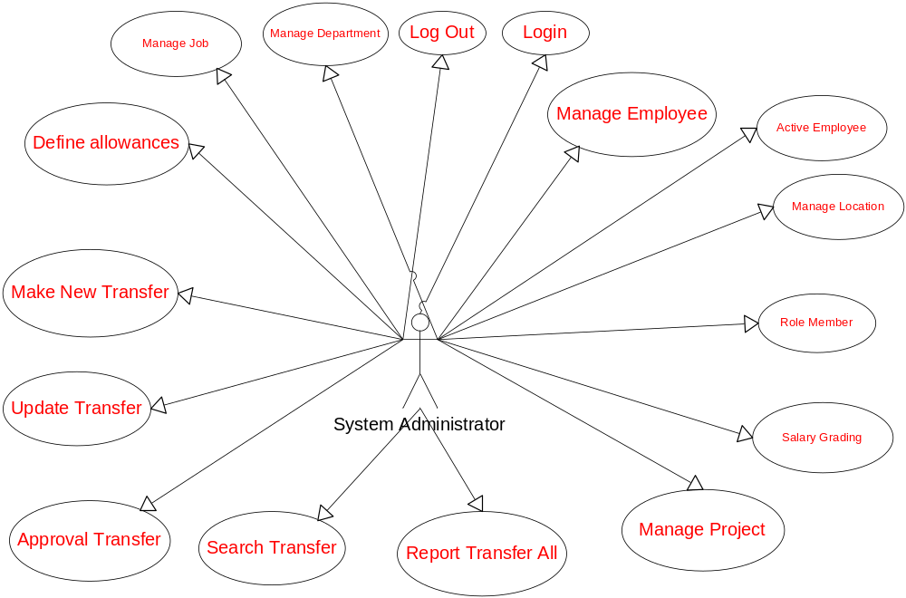
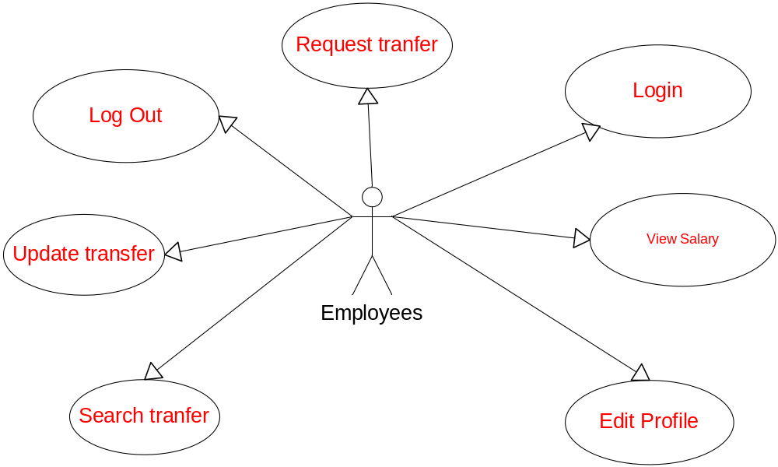
  - Entity Relationship Diagram
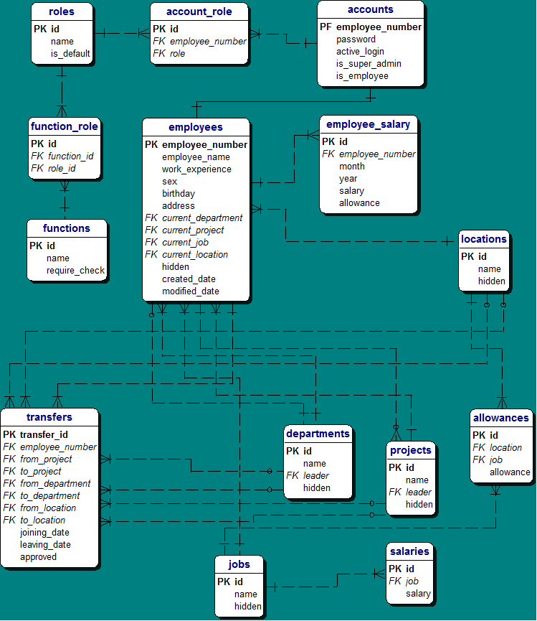

  - Database Relationship Diagram
- Diagram:
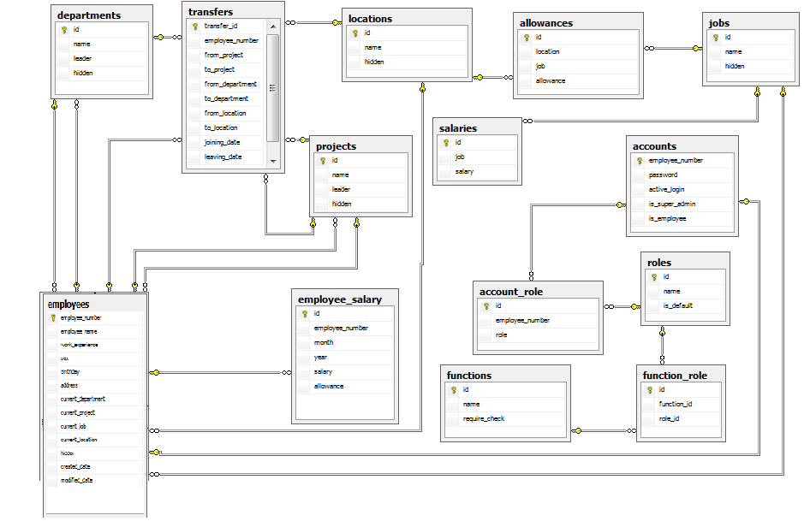
- Description:
- Account_role
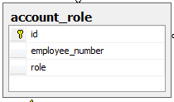
Column Name | Data Type | Primary Key | Foreign Key | Allow Null | Description
id | int | x |  |  | Id, is identity attrtibute
employee_number | nvarchar(10) |  | x |  | Employee ID
role | Int |  | x |  | Role ID

- Accounts
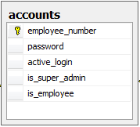
Column Name | Data Type | Primary Key | Foreign Key | Allow Null | Description
employee_number | nvarchar(10) | x |  |  | Username used to login
password | nvarchar(10) |  |  |  | Password used to login
active_login | tinyint |  |  |  | Mark account can login
is_super_admin | tinyint |  |  |  | Determine account is system admin or not. Default is zero
is_employee | tinyint |  |  |  | Determine account is normal account. Default is one

- Allowances
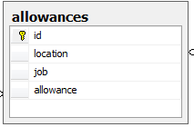
Column Name | Data Type | Primary Key | Foreign Key | Allow Null | Description
id | int | x |  |  | ID, is identity attribute
location | int |  | x |  | Location ID
job | int |  | x |  | Job ID
allowance | int |  |  |  | Allowance corresponding to location and job

- Departments
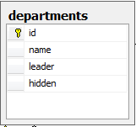
Column Name | Data Type | Primary Key | Foreign Key | Allow Null | Description
id | int | x |  |  | ID, is identity attribute
name | nvarchar(50) |  |  |  | Name of department
leader | nvarchar(10) |  | x |  | Employee that is leader of department
hidden | tinyint |  |  |  | Used to process logic delete function. Default is zero

- Employee_salary
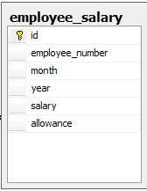
Column Name | Data Type | Primary Key | Foreign Key | Allow Null | Description
id | int | x |  |  | ID, is identity attribute
employee_number | nvarchar(10) |  | x |  | Employee ID
month | int |  |  |  | Salary of month
year | int |  |  |  | Salary of year
salary | int |  |  |  | Salary in month/year of employee
allowance | int |  |  |  | Total allowance in month/year of employee

- Employees
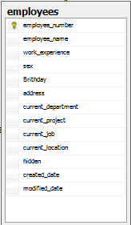

Column Name | Data Type | Primary Key | Foreign Key | Allow Null | Description
employee_number | nvarchar(10) | x |  |  | Employee ID
employee_name | nvarchar(50) |  |  |  | Name of employee
work_experience | int |  |  |  | Work experience of employee
sex | tinyint |  |  |  | Sex of employee
birthday | datetime |  |  |  | Birthday of employee
address | nvarchar(100) |  |  |  | Address of employee
current_department | int |  | x |  | Current department of employee
current_job | int |  | x |  | Current job of employee
current_location | int |  | x |  | Current location of employee
current_project | int |  | x | x | Current project of employee
hidden | tinyint |  |  |  | Used to process logic delete function. Default is zero
created_date | datetime |  |  |  | Created date
modified_date | datetime |  |  |  | Modified date

- Functions
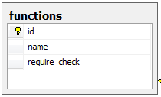
Column Name | Data Type | Primary Key | Foreign Key | Allow Null | Description
id | int | x |  |  | ID, is identity attribute
name | nvarchar(50) |  |  |  | Name of function
require_check | tinyint |  |  |  | Mark function need check perms of account logged before use. Default is one.

- Function_role
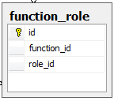
Column Name | Data Type | Primary Key | Foreign Key | Allow Null | Description
id | int | x |  |  | ID, is identity attribute
function_id | int |  | x |  | Function ID
role_id | int |  | x |  | Role ID

- Jobs
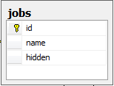
Column Name | Data Type | Primary Key | Foreign Key | Allow Null | Description
id | int | x |  |  | ID, is identity attribute
name | nvarchar(50) |  |  |  | Name of job
hidden | tinyint |  |  |  | Used to process logic delete function. Default is zero

- Locations
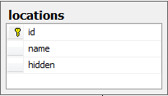
Column Name | Data Type | Primary Key | Foreign Key | Allow Null | Description
id | int | x |  |  | ID, is identity attribute
name | nvarchar(50) |  |  |  | Name of location
hidden | tinyint |  |  |  | Used to process logic delete function. Default is zero

- Projects
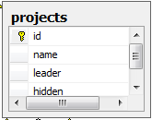
Column Name | Data Type | Primary Key | Foreign Key | Allow Null | Description
id | int | x |  |  | ID, is identity attribute
name | nvarchar(50) |  |  |  | Name of project
leader | nvarchar(10) |  | x |  | Employee ID of project leader
hidden | tinyint |  |  |  | Used to process logic delete function. Default is zero

- Roles
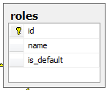
Column Name | Data Type | Primary Key | Foreign Key | Allow Null | Description
id | int | x |  |  | ID, is identity attribute
name | nvarchar(50) |  |  |  | Name of role
is_default | tinyint |  |  |  | Mark role is default role. We cann’t delete default role

- Salaries
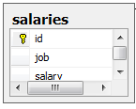
Column Name | Data Type | Primary Key | Foreign Key | Allow Null | Description
id | int | x |  |  | ID, is identity attribute
job | int |  | x |  | Job ID
salary | int |  |  |  | Salary of job

- Transfers
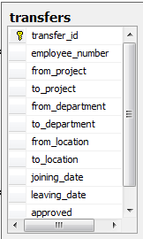
Column Name | Data Type | Primary Key | Foreign Key | Allow Null | Description
transfer_id | varchar(20) | x |  |  | Transfer ID. Is generate letters
employee_number | nvarchar(10) |  | x |  | Employee ID
from_project | int |  | x | x
to_project | int |  | x | x
from_department | int |  | x | x
to_department | int |  | x | x
from_location | int |  | x | x
to_location | int |  | x | x
joining_date | datetime |  |  |  | Date begin transfer
leaving_date | datetime |  |  |  | Date end transfer
approved | tinyint |  |  |  | Mark transfer approved or not. Default is zero

- Doubt on project specification:

- What does the word “location” mean in this sentence “Generate the allowances; the employee will be entitled for based on the transfer location and his post.” Give us the example. Currently, we assumed that location is the geographic location of the company branch.

