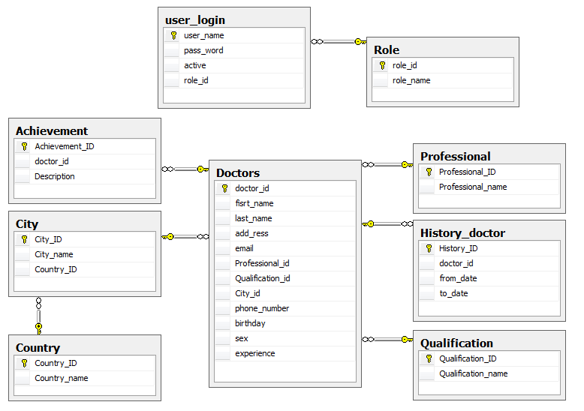

Database diagram

1.user_login : Table

Name | Data style | Description
user_name(PK) | varchar(40) | User name
Pass_word | varchar(20) | User’ password
Active | int | User status
Role_id | int | User role

2. History_doctor : Table

Name | Data style | Description
History_ID(PK) | int | history id
Doctor_id | int | Doctor id
From_date | smalldatetime | Coming date
To_date | smalldatetime | Out date

3. Professinal : Table

Name | Data style | Description
Professtional_ID(PK) | int | Professtional id
Professtional_name | varchar(40) | Professtional name

4. Qualification : Table

Name | Data style | Description
Qualification_ID(PK) | int | Qualification id
Qualification_name | varchar(40) | qualification name

5. Country : Table

Name | Data style | Description
Coutry_ID(PK) | int | Country id
Country_name | varchar(40) | Country name

6. City : Table

Name | Data style | Description
City_ID(PK) | int | City id
City_name | varchar(40) | City name
Country_id | int | Country id

7. Doctor : Table

Name | Data style | Description
Doctor_ID(PK) | int | Login id
First_name | varchar(40) | Doctor’ firstname
Last_name | varchar(40) | Doctor’ lastname
Add_ress | varchar(50) | Doctor’ home address
Email | Varchar(40) | Doctor’ email
Professtional_id | int | Doctor’ professtional id
Qualification_id | int | Doctor’ qualification id
City_id | int | Location id
Phone_number | varchar(25) | Doctor’ number phone
Birthday | smalldatetime | Day of birth
sex | varchar(6) | gender
experience | int | Experience years

8. Achievement : Table

Name | Data style | Description
achievement_ID(PK) | int | Achievement id
Doctor_id | int | Doctor id
desciption | varchar(255) | Describe doctor achievement

9. role_id : Table

Name | Data style | Description
Role_ID(PK) | int | Achievement id
Role_name | int | Doctor id

