


e-Project
SECOND REPORT
Center : hungvuong aptech
E - Project : doctor information system
Project Start Date: 25-Oct-2011
Project Submission Date: 25-Nov-2011
Team ‘s members :
-Nguyen Tan Cong
-Tran Hoang Anh
-Doan Hoang De
-Pham Duc Phuc

1. Site map
2. Flow chart
3. Interface system

- SITE MAP
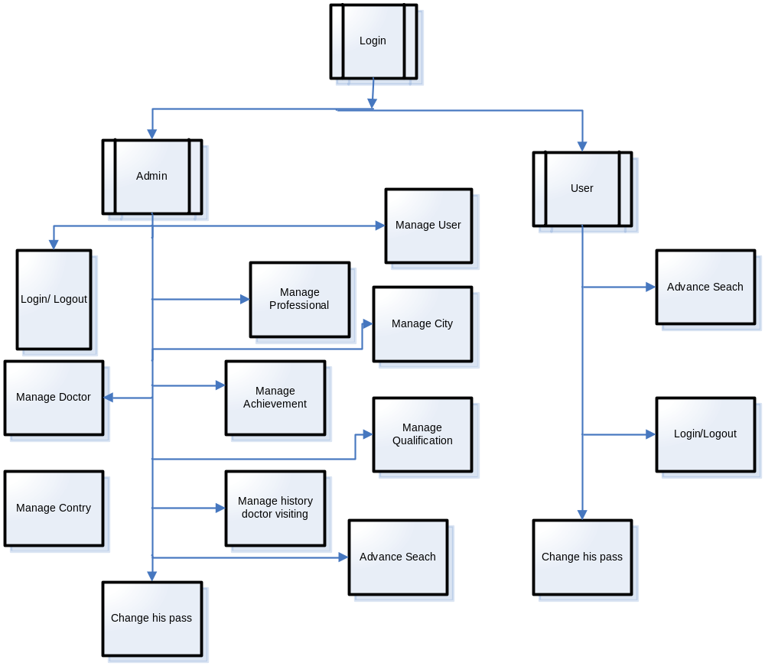
- FLOW CHART
  - LOGIN 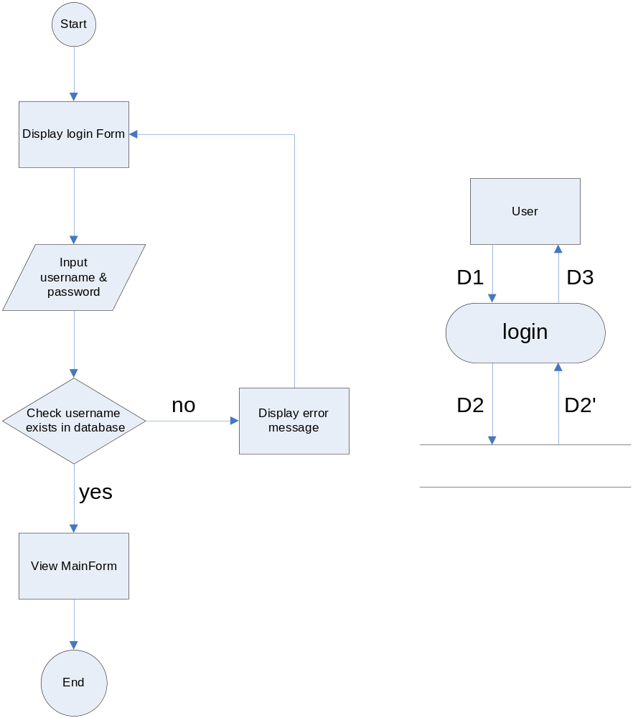
  - LOG OUT
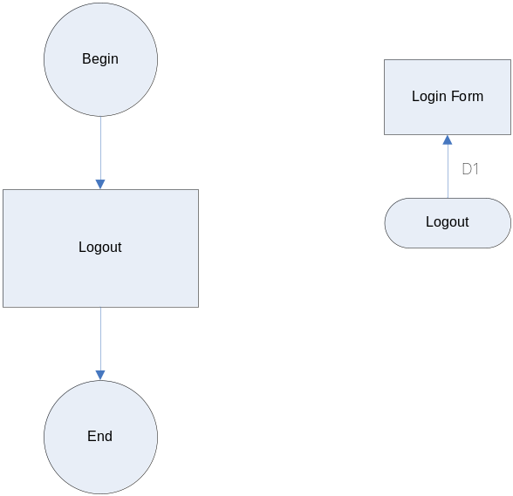
2.3 ADVANCE SEARCH
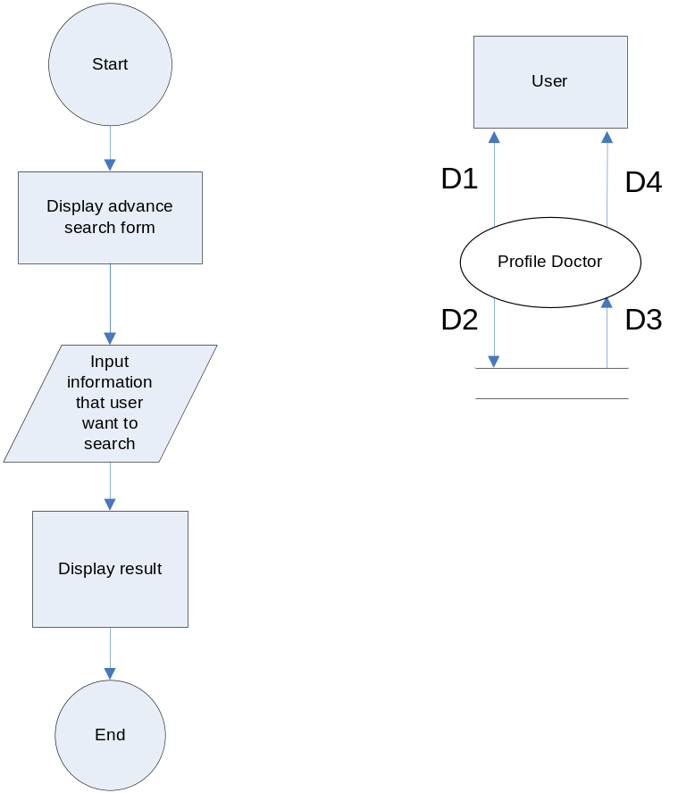
2.4 CHANGE PASSWORD 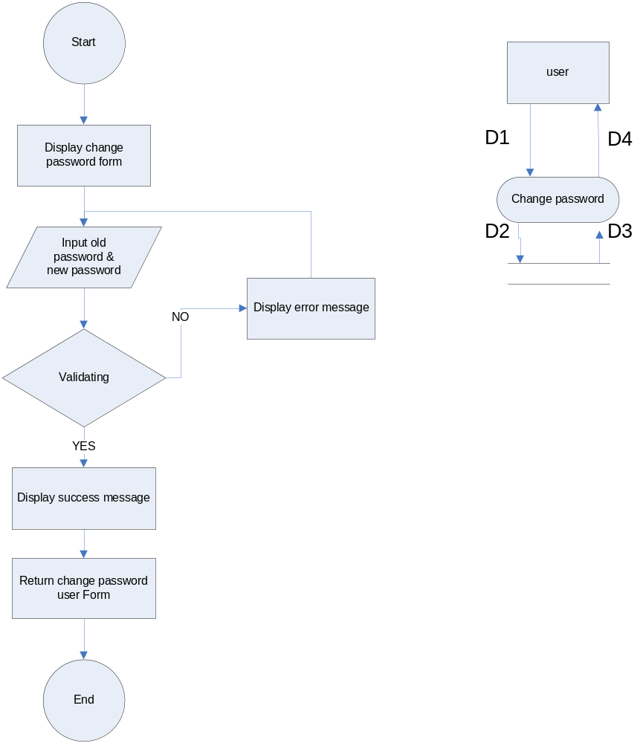
  - Manage achievement 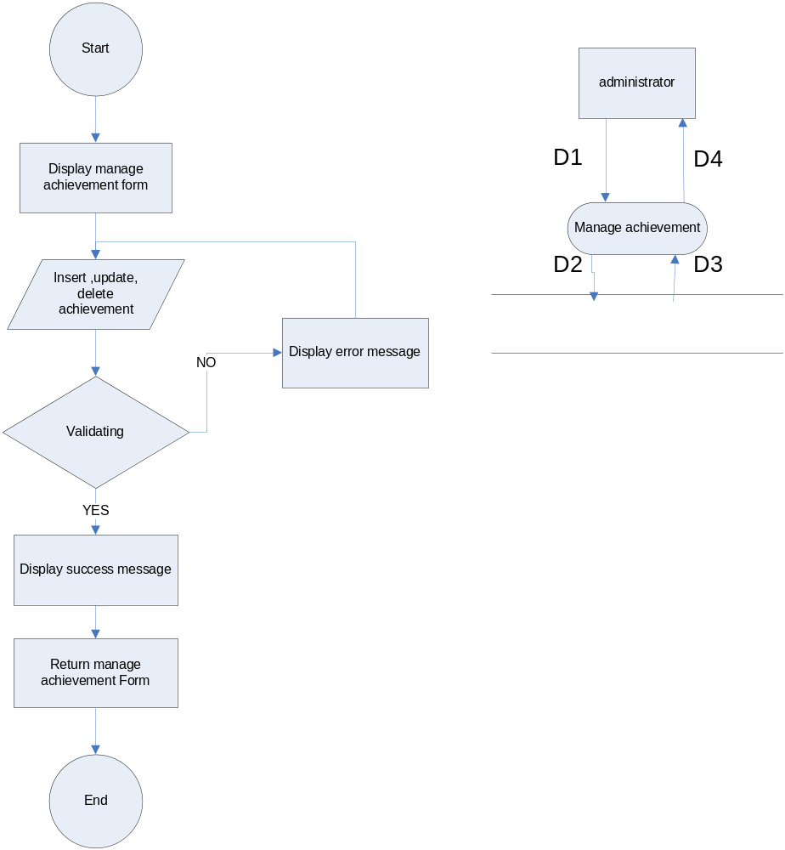
  - Manage city 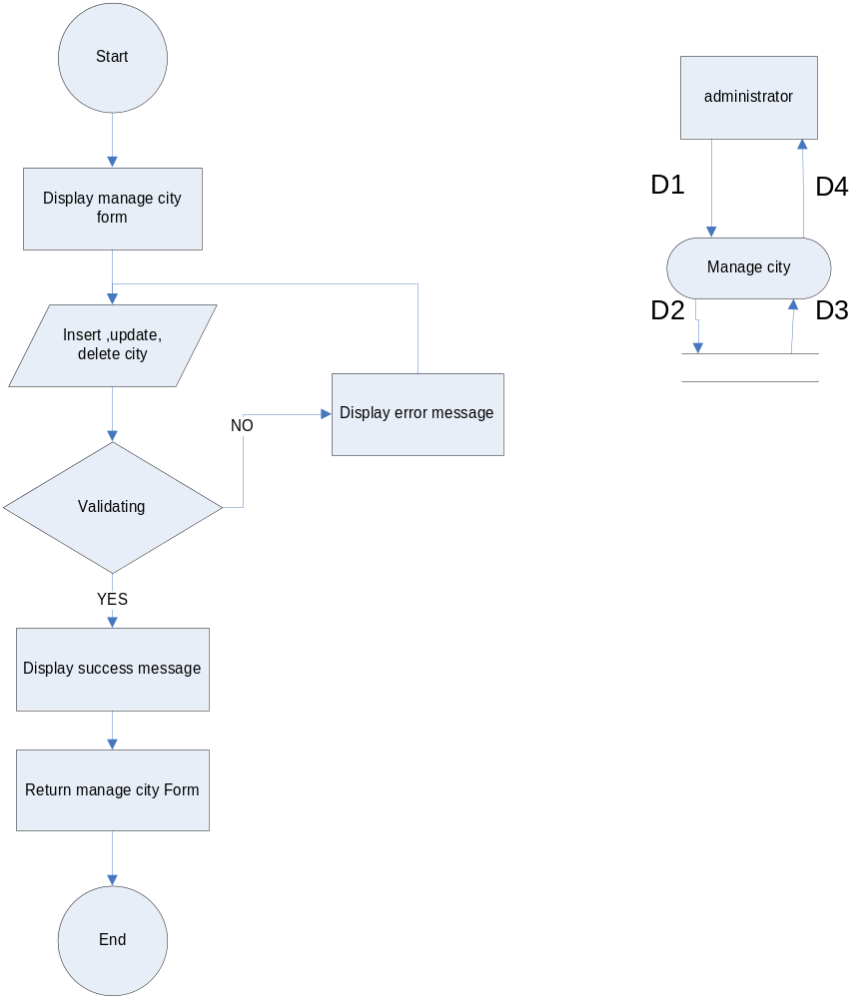
  - Manage country 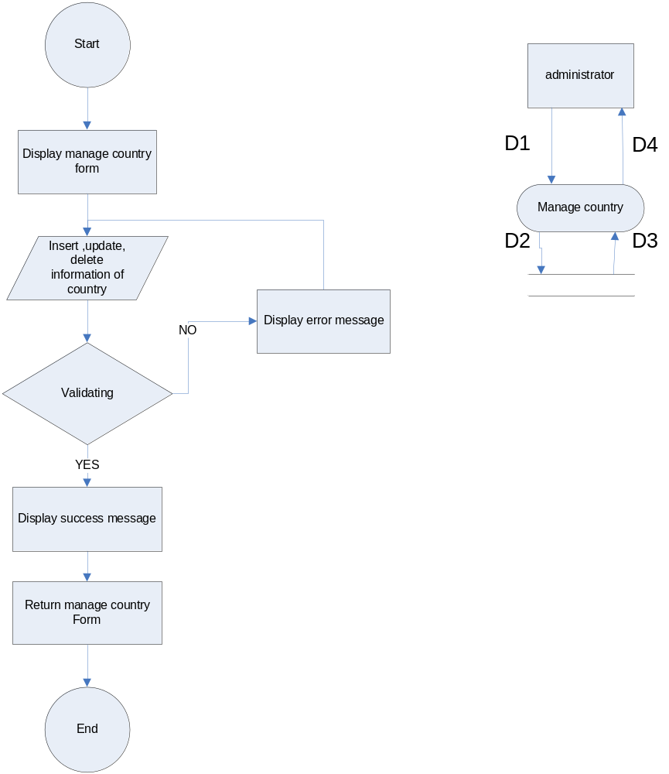
  - Manage doctors 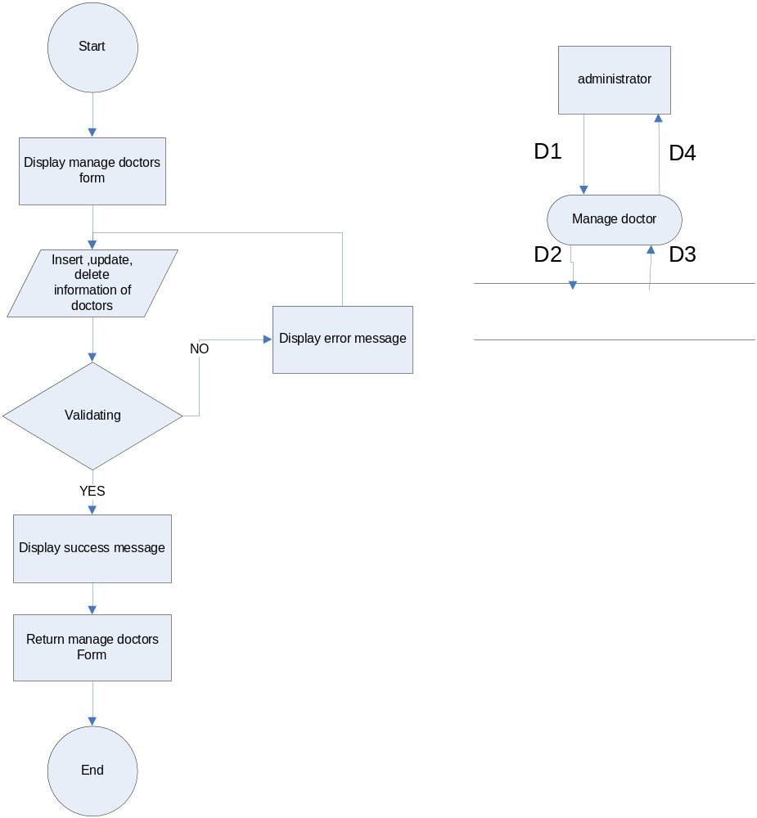
  - Manage history doctor 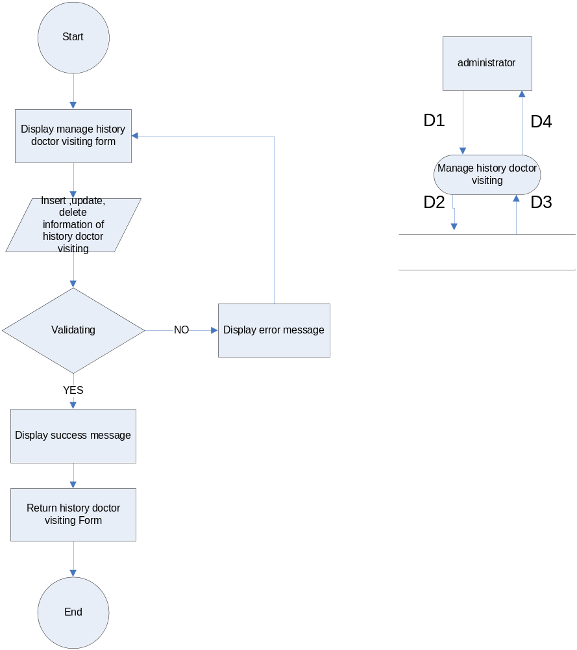
  - Manage professional 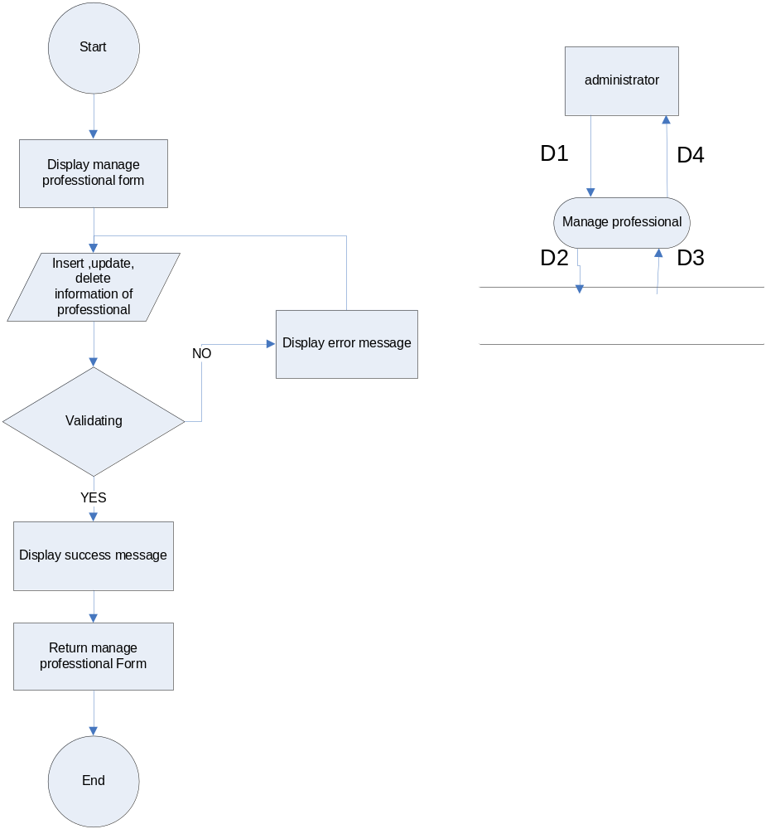
  - Manage qualification 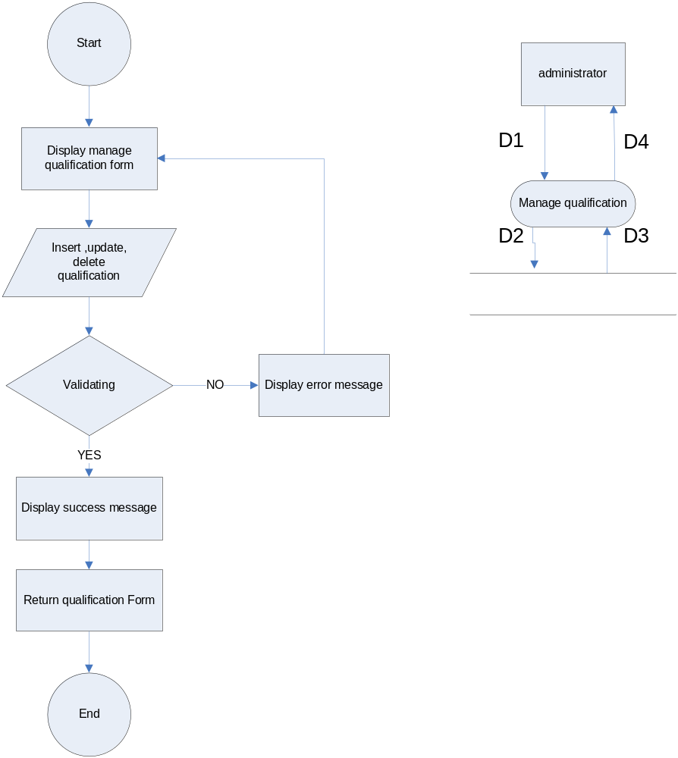
  - Manage user 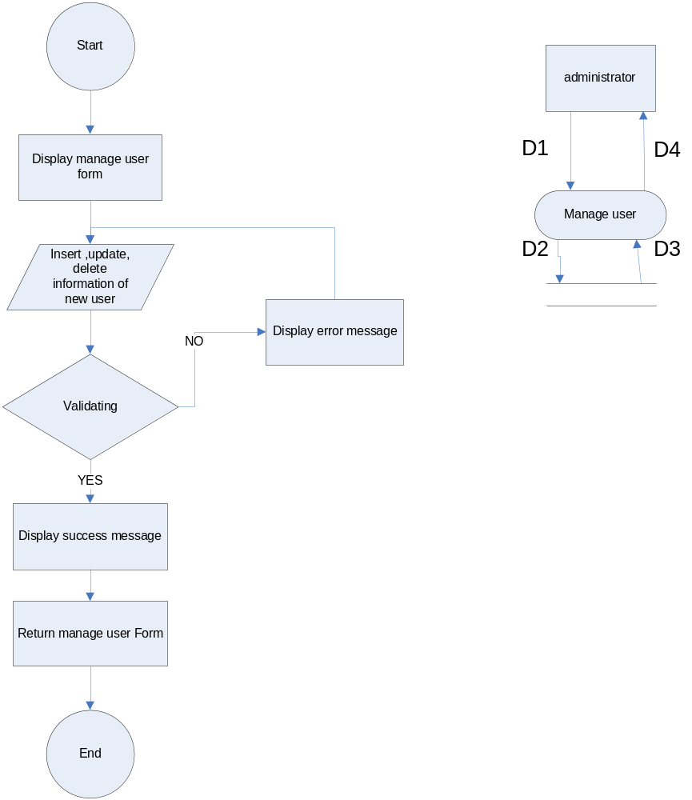
- Interface System
Form Login:
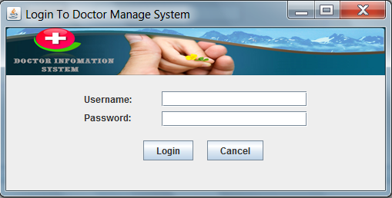

Main Form:
Administrator:
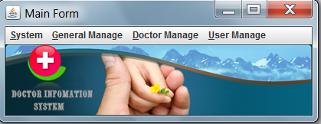
Employee:
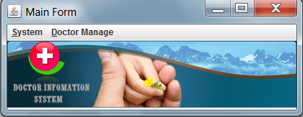

Manage Doctor Form:
