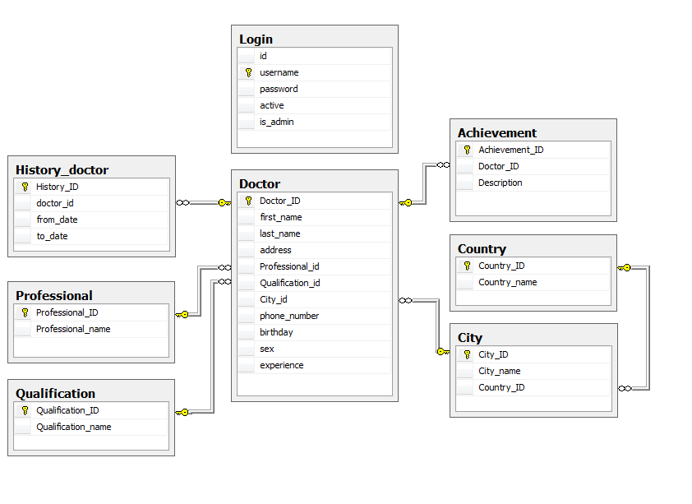

1.Login : Table

Name | Data style | Description
id | int | Login id
username | nvarchar(20) | User’ name
password | Nvarchar(20) | User’ password
active | int | User’ status
is_admin | int | User’ role

2. History_doctor : Table

Name | Data style | Description
History_ID | int | history id
Doctor_id | int | Doctor’ id
From_date | smalldatetime | Coming date
To_date | smalldatetime | Out date

3. Professinal : Table

Name | Data style | Description
Professtional_ID | int | Professtional’ id
Professtional_name | Nvarchar(30) | Professtional’ name

4. Qualification : Table

Name | Data style | Description
Qualification_ID | int | qualification’ id
Qualification_name | Nvarchar(10) | qualification’ name

5. Country : Table

Name | Data style | Description
Coutry_ID | int | Country id
Country_name | Nvarchar(20) | Country name

6. City : Table

Name | Data style | Description
City_ID | int | City’ id
City_name | Nvarchar(20) | City’ name

7. Doctor : Table

Name | Data style | Description
Doctor_ID | int | Login id
First_name | nvarchar(20) | Doctor’ first name
Last_name | nvarchar(20) | Doctor’ last name
Address | nvarchar(50) | Doctor’ home address
Professtional_id | int | Doctor’ professtional id
Qualification_id | int | Doctor’ qualification id
City_id | int | Location id
Phone_number | nvarchar(15) | Doctor’ number phone
Birthday | smalldatetime | Day of birth
sex | nvarchar(5) | gender
experience | int | Experience years

