1/ User Case

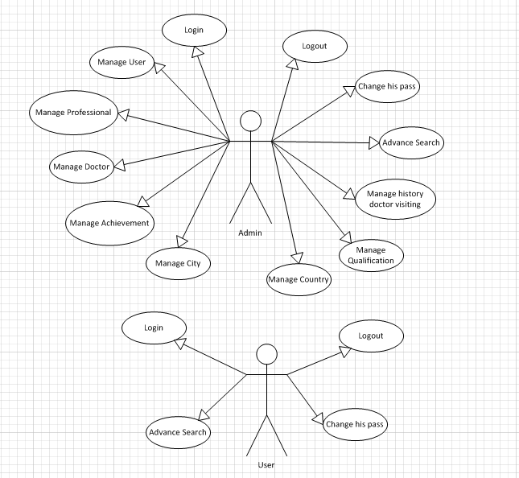

2/ List of Actors

|  |  |  |
| --- | --- | --- |
| No. | Actors | Comment |
| 1 | Admin | Manage system |
| 2 | Users | Manage information system |

3/ List of User-Case

|  |  |
| --- | --- |
| No. | User-Case |
| 1 | Login |
| 2 | Add User |
| 3 | Manage professional |
| 4 | Manage Doctor |
| 5 | Manage Achievement |
| 6 | Change pass |
| 7 | Advance Search |
| 8 | Logout |
| 9 | Manage city |
| 10 | Manage country |
| 11 | Manage qualification |
| 12 | Manage history doctor’ visiting |

4/ Description

4.1 / Login

|  |  |
| --- | --- |
| Use Case | Login |
| Summary | Allows user login to system with corresponding powers |
| Major Events : | Step 1 : When user start application form login will be displayed  Step 2 : User enter their Username and Password  Step 3: Press button “Login” program will check Username and Password in database.  Step 4 : If exist program will display a confirmation message “Login Successful”  Else program will display a confirmation message “Login Failed”  Step 5 : User press button “Exit” to exit this form |

4.2 / Manage User

|  |  |
| --- | --- |
| Use Case | Manage User |
| Summary | User management |
| Major Events : | Sep1: If the login is admin. From admin will appear  Setp2: Manage User, Add User, Delete User, Role is Admin or User.  Setp3:If successfully implemented in the "success " , failed in an error "error " |

4.3/ Manage Professional

|  |  |
| --- | --- |
| Use Case | Manage Professional |
| Summary | Present Professional. |
| Major Events: | Step1: Professional from out. Manage Professional.  Step 2:if the admin login ,Add new Professional, delete Professional, update Professional.  Step3: When successfully implemented, print "success ". Upon failure, print "error ". |

4.4/ Manage Doctor

|  |  |
| --- | --- |
| Use Case | Manage Doctor |
| Summary | Present Doctor. |
| Major Events: | Step1: Doctor from out. Manage doctor.  Step 2: if the admin login , add doctor, delete doctor , update doctor.  Step3: When successfully implemented, print "success ". Upon failure, print "error ". |

4.5/ Manage Achievement

|  |  |
| --- | --- |
| Use Case | Manage Achievement |
| Summary | Present Achievements. |
| Major Events: | Step1: Achievement from out, manage Achievement.  Step 2: if the admin login, add achievement ,delete achievement, update Achievement.  Step3: When successfully implemented, print "success ". Upon failure, print "error ". |

4.6/Advance Search

|  |  |
| --- | --- |
| Use Case | Search |
| Summary | Search engine rankings faster |
| Major Events: | Advance Search for( Doctor name, Professional name, qualification, location, achievement, visiting time, experience years)  press the Enter key begins search |

4.7/ Change pass

|  |  |
| --- | --- |
| Use Case | Change pass |
| Summary | Make more secure passwords |
| Major Events: | Step1: Change pass from out.  Step2: when press Ok if successful. Cancel button if you want the most satisfactory.  Step3: When successfully implemented, print "success ". Upon failure, print "error ". |

4.8/ Logout

|  |  |
| --- | --- |
| Use Case | Logout |
| Summary | Help user logout the program |
| Major Events: | Step 1 : When user want to out click "Logout" on the program interface  Step 2: Program will display a confirmation message “Do you want to sign out”  Step 3 : If click “Yes” user will exit program and disconnect with database  If click “No” user will turn back application interface |

4.9/ Manage City

|  |  |
| --- | --- |
| Use Case | Manage City |
| Summary | Present City. |
| Major Events: | Step1: Professional from out. Manage City.  Step 2:if the admin login ,Add new City, delete city, update city.  Step3: When successfully implemented, print "success ". Upon failure, print "error ". |

4.10/ Manage country

|  |  |
| --- | --- |
| Use Case | Manage country |
| Summary | Present country. |
| Major Events: | Step1: country from out. Manage country.  Step 2:if the admin login ,Add new country, delete country, update country.  Step3: When successfully implemented, print "success ". Upon failure, print "error ". |

4.11/ Manage Qualification

|  |  |
| --- | --- |
| Use Case | Manage Professional |
| Summary | Present Qualification. |
| Major Events: | Step1: Qualification from out. Manage Qualification.  Step 2:if the admin login ,Add new Qualification, delete qualification, update qualification.  Step3: When successfully implemented, print "success ". Upon failure, print "error ". |

4.12/ Manage history doctor’ visiting

|  |  |
| --- | --- |
| Use Case | Manage history doctor’ visiting |
| Summary | Present history doctor’ visiting. |
| Major Events: | Step1: history doctor’ visiting from out. Manage history doctor’ visiting.  Step 2:if the admin login ,Add new record, delete record, update record.  Step3: When successfully implemented, print "success ". Upon failure, print "error ". |