1651003 - Nguyễn Thị Minh Anh

CS427 - Game Development and Visualization

**Mini Project 1: 2D Games Report**

**Game name:**

“The Penguin World”

**Engine using:**

Unity 2019.1.3f1 Personal - 64 bit

**Main idea:**

“The Penguin World” is build based on the inspiration of my all-time favorite holiday season – Christmas, promises to remind us of the greatest time of the year. This 2-levels game so far is very simple and extremely easy to play. There is a main character “Penguin” with his mission on Christmas, that is trying his best to collect all the gifts available on game screen, therefore he can fully celebrate and enjoy his holiday with Santa Clause and Snow Man.

**How to start?**

Click “Start” button on main screen to start level 1. After completing level 1, level 2 will begin.

**How to play?**

Using keyboard to move Penguin.

**Main techniques:**

- 2D spite animations  
- 2D physics collider  
- Kinematic and Physics Controlling  
- Character Control with Keyboard  
- Rigidbody Component  
- Collision and Trigger Events  
- UI layout: Canvas with Button Events, Texts  
- UI Menu and Sound

**Resolution:**

1366 x 768

**Total scenes: 3**

* **Main Scene:** This scene is also the main menu for the game, containing a game title, some introduction, and a Start button to start game after being pressed.

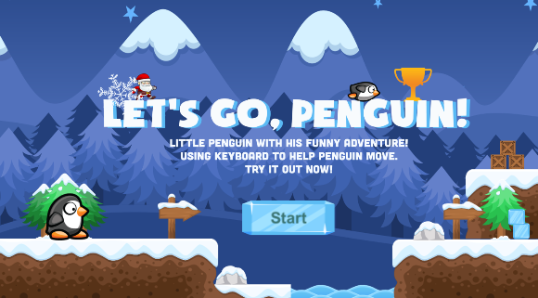

*Background music: we-wish-you-a-merry-christmas.mp3*

* **Scene1:** Level 1 (more details in next section).

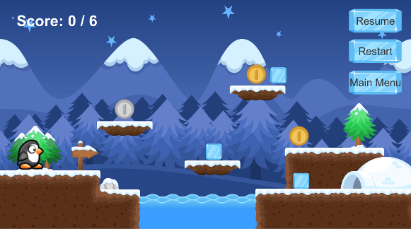

*Background music: jingle-bells-country.mp3*

* **Scene2:** Level 2 - final level (more details in next section).

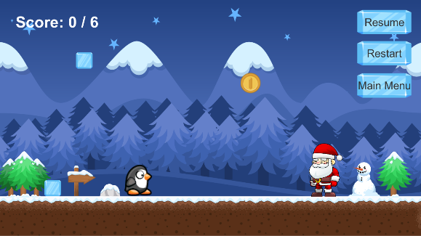

*Background music: jingle-bells-country.mp3*

**Levels in Detail:**

* **Level 1:**
* Target:
* Collect all the gifts available on screen (6 giftw: gold, silver, ice), each gift collected by Penguin will increase the score to 1. After gaining 6 scores, Penguin must go through Snow Tunnel on the right to complete level 1 and forward to level 2. Penguin cannot go through this tunnel unless already collects all items, there is a guide text if this case happens.
* Level 2 will start after Penguin succesfully completes level 1.
* How to play:
* Using keyboard to move Penguin to expect position.
* Left arrow to make Penguin go Left, Right arrow to go Right, Space to Jump (can be able to jump continously).
* UI:
* Background music: *jingle-bells-country.mp3*
* Navigation:

- Resume button: restart level 1, all processes in this level will be lost.  
- Restart button: restart level 1, all processes in this level will be lost.  
- Main menu: back to main menu.

* **Level 2:**
* Target:
* At first: I expected to have Penguin tried to collect 10 gifts thrown by Santa Claus, to win the game. Unfortunately, I got some problems to spawn the GameObject into 10 clones and I hope that I can fix them soon. So that I decided to make this level easier, that 1 gift collected by Penguin is enough to complete this level and win the game.
* “Merry Christmas, Penguin!!!” will show on screen after success.
* How to play:
* Using keyboard to move Penguin to expect position.
* Left and Right arrow to move Penguin to the left and right respectively.
* UI:
* Background music: *jingle-bells-country.mp3*
* Navigation:

- Resume button: restart level 2, all processes in this level will be lost.  
- Restart button: restart level 1, all processes in this level and level 1 will be lost.  
- Main menu: back to main menu

* **Note:**

I copy the source code from my previous homework A01, and improve it into this mini project and I still do not know how to change the .exe name after building this project. Therefore, please check my build file .exe at Build / PC / A01.exe

* **References:**

**Game Development Course** by **TA. Dat-Thanh Tran** on Youtube.

**Free Christmas MP3:** <http://www.freexmasmp3.com/>